Molecular Shapes WebLab
Name and date submitted (3 pts):
- Go to the PhET “Molecule Shapes” simulation. At the time of writing, it was located here https://phet.colorado.edu/en/simulation/molecule-shapes . Select the “Real Molecules” option. Also select “Molecule Geometry” and “Show Bond Angles”.
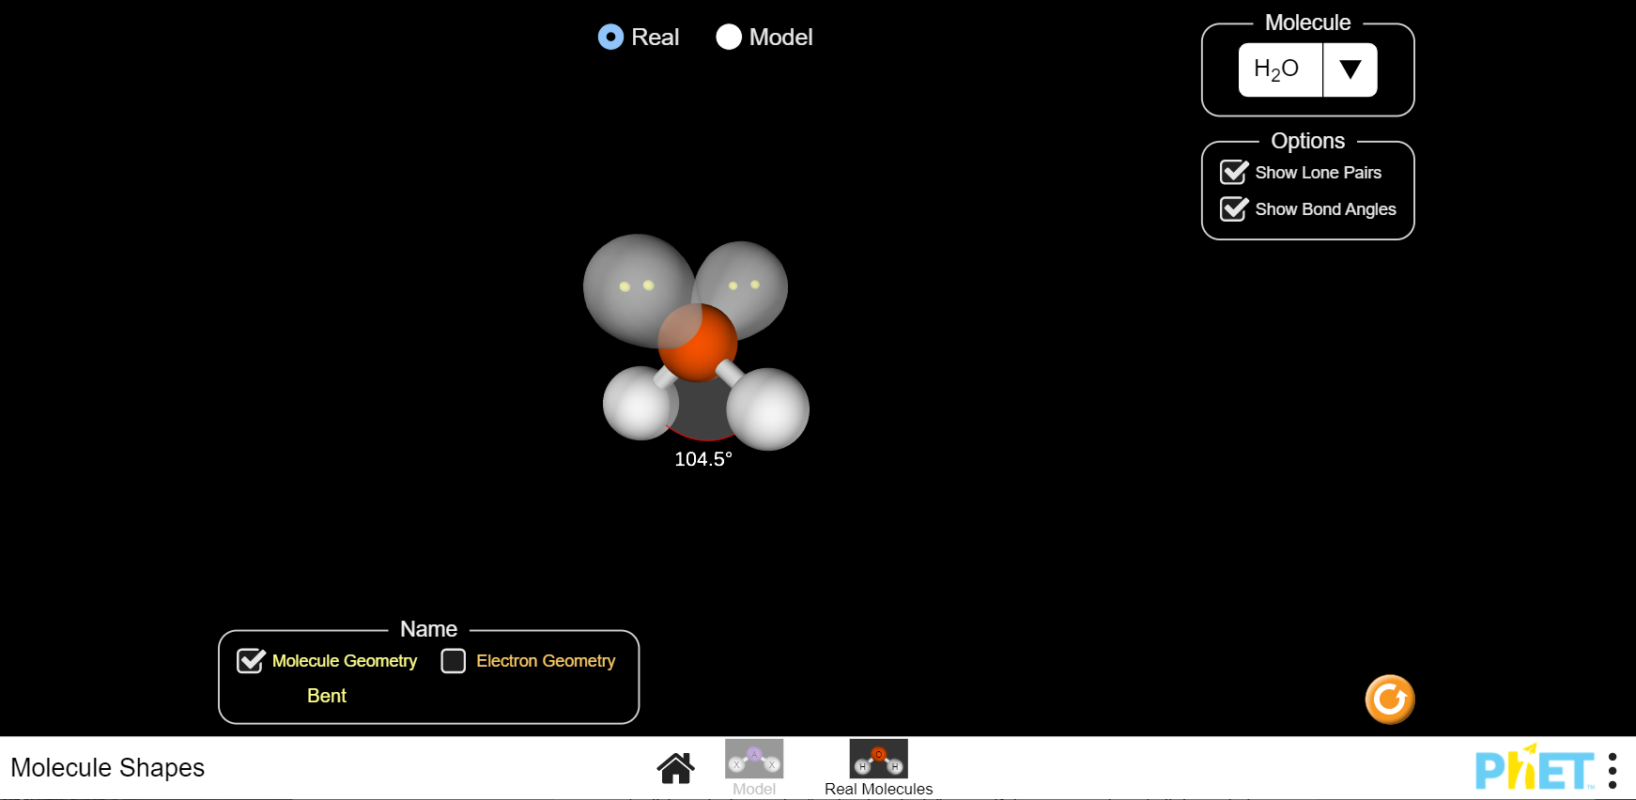

- Complete the following table.
Molecule | Lewis drawing | Bond angles | Shape name | 3-D Sketch
H₂
CH₄
NH₃
H₂O
CO₂
HCN
CH₂O

- Next, open the PhET “Molecule Polarity” simulation located here https://phet.colorado.edu/en/simulation/molecule-polarity . Select the “Real Molecules” option. Also select “Bond Dipoles”, “Partial Charges”, and “Molecular Dipole” as needed to complete the table below.
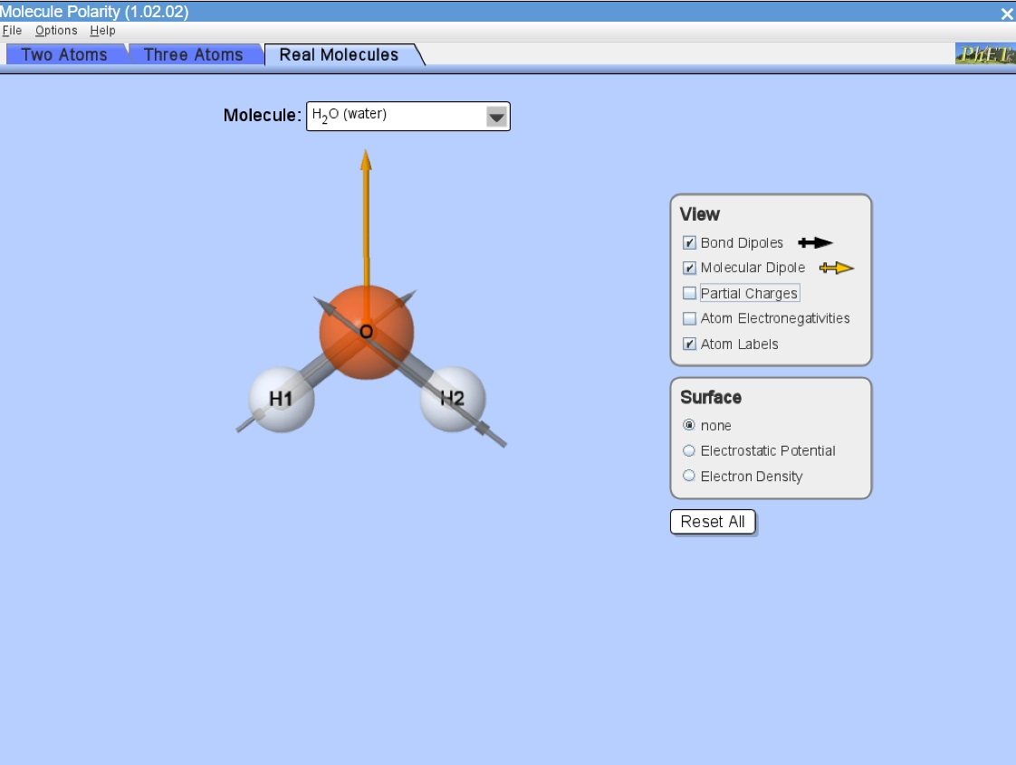

- Complete the table below.
Molecule | “Bond Dipoles” box:  Describe any bond polarity, and state the partial charges on the atoms if they exist. | “Molecular Dipole” box: Is the molecule itself “polar”? Describe the molecular dipole, if there is one. | Check “Electrostatic Potential” box:  Describe the red (negative) and blue (positive) regions of the molecule, if they exist.
H₂
CH₄
NH₃
H₂O
CO₂
HCN
CH₂O

- Predict the following shapes and angles (surrounding the central atoms) for the following. Determine what type of polarity also
H₂Si₂
N₂O₄
CH₃F

