Wind Turbine Calculations

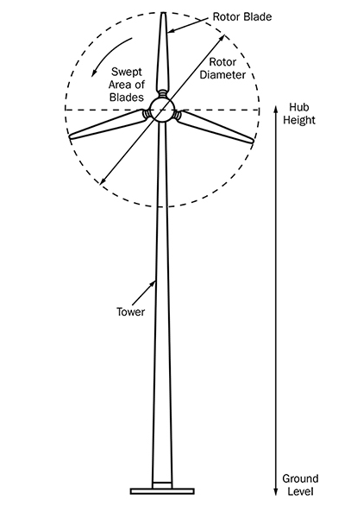
- Measure the Swept Area

Measure the swept area of your blades to estimate the total energy potential in a given area of wind.

The swept area refers to the area of the circle created by the blades as they sweep through the air.

Swept Area = ∏r2

∏ = 3.14 (pi)
r = Radius. This is equal to the length of one of your blades.

- Use the Wind Power Equation
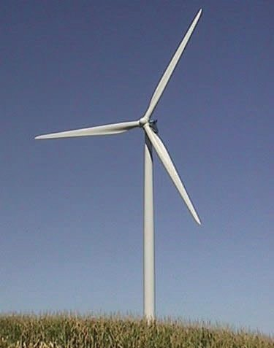

Now use the swept area of your wind turbine to calculate the total power in the wind that hits your turbine.

Wind Power Equation:

$$P=\frac{1}{2}ρAv^{3}$$

P = Power (Watts)
ρ = Air Density (1.225 kg/m3 at sea level)
A = Swept Area of Blades (m2)
v = Velocity of the wind (m/s)

By doing this calculation, you can see the total energy potential in a given cross section of wind.

Problems:

- What is the swept area in m² of a wind turbine with 3 blades that are each 3 meters long?

- If the wind is blowing at 3 meters/second, how much total power (Watts) is in the wind hitting the wind turbine from question one (blades 3-meters long)? Assume the wind turbine is at sea level.

- How much power (Watts) would be contained in the column of wind hitting the wind turbine if the wind was blowing at 6 m/s? (very strong wind)

- How much power (Watts) would be contained in the column of wind hitting the wind turbine if the wind was blowing at 9 m/s? (extremely strong wind)

- Tip Speed and Tip Speed Ratio

The Tip Speed is the speed of the rotating blade tip:

Tip Speed (m/s) = $\frac{(RPM)(circumference)}{(60)}$
RPM (revolutions/min): you can usually measure this using stopwatch
Circumference: use 2$π$r or ϖd

The Tip Speed Ratio (TSR) is the wind speed divided by the tip speed of the blades:

TSR (λ) = $\frac{tip speed (\frac{m}{s})}{wind speed (\frac{m}{s})}$
TSR doesn’t have units
Wind speed (m/s): look it up on wind map, or the problem will state it
Tip speed (m/s): compute from tip speed equation, above

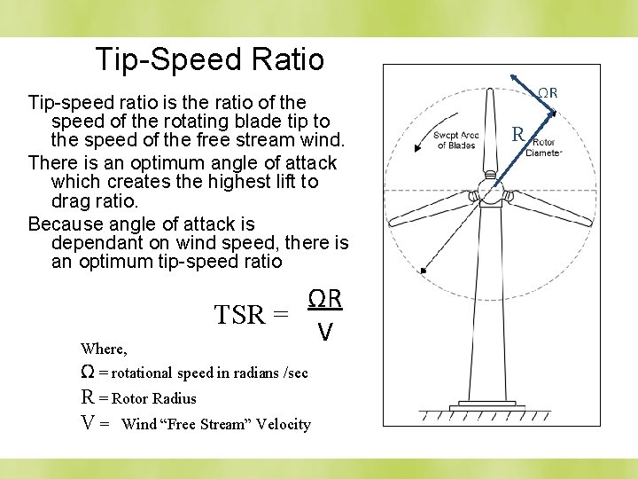

- Optimize the Tip Speed Ratio to establish the best Tip Speed and RPM’s for maximum power

If the rotor of the wind turbine spins too slowly, most of the wind will pass straight through the gap between the blades, therefore giving it no power.
If it spins too fast, the blades will blur and act like a solid wall to the wind. Also, rotor blades create turbulence as they spin through the air. If the next blade arrives too quickly, it will hit that turbulent air. So you need to optimize the tip speed.

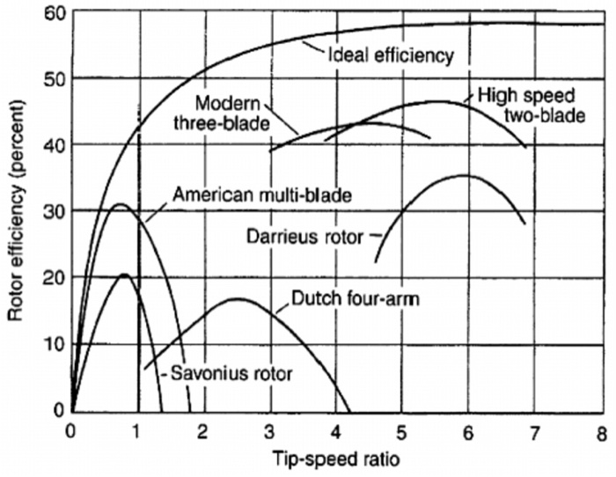

$Optimum TSR \left(λ\right)= \frac{4π}{n}$ (n = number of blades)

# of blades | Optimum TSR
2 | 6
3 | 4-5
4 | 3
6 | 2

Example: Using a 3-blade rotor, the optimum Tip Speed Ratio would be $\frac{4π}{3}$. Once you know that, you can back-out the optimum Tip Speed and thus the optimum RPM’s, using the equations in section 3 above.

Problems:

- Using your 3-blade turbine with 3-meter blades, what is the optimum rotor RPM’s with a wind speed of 3 m/s?

- Using your 3-blade turbine with 3-meter blades, what is the optimum rotor RPM’s with a wind speed of 6 m/s?

- Using your 3-blade turbine with 3-meter blades, what is the optimum rotor RPM’s with a wind speed of 9 m/s?

- If you went with a 4-bladed turbine, would it need to turn slower or faster than a 3-bladed unit? Strategy: pick a wind speed, say 3 m/s, and compute its optimum RPM’s, and compare a 3-blade to a 4-blade rotor.

- Calculate the Gear Ratios

Without a gearbox, utility-scale wind turbines using an ordinary generator would have to rotate at over 1,000 rpm to generate the 60 Hz AC electricity we use in our homes. That means the tips of those long blades would be rotating at over TWICE THE SPEED OF SOUND!

Therefore, to get the generator spinning at over 1,000 RPM, we use a system of gears.

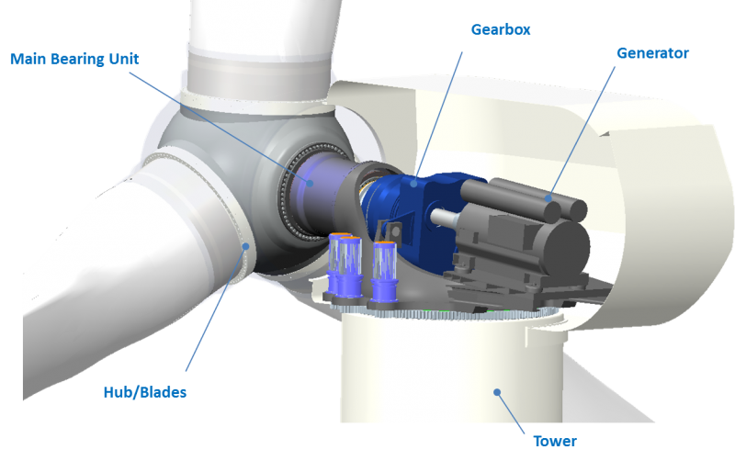

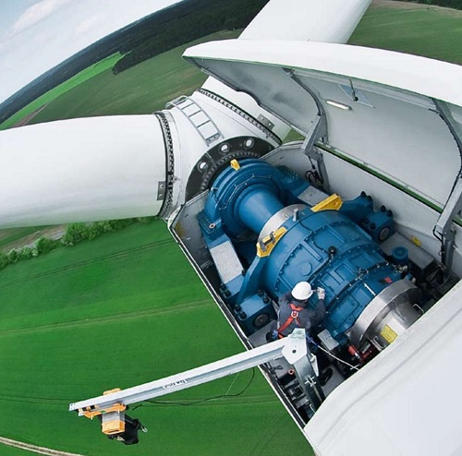
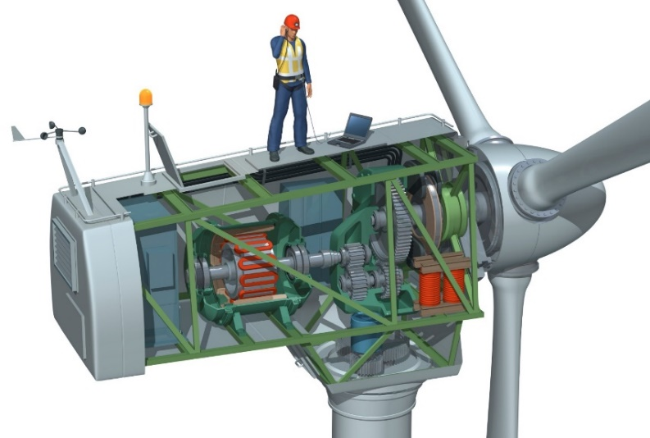

You will run the propeller shaft (slow) into the gearbox, the gears will then step up the speed, and then you run the output shaft (fast) from the gearbox to the generator.

The “gear ratio” of a system of gears can be computed many ways:

Gear Ratio equations:

$$GR= \frac{{RPM}_{in}}{{RPM}_{out}}=\frac{ω_{in}}{ω_{out}}=\frac{n_{out}}{n_{in}}$$

where RPM is revolutions/min, ω is radians/sec, and ‘n’ is the # of teeth.
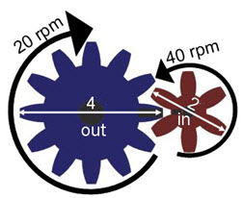

For example, the ‘gear ratio’ of the gears shown above would be

$GR=\frac{{RPM}_{in}}{{RPM}_{out}}=\frac{40}{20}=2$, or we might say “2:1”

Let’s say you have a blade rotation speed of only 60 RPM, but you need your generator to spin at 1,200 RPM to generate consequential amounts of electricity. Therefore, you will need a gear ratio of

$GR=\frac{{RPM}_{in}}{{RPM}_{out}}=\frac{60}{1200}=.05,$ or we might say a gear ratio of “1:20”.

Problems:

- Using a 3-bladed machine with 3-m blades, and a wind speed of 6 m/s (strong wind), you calculated the optimum RPM’s in a problem above. Let’s assume your generator needs to be rotating at 1,750 RPM to make enough volts. What gear ratio (GR) would your gearing system need to have?

Design problem:

Now it’s your turn. Decide on a location for a wind turbine and do the basic design calculations. Prepare a few Powerpoint slides and present to the class at a future date. Show pictures, graphs, and all your calculations!

Use RetScreen https://www.nrcan.gc.ca/maps-tools-and-publications/tools/modelling-tools/retscreen/7465 or a global wind map https://earth.nullschool.net/ to select a suitable location. Include the location (with map) and wind speed in your presentation, so we can envision where it is.

Assume your generator needs to spin at least 1,800 RPM to operate efficiently.

Decide on a blade length and number of blades. Note that big turbines can have blades which are 50m long, or even longer. You can use 2, 3, or 4 blades. Almost all big turbines use 3 blades, but it’s up to you.

Your presentation must show the calculations for the following: SHOW ALL WORK and JUSTIFY your decisions!

  - Decide how many blades you are going to use (3 blades is most common, but it’s up to you):

  - What is your swept area in m²?

  - What is the power in Watts of the wind hitting your blades?

  - What is your optimum TSR?

  - What is the tip speed in m/s?

  - What is the RPM of the blades?

  - What gear ratio does your gearing system need?

