Collision weblab

Name: Date:

Go to the PhET Collision Lab: https://phet.colorado.edu/en/simulations/collision-lab

Choose the “Explore 1D” option.

Important: Start off with the slider all the way to the right on “100% Elastic”.

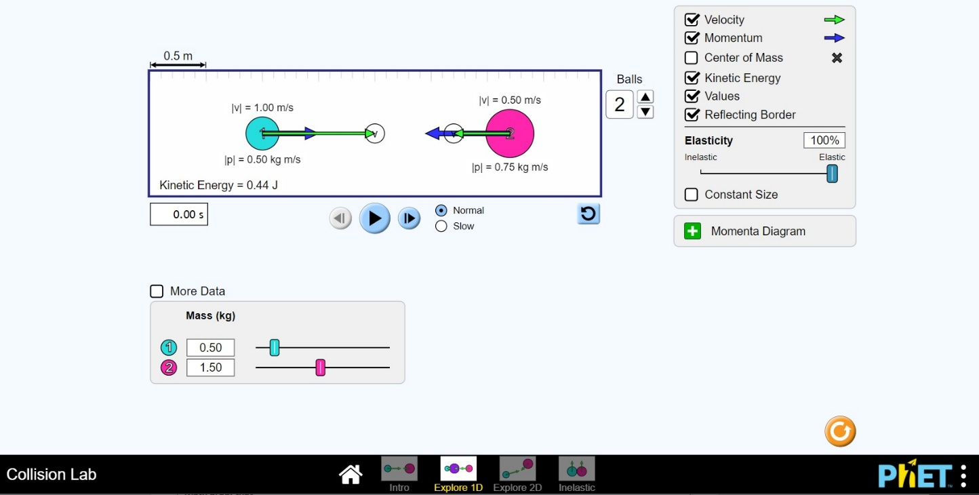

You have five (5) tasks described below. Perform each task, then diagram exactly how you accomplished each task. Be sure to include proper sizes and numbers to make clear exactly what you did. At the bottom of each box, show your math proof.

Task 1: Create a scenario where ball 1 collides with ball 2 so that each moves away in opposite directions
with equal velocities.
Before | After
Math proof that
total Momentum
was conserved:
Math proof that
total Kinetic Energy
was conserved:

Task 2: Create a scenario where ball 1 collides with ball 2 so that only ball 2 moves away and ball 1
completely stops.
Before | After
Math proof that
total Momentum
was conserved:
Math proof that
total Kinetic Energy
was conserved:

Task 3: Create a scenario where ball 1 collides with ball 2 so that both balls move away in opposite directions, and ball 2 has half the speed of ball 1.
Before | After
Math proof that
total Momentum
was conserved:
Math proof that
total Kinetic Energy
was conserved:

Task 4: Create a scenario where ball 1 collides with ball 2 so that ball 1 and 2 move away in the same direction, but ball 2 has twice the speed of ball 1.
Before | After
Math proof that
total Momentum
was conserved:
Math proof that
total Kinetic Energy
was conserved:

IMPORTANT: For Task 5, move the slider all the way left to “INELASTIC”. It should say “0% Elasticity”.

Task 5: Create a scenario like the “Collision of Sandwiches” homework problem, where a grilled cheese sandwich sliding to the right (ball 1) on a frictionless lunch counter collides with a submarine sandwich sliding to the left (ball 2), and they “stick” and continue to slide down the counter as one mass.
Before | After
Math proof that
total Momentum
WAS conserved:
Math proof that
total Kinetic Energy
WAS NOT conserved:

