Power Calculations problems
NOTE: This assignment is now on Canvas. Use the worksheet below, but enter your answers in Canvas.
(28 questions)

Ohm’s Law V = IR
Power equation P=VI
Power equation P=I²R

- Series Circuit. The battery is set at 75.0 volts, and the Ohms ratings are shown.
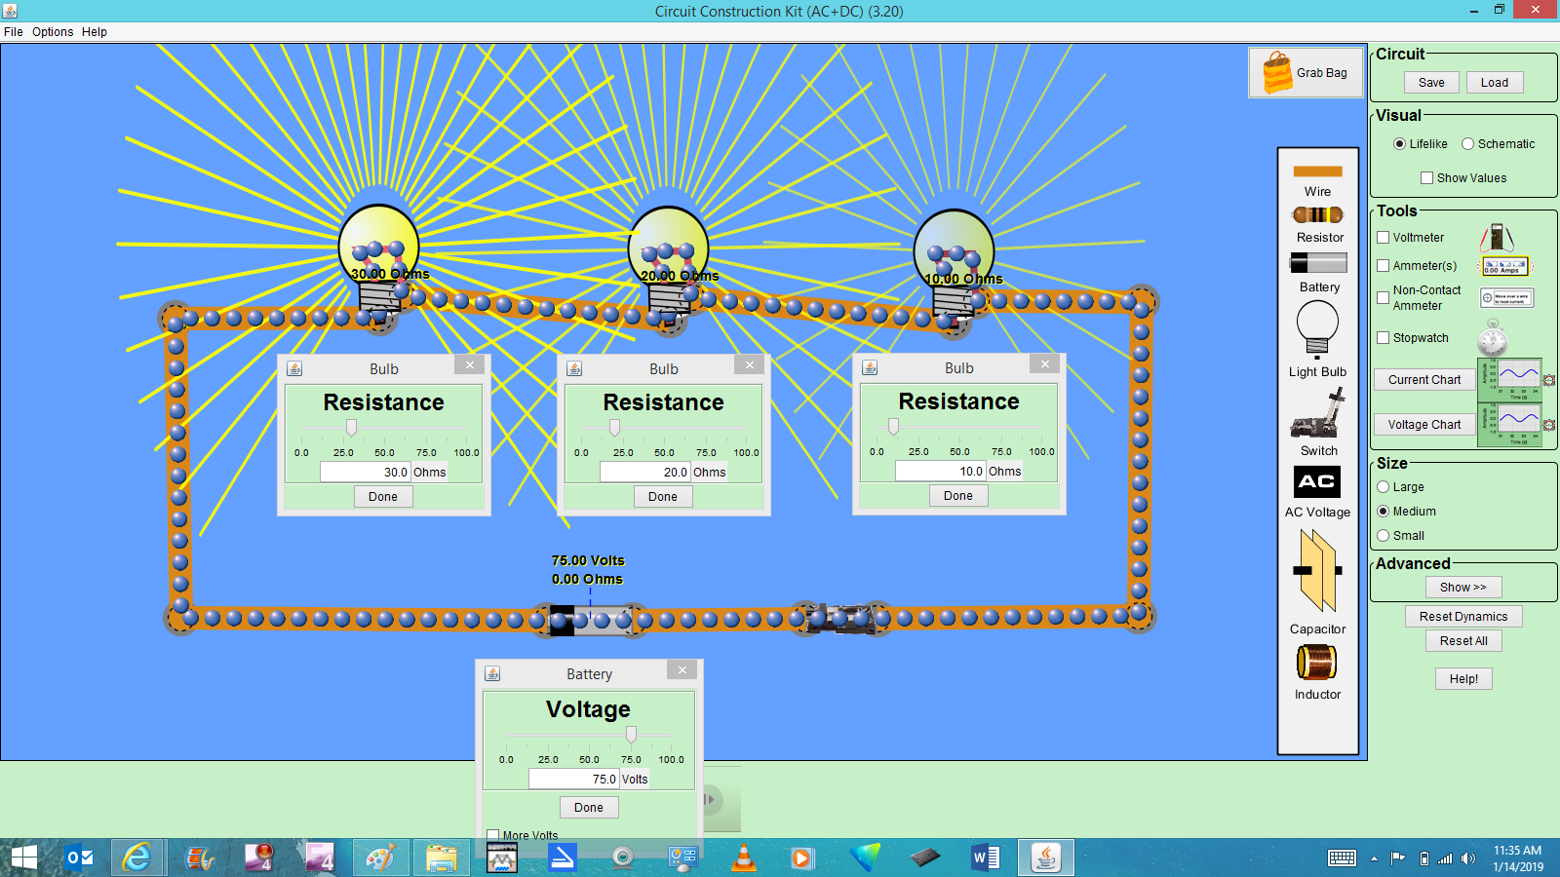

  - Total current in the circuit? (Amps)

  - Voltage drop across Bulb₁₀? (Volts)

  - Voltage drop across Bulb₂₀?

  - Voltage drop across Bulb₃₀?

  - Is Kirchhoff’s Voltage Law satisfied? Show work…

  - What is the Power drawn by Bulb₁₀? (Watts)

  - What is the Power drawn by Bulb₂₀?

  - What is the Power drawn by Bulb₃₀?

  - Assuming an electricity price of $.14 per kW-hr, what is the cost of lighting this circuit for 24 hours?

- Parallel Circuit
Note: the battery is set at 50 volts, and the Ohms ratings are shown.
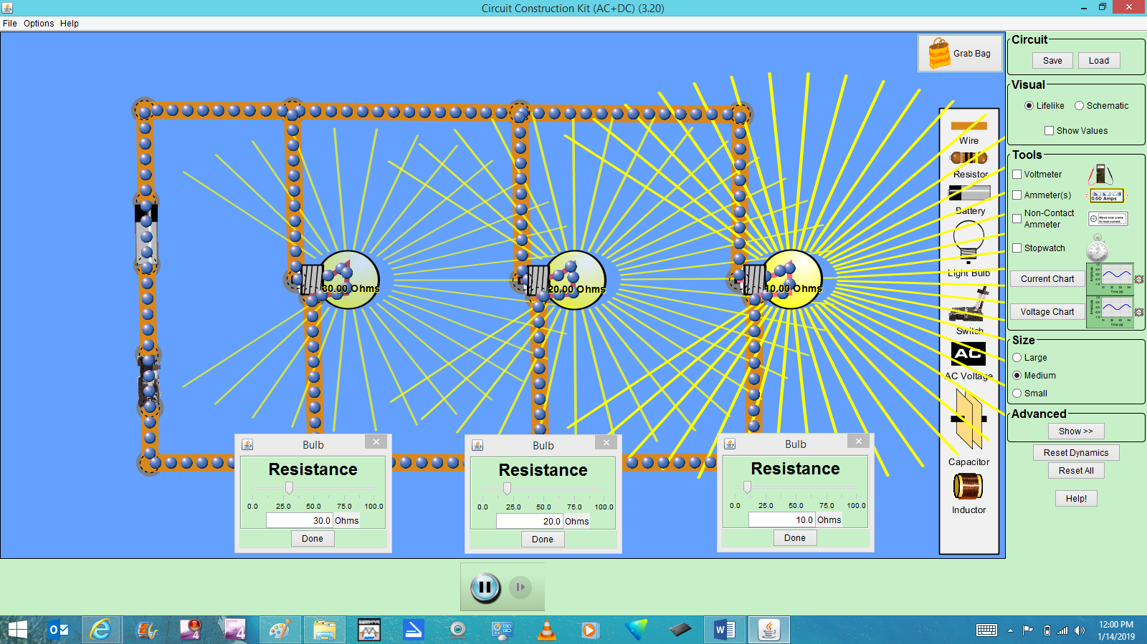

  - Voltage drop across Bulb₁₀? (Volts)

  - Voltage drop across Bulb₂₀?

  - Voltage drop across Bulb₃₀?

  - Current through Bulb₁₀? (Amps)

  - Current through Bulb₂₀?

  - Current through Bulb₃₀?

  - What is the Power drawn by Bulb₁₀? (Watts)

  - What is the Power drawn by Bulb₂₀?

  - What is the Power drawn by Bulb₃₀?

  - You have a gasoline-powered, portable generator, with an overall efficiency of 20% (it converts 20% of the energy-content of the gasoline into usable electricity). The energy content of the gasoline is 1.3 x 10⁸ J/gal, and it costs $3.50 per gallon. 1 W = 1 J/sec.
How much will it cost to power this circuit for 24 hours?

- Series-Parallel (Combination) Circuit. The battery is set at 40 volts, and the Ohms ratings are shown.
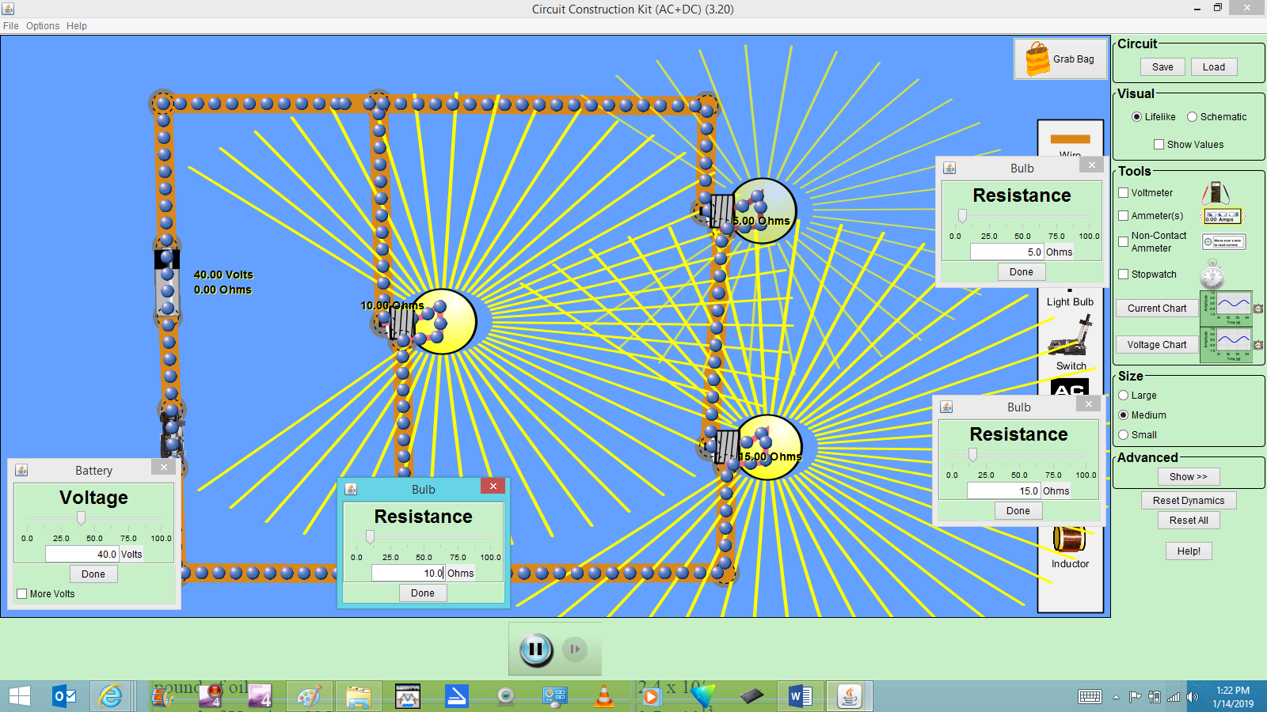

- Voltage drop across Bulb₁₀? (Volts)

- Voltage drop across Bulb₅ AND Bulb₁₅ combined?

- Current through Bulb₁₀? (Amps)

- Current through Bulb₅?

- Current through Bulb₁₅?

- What is the Power drawn by Bulb₁₀? (Watts)

- What is the Power drawn by Bulb₅?

- What is the Power drawn by Bulb₁₅?

- You have a portable, gas-fired turbine, with its output shaft connected to a generator. The gas turbine is 30% efficient, and the generator is 95% efficient. The natural gas is priced at $1.25/therm. 1 therm = 100,000 Btu’s.
How much will it cost to power this circuit for 24 hours?

