9. Fluid Mechanics (Hydraulics) homework problems
Name and date submitted (3 pts):
Instructions: Using this form as a template, create space in the document below and write or type your answers. Turn in your completed work as an email attachment.
(20 questions, 100 points possible).
- T/F: Pressure: Fluid particles are always moving, bumping the container and causing pressure.
- T/F: Pascal’s Law states, “If you change the pressure in a confined fluid, that change is felt equally throughout all the fluid.”
- T/F: 1 Pascal is equal to 1 Newton of force over a square meter (N/m²)
- T/F: Archimedes’ Principle states, “A submerged or partially-submerged object is buoyed up by a force equal to the weight of the fluid it is displacing.”
- When you go deeper in the water, the pressure increases because
  - There is more salt in the water
  - There is more water on top of you
  - The water temperature gets colder
  - There are living organisms in the water

- 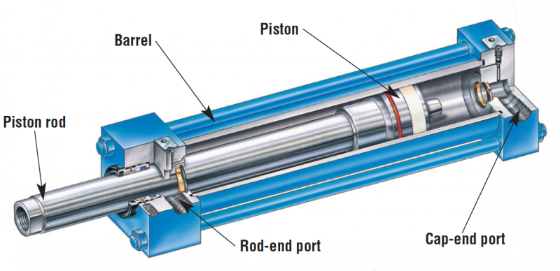In a certain hydraulic machine, the input piston has an area of 2 cm² and the output piston has an area of 32 cm². The output force will be ____________ the input force.
  - 16 times
  - 1/16 of
  - 32 times
  - 1/32 of

- The pascal is a unit of
- Pressure
- Force
- Mass
- Volume

- Pressure is
- Force
- Volume x force
- Force / area
- Force / volume

- Suitable units of pressure are
- Feet-pounds
- Pounds per square inch
- Newtons per square meter
- Atmospheres
- All of the above
- A & B only
- B, C, and D

- Suitable units for the flowrate of a fluid are
- Gallons per minute
- 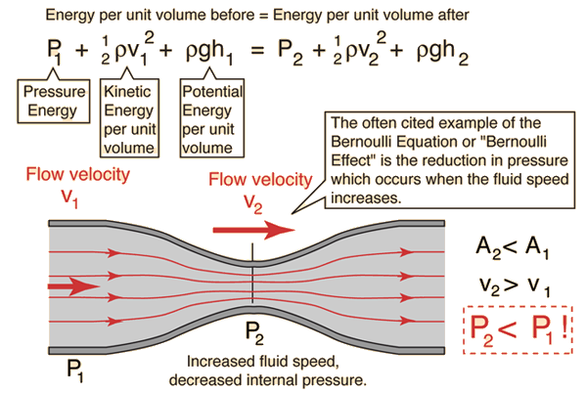m³ per second
- ft³/sec
- all of the above

- Bernoulli’s Principle states
- A fluid’s pressure increases as its speed increases
- A fluid’s pressure decreases as its speed increases
- A fluid’s volume increases as its pressure increases
- A fluid’s volume increases as its force increases

- When you compare the air pressure above the wing of a moving airplane to the air pressure below the wing,
- There will be less pressure above the wing
- There will be less pressure below the wing
- There will be equal pressure above and below the wing
- Not enough information to tell

- Steel ships float because within their hulls are large volumes of
- Water
- Ballast
- Air
- Insulation

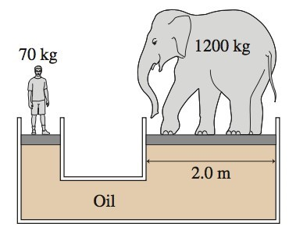
- In the figure, the man and elephant are at equilibrium (perfectly balanced). What is the diameter in meters of the platform the man is standing on?

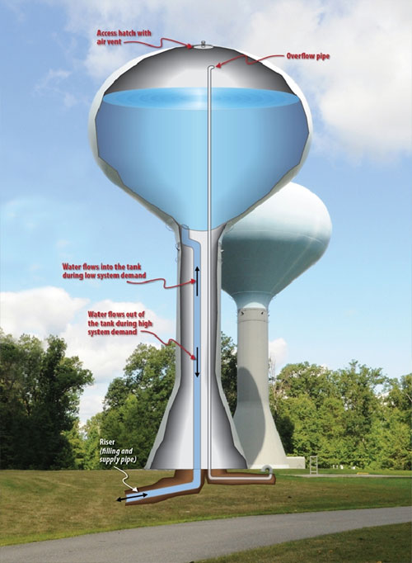
- Some engineers are designing a municipal water supply system using an elevated storage tank to create pressure. If they must ensure the average household receives a minimum of 40 psi (lbs/in²) of pressure at the faucet, how high in feet must the tank be situated to create that pressure due to gravity? Assume all the houses are on level ground, and ignore friction losses in the pipes. Hint: 1 atmosphere pressure is approximately 32-ft in water head.

- Your client has asked you to design a drinking water supply system for a church camp located on an island. To store enough water for extended use, you have calculated that he/she needs a cylindrical storage tank 12-ft in diameter and 20-ft high. Your next step is to size the pump which keeps the tank full of pristine drinking water.
Refer to the pump operating curves below:
Assuming you need to pump at a pressure of 100 feet in head (just over 40 psi pressure),
  - How long in minutes will it take the ½-hp pump to completely fill the tank?
  - How long in minutes will it take the 1-hp pump to completely fill the tank?
Hint: on the graph, find each pump’s flowrate in gals/min at 100 feet in head, and use the tank’s capacity in gallons to determine the time to fill.
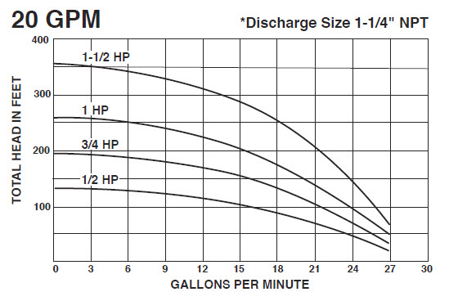

Hydraulics problem:
- The small piston has a surface area of 2 in², and the large piston has a surface area of 100 in². If you need to lift 1,000 lbs (F2) with the large piston, how much force (F1) in pounds do you need to apply to the small piston?
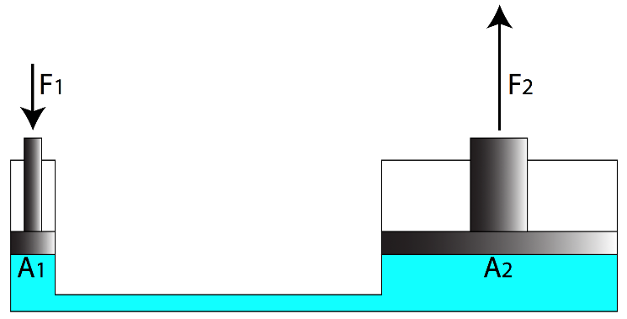
- Using the same information as above, how far in inches would piston A1 need to travel in order to move piston A2 a distance of 1 inch?

- What is the ‘mechanical advantage’ of this hydraulic machine?

- What would be the pressure in pounds per square inch (lbs/in²) of the hydraulic (blue-green) fluid in the machine?

