9. Fluid Mechanics problems
Name and date submitted (3 pts):
Instructions: Create space in the document below and write or type your answers. KEEP THE SAME NUMBERING.
(13 questions, 100 points possible).
- (7 pts) A garden hose is used to fill a 5.00 gallon bucket in 2.75 minutes. What is the flow rate in gpm of water through the hose? (see similar example problem in the book)

- (7 pts) If a garden hose is 50 feet long and water moves from the spigot to the end of the hose in 35 seconds, what is the water’s flow velocity in inches per minute? (see similar example problem)

- (8 pts) A hydraulic fluid travels through a pipe at 1,000 in/min. The pipe has an inner diameter of 1.50 inches. What is the hydraulic fluid’s flow rate in gallons per minute (gpm)? (see similar example problem)

- (8 pts) A closed, flexible container of gas has a volume of 350 cm³ (V₁). The gas exerts an absolute pressure of 120 kPa (p₁) on the inside surfaces of the container. Assuming that the temperature remains constant, what is the volume of the container if the pressure changes to 100 kPa (p₂). (see similar example problem and use Boyle’s law)

- (8 pts) A sample of nitrogen gas has a volume of 85.0 cm³ (V₁) at 15⁰C (T₁). At what temperature (⁰C) would the gas have a volume of 35.0 cm³ (V₂)? (see similar example problem and use Charles’ law)

- (8 pts) A sealed, rigid container is used to store a gas. A pressure gauge that is built into the container displayed an initial pressure of 0 psig (p₁) at standard atmospheric pressure and 20⁰F (T₁). If the temperature changes to 90⁰F (T₂), what is the new pressure gauge reading if the container remains at standard atmospheric pressure? (see similar example and use Gay-Lussac’s law)

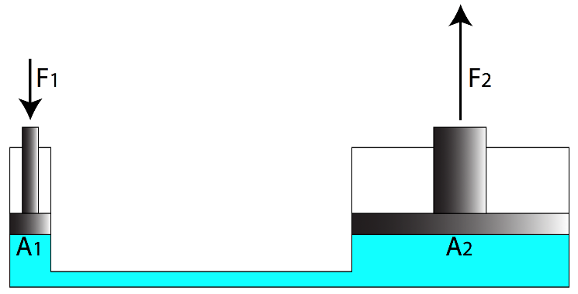
- (8 pts) The small piston has a surface area of 2 in² (A₁), and the large piston has a surface area of 100 in² (A₂). If you need to lift 1,000 lbs (F₂) with the large piston, how much force (F₁) in pounds do you need to apply to the small piston? (use Equation 7-4 and follow the similar example)

- (8 pts) Using the same information as above, how far in inches would piston A₁ need to travel in order to move piston A₂ a distance of 1 inch? (use Equation 7-5 and follow the similar example)

- (7 pts) What is this machines ‘mechanical advantage’ or hydraulic amplification of force? (see example p. 238)

- (7 pts) What would be the pressure in pounds per square inch (lbs/in²) of the hydraulic (blue-green) fluid in the machine? (Equation 7-4 and the example on the same page)

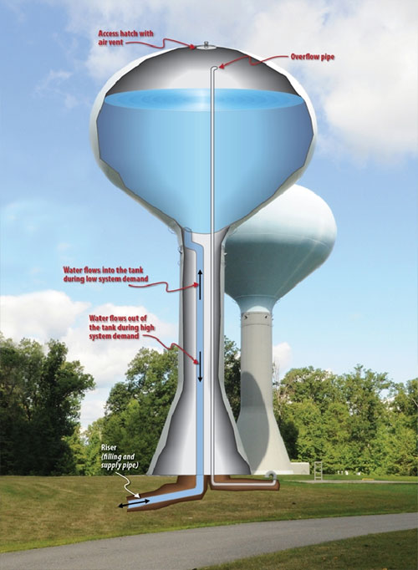
- (7 pts) You are hired to design a municipal water supply system using an elevated storage tank to create pressure. You must ensure that the average household receives a minimum of 40 psi (lbs/in²) of pressure at the faucet. How high in feet must the tank be situated to create that pressure due to gravity? Assume all the houses are on level ground, and ignore friction losses in the pipes. Hint: 32-ft in water head (height) will create 1 atmosphere of pressure, and 1 atmosphere is equal to 14.7 psi.

- (7 pts) You are hired to design a drinking water supply system for a church camp located on an island. To store enough water for extended use, you have calculated that the camp needs a cylindrical storage tank 12-ft in diameter and 20-ft high. What is the tank’s capacity in gallons? (1 ft³ = 7.5 gals)

- (10 pts) Continue: Now you need to size the pump which keeps the tank full of water. Refer to the pump operating curves below. Assume you need the pump to pump at a pressure of 100 feet in head (about 40 psi pressure) in order to fill the tank.
  - How long in minutes will it take the ½-hp pump to completely fill the tank?

  - How long in minutes will it take the 1-hp pump to completely fill the tank?

Hint: on the graph, find each pump’s flowrate in gals/min at 100 feet in head, and use the tank’s capacity in gallons to determine the time to fill.
