Gas Properties weblab
Name and date submitted (3 pts):
Create space in the Word document below, and write or type your answers. Turn in your completed work by the due date. MUST SHOW YOUR WORK!
(15 questions, 4 points each, 60 points possible)
Go to https://phet.colorado.edu/ and find the “Gas Properties” simulation. At the time of writing, it was located here https://phet.colorado.edu/sims/html/gas-properties/latest/gas-properties_en.html
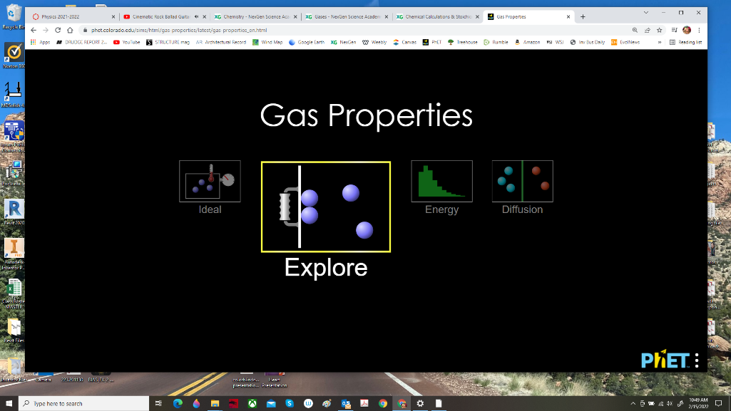
Hit the “play” button and select the “Explore” option.

Expand the “Particles” dropdown, check the “Width” box, and add 250 “Heavy Particles” by pumping the bicycle pump 5 full times.
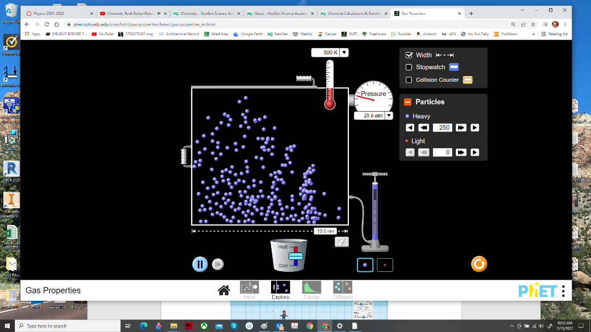
Wait a few moments, and then record the temperature and pressure. The pressure will bounce around a little, so use the average.

- Temperature ___________ ⁰K

- Pressure ___________ atm

What happens when you vary the temperature?
- Use the “Heat/Cool” slider to exactly double the temperature in the reactor. Do not change the volume. What is the new pressure? _________________ atm

- Use the combined gas law $\frac{P_{1}V_{1}}{T_{1}}=\frac{P_{2}V_{2}}{T_{2}}$ to predict the pressure if you keep raising the temperature up to 750 ⁰K: ________________ atm

- Now carefully raise the temperature in the reactor to 750K. Was your prediction correct?

What happens when you vary the volume?
- Use the “Heat/Cool” slider to return the temperature back to 300 ⁰K. Now slowly(!) reduce the volume by half… in other words slide the partition from 10 nm down to just 5 nm. You will need to cool down the reactor while doing this, or the lid may fly off. If it does, just hit “reset” and proceed with more caution. When you’re finished, the volume should be reduced in half, and the temperature returned to 300 ⁰K.

What is the new pressure? _______________ atm

- Use the combined gas law $\frac{P_{1}V_{1}}{T_{1}}=\frac{P_{2}V_{2}}{T_{2}}$ to predict the pressure if you re-set the sliding partition at 7.5 nm, keeping the temperature at 300 ⁰K: ________________ atm.

(Tip: With the partition set at 10 nm, the volume of the cubic reactor would be 10 x 10 x 10, or 1,000 nm³. With the partition set at 7.5 nm, the volume of the reactor would be 7.5 x 10 x 10, or 750 nm³. And so on….. )

- Now carefully slide the partition to 7.5 nm. Was your prediction correct?

What happens when you vary the pressure?
Return the temperature back to 300 ⁰K, and slide the moving partition back to 10 nm.

- Cut the pressure in half by opening the lid and allowing half the particles to escape so that you have exactly 125 “Heavy Particles” left in the reactor. (If you’re off by a couple, that’s okay). Then close the lid and readjust the temperature back to 300 ⁰K.

What is the new pressure? ______________ atm

- Use the combined gas law $\frac{P_{1}V_{1}}{T_{1}}=\frac{P_{2}V_{2}}{T_{2}}$ to predict the pressure if you reopened the lid and allowed all except 50 particles escape. (i.e. you have gone down from 250 to just 50 particles in the reactor). Assume you maintained the temperature at 300 ⁰K.

_________________ atm

- Now do #9 with the software…. Was your prediction correct?

What happens with a mixture of gases?
Dalton’s “Law of Partial Pressures” states, “For a mixture of gases in a container, the total pressure exerted is the sum of the pressures that each gas would exert if it were alone in the container”.
P_{Total} = P₁ + P₂ + P₃ + …..
Hit the “Reset” button, and make sure the moving partition is set back to 10 nm.
- Add 150 “Heavy Particles” alone and record the pressure. _____________________ atm

- Now start over. Add 100 “Light Particles” alone and record the pressure.
___________________ atm

- Use the Law of Partial Pressures to predict the total pressure for a mixture of 150 Heavy and 100 Light particles (at 300 ⁰K and 10 nm).

P_{Total} = ___________________ atm

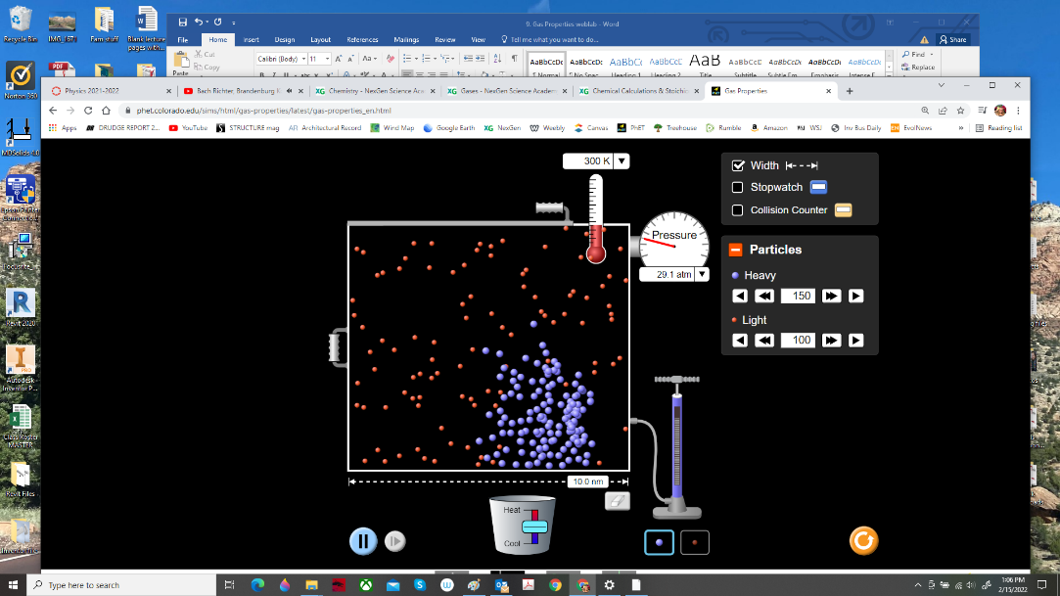

- Now create the mixture in #13 using the software (maintaining 300 ⁰K and 10 nm). Was your prediction correct?

