Welcome!
Welcome to Algebra I, the foundation for high school mathematics. In this 2-semester course we will cover linear equations, graphing, exponents, polynomials, factoring, quadratic equations, etc. The Prentice Hall textbook is a classic text, has been used in private and public schools for many, many years, and there is an almost endless variety of supplemental resources, online videos, and workbooks/worksheets that you can find for sale or free if you wish to supplement the textbook. Only the textbook is required for the class, however.

Instructor
Mr. Kris Johanson. I am available throughout the week to answer questions about your homework. kjohanson@san.rr.com.

Requirements
- Textbook: Prentice Hall Mathematics Algebra I, ISBN 0-13-052316-X (available for $5-10)
- TI-30Xa scientific calculator ($9-10)
- Access to a computer with Internet connection

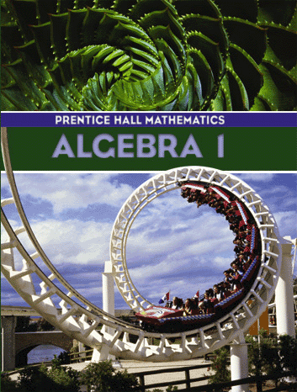Grade level & prerequisites
Algebra I is typically taken in the 8th or 9th grades, but any high school student who has passed Pre-Algebra is encouraged to take the course.

What is the class like?
The class will be “fun but structured”. We will open with a brief devotional and prayer to get our minds focused. I will then explain the new material. Be ready to take notes and ask questions during the lecture! You will have a chance to bring up questions from the prior week. If time permits, I may ask you to work a problem. I will assign a set of homework problems that you can complete in Canvas®. Parents will be able to view their student’s progress in Canvas anytime.

Course requirements
- Attend the classes. Be on time.
- Bring your book and calculator to each class!
- Take notes and ask relevant questions during the lectures
- Turn in your work by the due date
- Don’t fall behind in your work. Do not procrastinate!

Extended class hours
If parents want additional class time, I can schedule a live webinar on Wednesdays. Details to be worked out.

