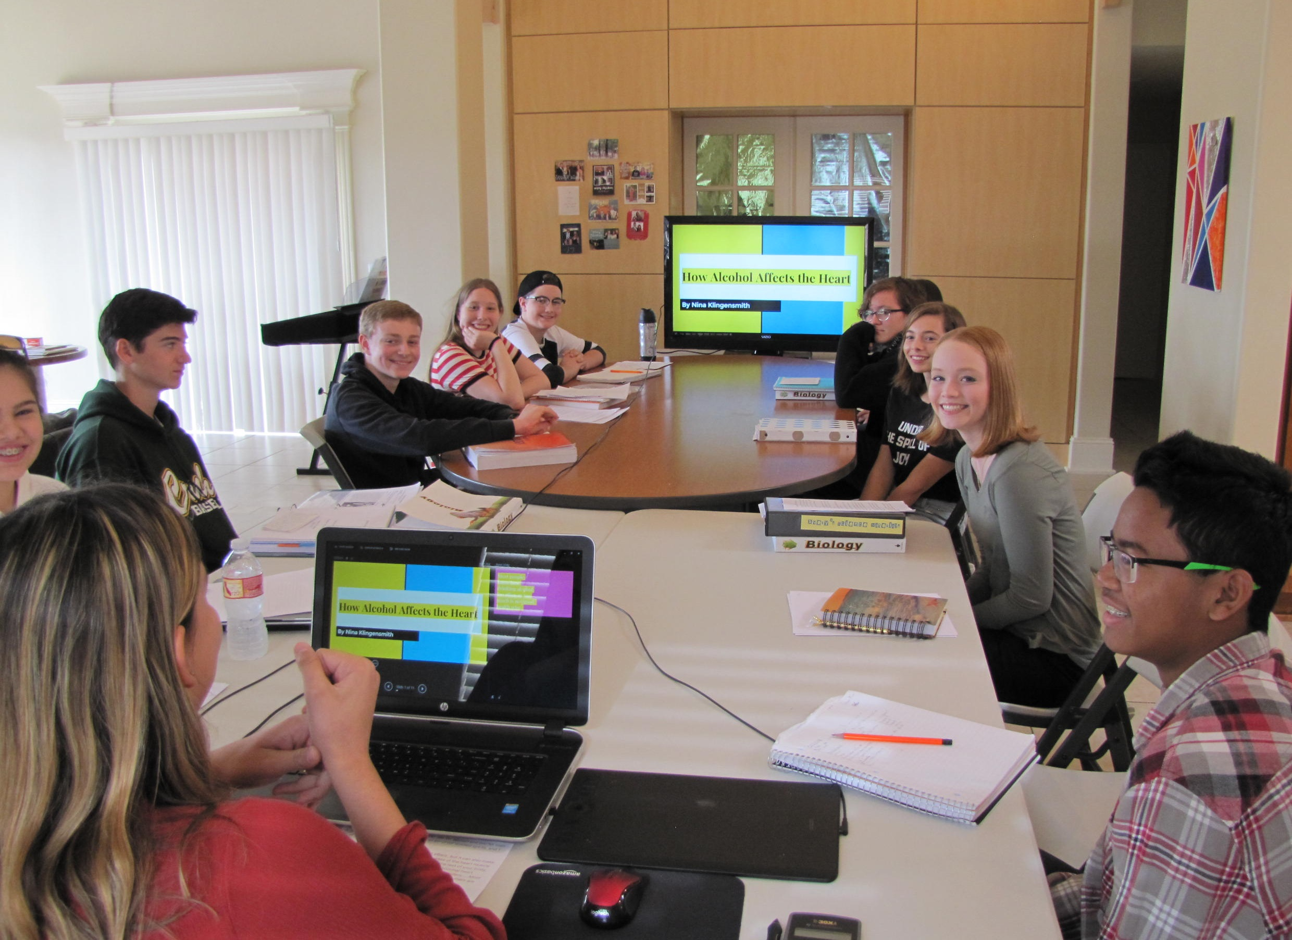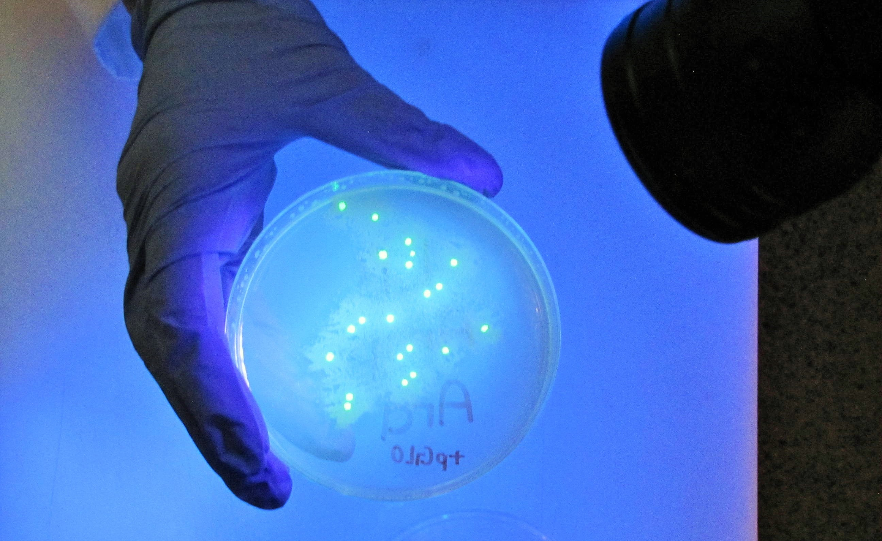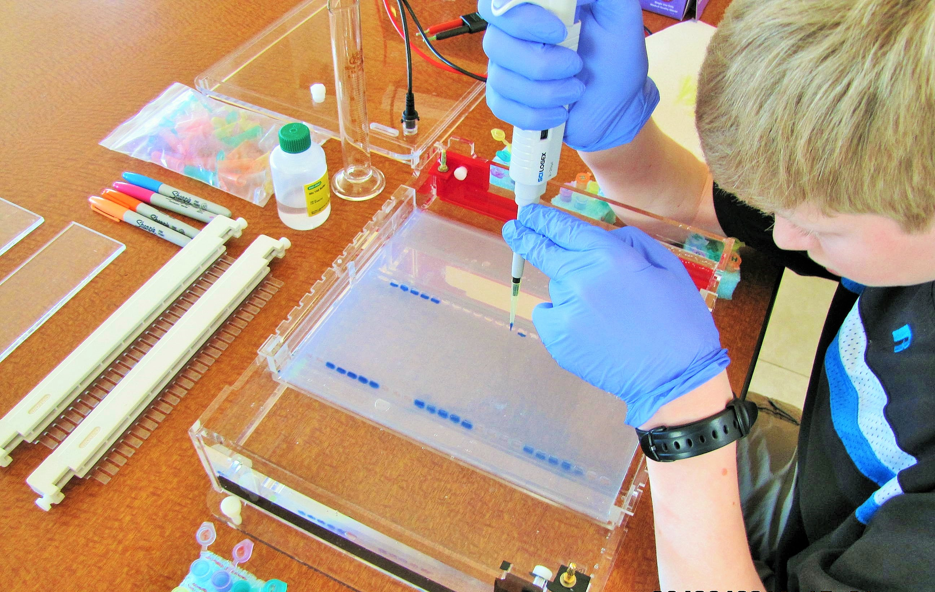
Welcome!
This is an introductory Biology course with hands-on labs. (2020-21 labs will be modified due to Covid-19 concerns). The class covers a standard U.S. high school Biology curriculum, including chemistry of life, cells, cell energetics, photosynthesis, genetics, DNA and RNA, bacteria & viruses, body systems, ecosystems & biosphere, and related topics. Prerequisites: Completed Physical Science and concurrent Algebra I.

Technical requirements: Access to a computer with Internet connection and typical word processing & presentation software.

Instructor: Kris Johanson, M.S. kjohanson@san.rr.com. I am available throughout the week to answer questions about your homework topics.

Textbook: OpenStax Concepts of Biology. AP students will also need Princeton Review Cracking the AP Biology Exam, latest edition. You don’t need to buy a lab manual. I will provide lab protocols as needed throughout the course.

Course Outline Labs
Unit 1 – Chemistry of Life Food Chemistry lab
Unit 2 – Chemistry of Life DNA Extraction lab
Unit 3 – Cell Structure & Function Diagnosing Diabetes lab
Unit 4 – Cell Structure & Function Osmosis & Diffusion lab
Unit 5 – How Cells Obtain Energy Biofuels lab
Unit 6 – Photosynthesis Algae Photosynthesis lab
Unit 7 – Mitosis – How Cells Reproduce HHMI Eukaryotic Cell Cycle & Cancer
Unit 8 – Meiosis – How Traits are Inherited Mitosis & Meiosis lab
Unit 9 – Classical Genetics Wisconsin Fast Plants lab
Unit 10 – DNA Bio-Rad DNA Fingerprinting lab I
Unit 11 – Proteins Bio-Rad DNA Fingerprinting lab II
Unit 12 – Biotechnology Bio-Rad DNA Gene Splicing lab I
Unit 13 – Origins of Life Bio-Rad DNA Gene Splicing lab II
Unit 14 – Body Systems Cow eye dissection
Unit 15 – Body Systems Sheep heart dissection
Unit 16 – The Immune System & Disease Bio-Rad Microbes & Disease lab I
Unit 17 – Population & Ecology Fruitfly Behavior lab
Unit 18 – Ecosystems & Biosphere HHMI Population Regulation in the Serengeti

Homework
Weekly homework will be assigned from each chapter. Typical homework for this class consists of standard end-of-chapter questions and short Internet research assignments. I go over the homework questions carefully on the Internet to provide additional support (included in the course). Students should read the chapter ahead of time and be prepared to take notes and participate in class discussion. Estimated homework and study time for Biology is at least 5 hours per week.

Teaching Pedagogy (Read the Covid-19 update on the homepage)
The course uses a combination of hands-on labs, classroom instruction, and customized Internet homework videos. During classes there is typically much lively discussion, and class cohesiveness and positive student-student interaction is encouraged over the course of the year.

Exams
There will be a take-home style, open-book, midterm and final exam, covering material learned that semester. The exams are not burdensome, and you will be given a week to complete each one. Emphasis is on applications, not on rote memorization.

Course Requirements
- Attend the classes (including both in-person and webinar sessions). Be on time.
- Take notes and ask relevant questions during the lectures
- Participate in the class labs
- Turn in your homework assignments by the due date
- Don’t fall behind in your work. Do not procrastinate!

Grading Policy
Work will be graded on a point system. A student’s total points earned will be divided by total points possible and converted to a percentage.

Grading Scale Grading Elements
above 90% A: advanced Class participation 25%
89 – 80% B: proficient Labs 25%
79 – 70% C: basic Weekly homework 25%
69 – 60% D: below basic Midterm & Final 25%
Below 60% F: far below basic Total 100%

Timely completion of the required assignments is a basic requirement. Assignments turned in early will receive a “bonus incentive”. Assignments turned in later than the due date will receive a reduced grade.

Progress Reporting
Attendance, homework, lab reports, and teacher comments are reported in Canvas, and parents can access this information any time. Student progress reports are emailed to parents at the end of each semester.

