Black Powder lab
Black Powder is a mixture of charcoal (C), potassium nitrate (KNO₃), and sulfur (S). The charcoal does the 'burning', the nitrate supplies the oxygen, and the sulfur binds it together to make it burn quickly. As long as you don't "confine it" within a container, it will just burn fast - not explode.
We will make and (carefully) test old fashioned black powder. The homework builds off this lab. This is an excellent launching pad for discussing chemical reactions and thermodynamics:
- Balancing chemical reactions
- Stoichiometry
- Thermodynamics
- Limiting reactants
- Moles
- Enthalpy of reaction
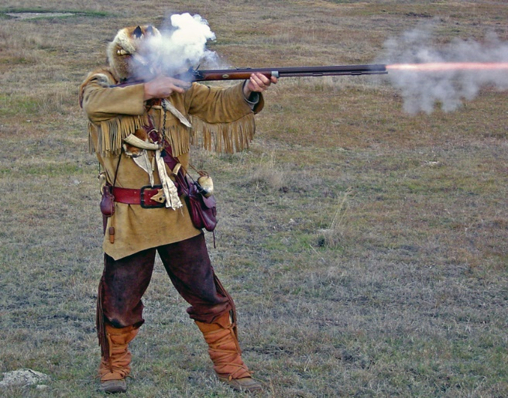
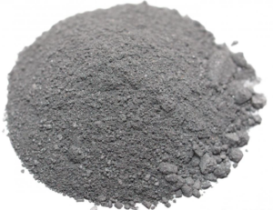

Reaction for the burning of black powder:
10KNO₃ + 8C + 3S → 2K₂CO₃ + 3K₂SO₄ + 6CO₂↑ + 5N₂↑

Calculate the required mass of reactants:
To make black powder you will combine 75 mass% KNO₃, 15 mass% C, and 10 mass% S. Let’s say we want to make 673g of black powder (the combined mass of all 3 reactants will be 673g).
- How many grams of potassium nitrate will we actually use? ______
- How many grams of carbon will we actually use? _______
- How many grams of sulfur will we actually use? ________
- Finish the table:
Reaction: | 10KNO₃ + | 8C + | 3S →
Mass using today: | g | g | g

The reaction we are about to carry out looks like this:
10KNO₃ + 8C + 3S → 2K₂CO₃ + 3K₂SO₄ + 6CO₂↑ + 5N₂↑
- What is the molecular weight in g/mol of potassium nitrate? ________
- What is the atomic weight in g/mol of carbon? _______
- What is the atomic weight in g/mol of sulfur? ________
- What is the mass in g of 5 mols of potassium nitrate? ________
- Look again at the recipe you just made, above. How many mols of potassium nitrate will we be reacting today? ________
- How many mols of carbon will we be reacting today? _________
- How many mols of sulfur will we be reacting today? __________
- Finish the table:
Reaction: | 10KNO₃ + | 8C + | 3S →
Moles you are using today: | mols | mols | mols

Now make the black powder:
Put on eye protection which completely protects your eyes. Wear a full lab coat to protect your clothing. Put on latex gloves if your skin is sensitive. Wash with soap and water if you get any black powder on your skin or eyes. Notify the teacher immediately if you have any skin sensitivity to the sulfur or charcoal briquettes. We will be testing the black powder outside, at a safe distance and with plenty of ventilation.
- You will obtain the carbon from charcoal briquettes. Charcoal is actually C₇H₄O, but it’s close enough to pure C that we will ignore the difference in order to simplify the lab report. Weigh out the briquettes, break them up a little bit with a hammer, and then pulverize them to a fine powder in a blender. Pour the powder in a clean, dry pickle jar and set it aside.
- Weigh out the potassium nitrate. Pulverize it to a fine powder in the blender. Add it to the pickle jar.
- Weigh out the sulfur and add it to the pickle jar on top of the other ingredients.
- Put the lid (loosely!) on the pickle jar and slowly rotate the jar to combine all 3 ingredients. Keep the lid somewhat loose while mixing. Just keep rotating, tumbling, and mixing until the color is consistent and all ingredients are thoroughly combined.
- When thoroughly mixed and blended, set the jar on the lab bench with the lid loosely attached. Work through the questions below, and then we will go outside and test the black powder.

Now compute the theoretical amounts of reactants needed:
Here’s the reaction again:
10KNO₃ + 8C + 3S → 2K₂CO₃ + 3K₂SO₄ + 6CO₂↑ + 5N₂↑

Stoichiometrically speaking, in an ideal world where you don’t need any excess reactants, if you wanted to react 5 mols of potassium nitrate in the reaction above, how many mols of the other 2 reactants would be theoretically needed in this process? Look carefully again at the reaction:

5 mols ? mols ? mols
10KNO₃ + 8C + 3S →

- Above: How many mols of carbon would be needed? _________
- Above: How many mols of sulfur would be needed? _________
- Finish the table:

Reaction: | 10KNO₃ + | 8C + | 3S →
Moles theoretically needed: | 5.0 mols | mols | mols

Compare actual to theoretical (stoichiometric) amounts:
You have calculated both the actual recipe, and the theoretical recipe, for black powder. Now compare.

- Finish the table:

 | KNO₃ | C | S
Moles actually using today: | 5 mols | mols | mols
Moles theoretically needed: | 5 mols | mols | mols

Limiting reactant:
- What is the limiting reactant in our reaction today? _________

Enthalpy of Reaction:
- The combustion of black powder generates a lot of heat. Is it exothermic, or endothermic?

- It also generates a lot of rapidly-expanding gas, which creates an explosion if the powder is confined (ours will not be confined). Specifically, what gases are generated in the reaction?

- Use Hess’s Law to calculate the enthalpy of reaction in kilojoules for the black powder reaction we are about to carry out. Use the values given in the table below. Note: By using Hess’s Law in this way, you will be calculating the enthalpy of reaction for reacting 10 mols of KNO₃ with the other reactants. Since we are only using 5 mols of KNO₃ today, divide your answer in half!
 | 10KNO₃ + | 8C + | 3S → | 2K₂CO₃ + | 3K₂SO₄ + | 6CO₂↑ + | 5N₂↑
Enthalpy of formation, ∆H°_{f} | -495 KJ/mol | 0 KJ/mol | 0 KJ/mol | -1,151 KJ/mol | -1,430 KJ/mol | -393 KJ/mol | 0 KJ/mol
Hess’s Law: ∆H°_{reaction} = ∑∆H°_{f (products)} - ∑∆H°_{f (reactants)}

Set up your equation here:

Enthalpy of reaction in kilojoules for reacting 5 mols of KNO₃:

