Josh Guy
5/9/21
Government

California Rifle & Pistol Association, Inc v. Xavier Becerra Attorney General of the State of California (High Capacity Magazine Ban), 2020

The official name of this case is very long (Virginia Duncan; Richard Lewis; Patrick Lovett; David Marguglio; Christopher Waddell; California Rifle & Pistol Association, Inc v. Xavier Becarra…), so I shortened it in the title. This case wrapped up a large, four-year-long, California case that was decided by the 9th Circuit Court of Appeals on August 14th, 2020 after California banned the sale and possession of more than 10-round gun magazines (high capacity magazines). It was not a Supreme Court case but was still a very important Second Amendment win.

In November, 2016, California banned high capacity magazines with Proposition 63 that was to go into effect on July 1st, 2017. Those in favor of the ban said these weapons were used in mass shootings and had little to do with self defense. However, on June 29th, 2017, Judge Roger Benitez ordered Attorney General Becerra not to enforce Prop. 63. Then, on July 27th, 2017, Becerra appealed to the 9th Circuit Court of Appeals so that he could indeed enforce the magazine ban against the will of many. The case was appealed back and forth for about two years but eventually, on March 29th, 2019, Judge Roger Benitez ruled that Prop. 63’s ban on high capacity magazines violated the Second Amendment. But there was another injunction set in place so we Californian citizens could not actually buy the high capacity magazines even after three years of bantering back and forth on the legality of the ban.

Finally, four years after the unconstitutional magazine ban, on August 14th, 2020, the 9th Circuit affirmed Judge Benitez’s ruling, legalizing the magazines. It was a confusing timeline but eventually the ban was removed. The “right of the people to keep and bear arms, shall not be infringed” was certainly being infringed by the state of California severely limiting the power of weapons you could own. They took away the people’s ability to have military grade weapons.

Judge Kenneth Lee wrote, “this … ban on high-capacity magazines is indefensible, dangerous for our communities and contradicts well-established case law. I strongly disagree with the court's assessment that 'the problem of mass shootings is very small.' Our commitment to public safety and defending common sense gun safety laws remains steadfast.” Lee then said exactly what we were all upset about over the last year with the government stripping away our freedoms in the name of “public safety” with their covid rules, “the state could ban virtually anything if the test is merely whether something causes social ills when someone other than its lawful owner misuses it. Adopting such a radical position would give the government carte blanche to restrict the people’s liberties under the guise of protecting them.” The official ruling of the case was a two to one victory in favor of lifting the high capacity gun magazine ban. The sole dissent was written by Judge Barbara Lynn, “California’s law ‘does not place a substantial burden on core Second Amendment rights because it does not prevent the use of handguns or other weapons in self-defense’,” which does not make a whole lot of sense. Many people actually need high caliber weapons if, for example, they live in a rural area with a distant sheriff and they need to handle crime on their own, as Judge Lee said to an extent.

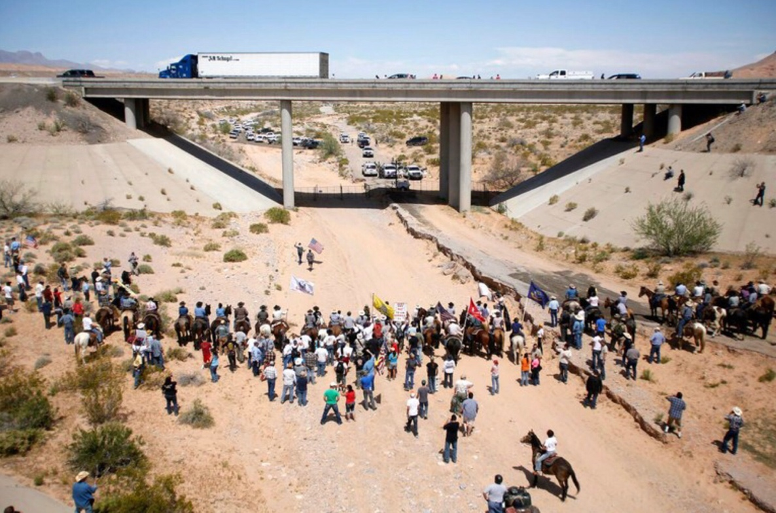
This other case that really interested me, is a little different. In 2014, there was an armed standoff in Nevada between Cliven Bundy, a rancher, and his small army against a bunch of federal agents. The federal agents killed his livestock that they claimed was on federal property and they proceeded to attempt to confiscate Bundy’s land. The government brought in heavily armed agents ready to fight, but Bundy and his men had similarly powerful weaponry (military grade weapons) and actually drove them back and held the line! As recently as January 8th, 2018 a federal judge upheld that the government was in the wrong. The government tried to wrongfully take a rancher’s land and was met with an equal force and was driven away, this is why we have the Second Amendment and military grade weapons. I have not been able to find the official name of the case that followed but I believe it was called the Cliven Bundy Stand-off Case.
(This was a picture taken during the event of Bundy’s army vs. the government agents)

