AP BIO

ENZYME ACTIVITY LAB

In this exercise you will study the enzyme catalase, which accelerates the breakdown of hydrogen peroxide (a common – but poisonous - byproduct of oxidative metabolism) into water and oxygen, according to the summary reaction:

2H₂O₂ + catalase 2H₂O + O₂ + catalase

This reaction is extremely important in the cell because it prevents the accumulation of hydrogen peroxide (H₂O₂), a strong oxidizing agent that tends to disrupt the delicate balance of cell chemistry. All of this occurs in the peroxisome.

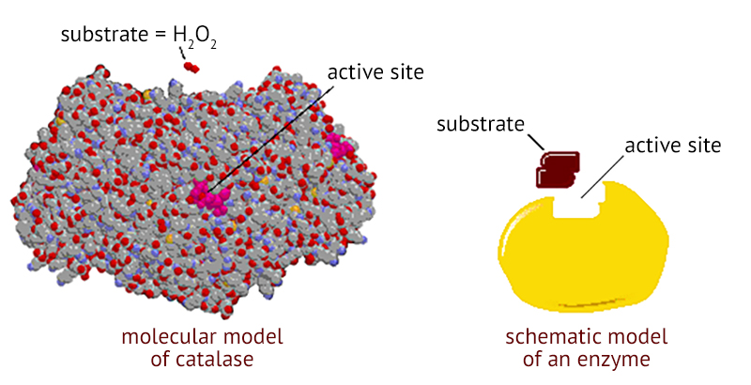
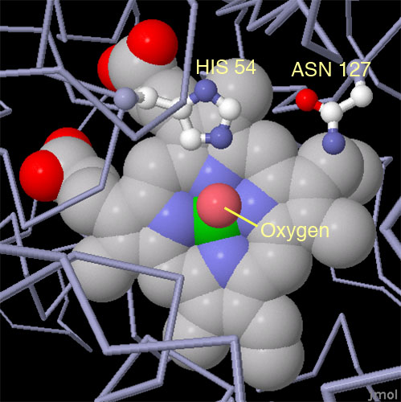

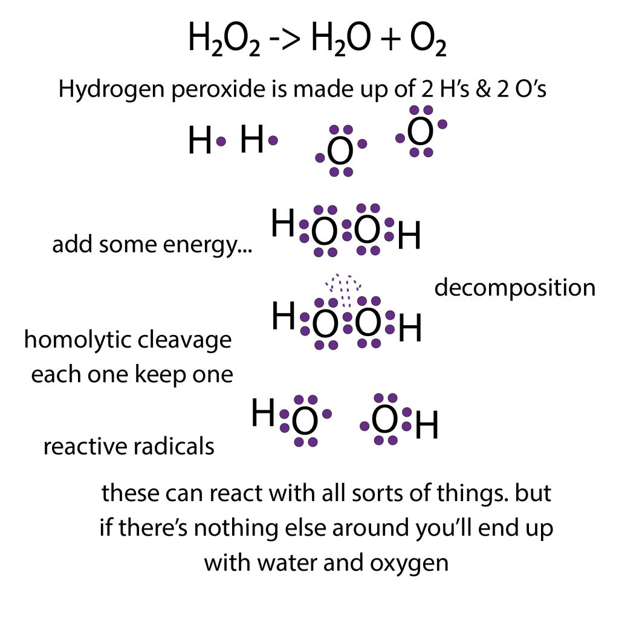

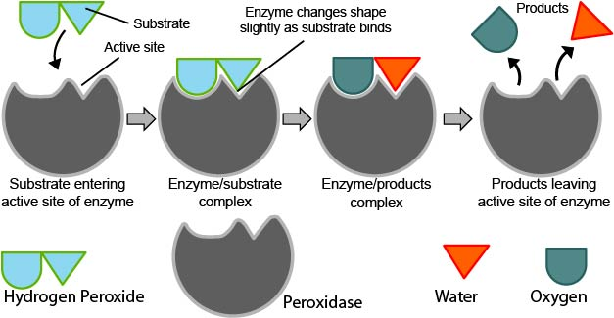

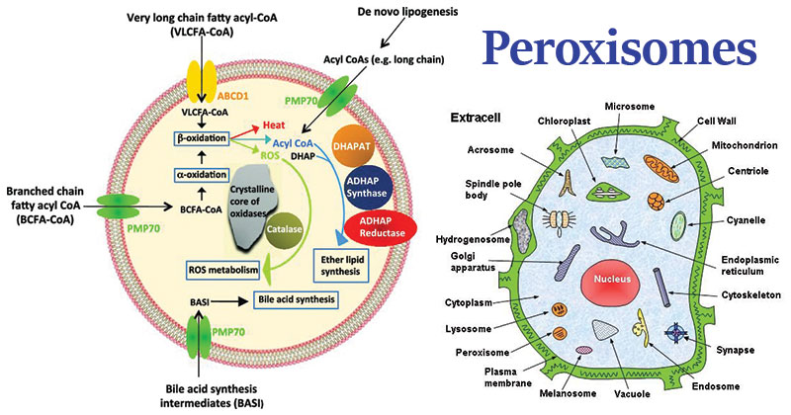

3D interactive diagrams, amino acid sequences, closeup of mechanism

Human catalase on UniProt https://www.uniprot.org/uniprot/P04040
Catalase on Protein Data Bank https://pdb101.rcsb.org/motm/57
Human erythrocyte catalase on Protein Data Bank https://www.rcsb.org/structure/1DGH
Peroxisome structure and function https://microbenotes.com/peroxisomes-structure-and-functions/

ENZYMES

Reactions in cells are catalyzed by biological catalysts known as enzymes which can accelerate reactions by as much as 10¹⁴ to 10²⁰ times. They are generally large proteins made up of several hundred amino acids, and often contain a non-proteinaceous group (in this case a ‘heme’ group) that is important in the actual catalysts.

In an enzyme-catalyzed reaction, the substance to be acted upon, the substrate, binds to the active site of the enzyme. The enzyme and substrate are held together in an enzyme-substrate complex by hydrophobic bonds (think ‘clustering’), hydrogen bonds, and ionic bonds.

The enzyme then converts the substrate to the reaction products in a process that often requires several chemical steps, and may involve covalent bonds. Finally, the products are released into solution and the enzyme is ready to form another enzyme-substrate complex. As is true of any catalyst, the enzyme is not used up as it carries out the reaction, but it recycled over and over. One enzyme molecule can carry out thousands of reaction cycles every minute. Catalase has one of the highest turnover rates known; over 3.6 x 10⁷ molecules of hydrogen peroxide are converted to product by an enzyme molecule per minute. Almost all the cells types in mammals contain catalase, with liver, kidney and erythrocytes being particularly rich sources.

Every enzyme is specific for a certain reaction because its amino acid sequence is unique and causes it to have a unique three-dimensional structure. The “business” end of the enzyme molecule, the active site, also is specific so that only one or a few of the thousands of compounds present in a cell can interact with it. If there is a prosthetic group on the enzyme, it will form part of the active site. Prosthetic groups can be vitamin derivatives and certain metal ions such as iron, manganese, and copper. Catalase uses a heme group consisting of an iron atom attached to four nitrogen atoms and connected together in a large ring called a porphyrin.(see diagrams below).

Any substance that blocks or changes the shape of the active site will interfere with the activity and efficiency of the enzyme. If these changes are large enough, the enzyme can no longer act at all, and has become denatured.

Factors which affect an enzyme’s efficiency

- pH – pH is a negative logarithmic scale that measures the acidity of H⁺ concentration in a solution. The scale runs from 0 to 14 with 0 being the highest in acidity and 14 the lowest. Neutral solutions have of pH of 7. Acid solutions have a pH less than 7; basic solutions have a pH greater than 7. Amino acid side chains contain groups such as -COOH and –NH₂ that readily gain or lose H⁺ ions. As the pH is lowered, an enzyme will tend to gain H⁺ ions, and eventually enough side chains will be affected so that the enzyme’s shape is disrupted. Likewise, as the pH is raised, the enzymes have an optimum in the neutral pH range and are denatured at either extremely high or low pH. Some have an appropriately low pH optimum. A buffer is a compound that will gain or lose H⁺ ions so that the pH changes very little.

- SALT CONCENTRATION – If the salt concentration is very low or zero, the charged amino acid side chains of the enzyme will stick together. The enzyme will denature and form an inactive precipitate. If, on the other hand, the salt concentration is very high, normal interaction of charged groups will be blocked, new interactions occur, and again the enzyme will precipitate. An intermediate salt concentration such as that of blood (0.9%) or cytoplasm is optimum for most enzymes.

- TEMPERATURE – All chemical reactions speed up as temperature increases. As the temperature increases, more of the reacting molecules have enough kinetic energy to undergo the reaction. Since enzymes are catalysts for chemical reactions, enzyme reactions also tend to go faster with increasing temperature. However, if the temperature of an enzyme-catalyzed reaction is raised still further, an optimum is reached. Above this optimum point the kinetic energy of the enzyme and water molecules is so great that the structure of the enzyme molecules starts to be disrupted. The positive effect of speeding up the reaction is now more than offset by the negative effect of denaturing more and more enzyme molecules. Many proteins are denatured by temperatures around 40⁰ – 50⁰ C, but some are still remain active at 70⁰ – 80⁰ C, and a few even withstand being boiled.

- ACTIVATORS & INHIBITORS – Many molecules other than the substrate may interact with an enzyme. If such a molecule increases the rate of the reaction it is called an activator. If the molecule decreases the reaction rate it is called an inhibitor. The cell can use these molecules to regulate how fast the enzyme acts. Any substance that tends to unfold the enzyme, such as an organic solvent or detergent, will act as an inhibitor. Some inhibitors act by reducing S-S bridges that stabilize the enzyme’s structure. Many inhibitors act by reacting with side chains in or near the active site to change or block it. Others may damage or remove the prosthetic group. Many well-known poisons, such as potassium cyanide and curare, are enzyme inhibitors that interfere with the active site of a critical enzyme.

- CONCENTRATION - While not affecting the enzyme’s shape, the reaction rate may be further affected by either the enzyme concentration and/or the substrate concentration. The more molecules of either that are present will increase the mathematical probability of random collisions and enzyme- substrate couplings.

INSTRUCTIONS

You will measure the rate of activity of catalase under different conditions. You will conduct a biological assay, whereby a disc of filter paper will be immersed in the enzyme solution, and then placed in a hydrogen peroxide substrate contained in a 100ml graduated cylinder. The oxygen produced from the subsequent reaction will become trapped in the disc, thus giving it buoyancy. The time measured from the moment the disc is released from the bottom of the graduated cylinder until it reaches the surface of the solution (the 100ml mark) is a measure of the rate of the enzyme activity. (The disc should be flat on top of the solution at the end.)

Note: Hydrogen peroxide can irritate the skin. Use gloves and forceps and/or keep your hands rinsed in tap water frequently.

- Add a small pinch (less than 0.1 g) of catalase enzyme in 2 ml of room-temperature distilled water in a suitable dish. RETURN THE REST OF THE CATALASE TO THE FREEZER. Drop-in a stirring bar and set the stirring speed to slow. The catalase will stay active for the 30-60 minutes required for the experiment; if you require more time, place the dish in an ice bath after stirring it.

- The exact concentration isn’t that important. We will call this concentration “1X”.

While the catalase is stirring/dissolving, do the following:

- Cut-out small discs of coffee filter paper. Keep the size consistent! Use a hole punch, for example.

- Vary the substrate concentration: Prepare (and label!) several 100 ml graduated cylinders with 3%, .3%, .03%, and 0.0% H₂O₂ solutions. Use room-temperature water to dilute the solutions. Don’t vary the water temperature from trial-to-trial!

- Soak the discs in the catalase solution long enough to saturate them (at least 5 s). Using forceps or a dissection needle (works well!), transfer the soaked disc to the end of a 10-inch glass rod.

- Using the long glass rod, push the disc to the bottom of the first substrate solution, and then slide the rod off the disc (be gentle with the disc, don’t ‘smash’ it into the bottom of the cylinder so it stays ‘glued’ there). Don’t suddenly jerk the glass rod out of the graduated cylinder – leave it in place, off to one side. The oxygen produced from the breakdown of the hydrogen peroxide by catalase becomes trapped in the fibers of the disc, thereby causing the disc to float to the surface of the solution.

- Measure (using a stopwatch) the amount of time from when the disc was placed at the bottom of the beaker until the disc floats on top of the solution.

The rate (R) of the reaction is calculated as R = 1/t.

- Vary the pH: Now run the same procedure with 0.30% H₂O₂ solutions having pH’s of 3, 5, 11, and 14. (you already have the data for pH=7). Use drops of HCl to lower the pH below 7, and drops of NaOH to raise the pH above 7. Employ small beakers with stir bars to adjust the pH to the desired level.

- Fill out Tables 1 and 2.

- Complete Graphs 1 and 2. On Graph 1, plot ‘substrate concentration’ in % along the x-axis and rate (R) in 1/s along the y-axis. On Graph 2, plot pH along the x-axis and rate (R) in 1/s along the y-axis. Label your graphs and draw best-fit lines.

- Respond to the questions at the end.

DATA TABLES

Name _________________________________ Date _______________

Table 1 – Effect of Substrate (H₂O₂) Concentration on Enzyme Activity

Substrate Concentration | Time to Float Disc (in seconds)
 | Trial 1 | Trial 2 | Trial 3 | Average | Rate (R) | Class Average
3.0 % H₂O₂
0.3% H₂O₂
0.03% H₂O₂
0% H₂O₂

Table 2 – Effect of pH on Enzyme Activity

Use 0.3% substrate concentration for all | Time to Float Disc (in seconds)
 | Trial 1 | Trial 2 | Trial 3 | Average | Rate (R) | Class Average
0.3% H₂O₂
pH=3
0.3% H₂O₂
pH=5
0.3% H₂O₂
pH=7
0.3% H₂O₂
pH=11
0.3% H₂O₂
pH=14

Graph 1: Reaction Rate ‘R’ (1/sec) (y-axis) vs. Substrate Concentration (%) (x-axis)

Graph 2: Reaction Rate ‘R’ (1/sec) (y-axis) vs. pH (x-axis)

LAB REPORT QUESTIONS

- What is meant by “assay”? You may need to look it up.

- How does an enzyme work? Explain using correct chemistry terms.

- Why is an enzyme “specific” to a particular reaction? Explain using correct terms.

- What is meant by “denatured”?

- What is meant by “pH”? Explain.

- Why/how does a low pH ruin an enzyme? Use correct chemistry terms.

- Why/how does a very-low salt concentration ruin an enzyme? Explain using correct terms.

- Why/how does high temperature ruin an enzyme? Explain.

- How do inhibitors work? Explain!

- Name two well known poisons which act as enzyme inhibitors.

- What organelle contains the catalase enzyme?

- Name three types of cells (tissues) where catalase is found in high concentrations in mammals.

- Write the reaction formula

- What is the enzyme in this reaction?

- What is the substrate in this reaction?

- What are the products of this reaction?

- What is the gas produced and how could you demonstrate that if you had to?

- How is the rate of enzyme activity affected by increasing the concentration of the substrate?

- Explain why, using correct chemistry terms

- What do you think would happen if you increased the substrate concentration to 40.0% hydrogen peroxide?

- How is the rate of enzyme activity affected by pH?

- Explain why, using correct chemistry terms

- What was your hypothesis, H₁, at the outset of this experiment? Write it here:

- What might have been the null-hypothesis, H₀, if this had been a ground-breaking experiment? Write one possibility, here:

- What is your “control” with the substrate-concentration series of trials?

- What is your “control” with the pH-varying series of trials?

- Reproducibility: Is your experiment “reproducible”? Explain.

- Falsifiability: Are your experimental results “falsifiable”? Explain.

