Activity 3.2.6 Beam Design

Introduction
Beam design is based on four important considerations: bending moment, shear, deflection, and cost. Once the design loads have been determined and the beam has been analyzed to determine the resulting internal shear forces and bending moments imposed, a structural engineer can select a cost-effective beam design that will provide sufficient shear and bending strength and adequate stiffness to limit deflection to acceptable limits.

Beam design methods are dictated by building codes and standards and require the inclusion of a factor of safety. Therefore, the beam design selected must possess more strength than required to resist the imposed loads.

In this activity you will design floor framing (beams and girders) for a hotel.

Equipment
- Pencil
- Calculator
- Computer with Internet access
- Website: http://www.structural-drafting-net-expert.com/
- Activity 3.2.4 Beam Analysis Short Cuts (completed)
- MD Solids software

Procedure
The Partial Second Floor Framing Plan for a new hotel is given below. The second floor will be used for conference space. Design the following floor framing members for the hotel structure.
- Interior beam
- Exterior beam
- Girder on column line 3
- Girder on column line 5

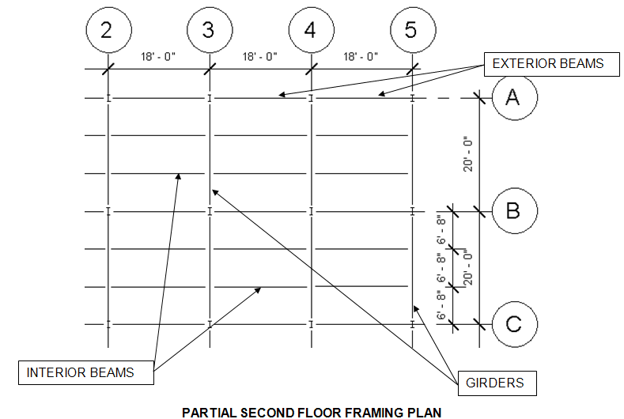

Criteria
The following data is to be used for design of the floor framing:
- Dead load = 50 psf
- Assume the weight of the floor beams and girders are included in the dead load
- Floor live load = 100 psf (Hotels—Public space per IBC table 1607.1)
- F_{y} = 50,000 psi
- The floor will support a plaster ceiling
Note: E = 29,000,000 psi for structural steel

- Complete the following for each beam and girder using the Allowable Strength Design method. You must show all work and include proper units for full credit.
      - Calculate the loading
      - Create a beam diagram
      - Calculate end reactions
      - Calculate the maximum moment
      - Calculate the required nominal moment
      - Calculate required plastic section modulus
      - Choose an efficient steel wide flange to safely carry the load
      - Check shear capacity
      - Calculate deflection limits
      - Check deflection using beam formula; if necessary, revise member choice and recalculate deflection
      - Choose final design; prove that the revised choice is sufficient to carry bending moment and shear

Interior Beam

- Include the loading and beam diagrams. .
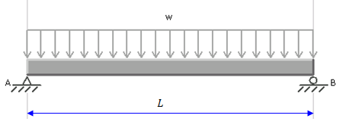Simple Beam- Uniformly Distributed Loads
W_{DL} = (50 lb/ft²) (6.67 ft) = 333.5 plf
W_{LL} = (100 lb/ft²) (6.67 ft) = 666.67 plf
W = W_{DL} + W_{LL} = 333.5 + 666.67 = 1,000.17 plf = 1,000 plf

- Calculate the end reaction and maximum moment.
R = $\frac{ωL}{2}$ = $\frac{1,000(18 ft)}{2}$ =$\frac{18,000}{2}$ = 9,000 lb
M = $\frac{ωL^{2}}{8}$ = $\frac{1,000({18}^{2})}{8}$ = $\frac{1,000(324)}{8}$ = $\frac{324,000}{8}$ = 40,500 ft*lb

- Calculate the required nominal moment.
M_{n} $≥$ M_{a}Ω_{b} = (40,500 ft*lb)(1.67) = 67,635 ft*lb

- Determine the required plastic section modulus and select an efficient wide flange.
M_{n} = F_{y}Z_{x} = Z_{x} $≥$ (67,635 ft*lb (12in/ 1 ft) / 50,000 (lb/in²) = 16.2324

W10x17
Z_{x} = 18.7 in³
I_{x} = 81.9 in⁴
d = 10.11 in
t_{w} = 0.24 in

- Check the shear strength.
V_{n} $≥$ V_{a}Ω_{v} $≥$ (9,000 lb)(1.5) = 13,500 lb
V_{n} = 0.6F_{y}dt_{w} = 0.6(50,000(lb/in²)(10.11 in)(0.24 in) = 72,792 lb $≥$ 13,500 lb
Good

- Calculate deflection limits.
∆_{DL+LL} ≤ L/240 = (18 ft)(12in/1ft) / 240 = 0.9
∆_{LL} ≤ L/360 = (18ft* (12 in/1ft))/ 360 = 0.6 in

- Calculate actual deflections.
∆_{DL+LL} = $\frac{5wL^{4}}{384EI}$ = $\frac{5(1,000\frac{lb}{ft}* \frac{1ft}{12in})(18ft*\frac{12in}{1ft}) ^{4}}{384(29,000,000\frac{lb}{{in}^{3}})(81.9{in}^{4})}$ = 0.99 in $<0.9 in$ Not Good
∆_{LL} = $\frac{5wL^{4}}{384EI}$ = $\frac{5(666.67\frac{lb}{ft}* \frac{1ft}{12in})(18ft*\frac{12in}{1ft}) ^{4}}{384(29,000,000\frac{lb}{{in}^{3}})(81.9{in}^{4})}$ = 0.66 in $<0.6 in$ Not Good

- Select a final design.
W10x19

Exterior Beam

- Include the loading and beam diagrams.
Simple Beam- Uniformly Distributed Loads
W_{DL} = (50 lb/ft²) (3.33 ft) = 166.55 lb/ft = 166.5 plf
W_{LL} = (100 lb/ft²) (3.33 ft) = 333.33 lb/ft = 333 plf
W = W_{DL} + W_{LL} = 166.5 plf +333 plf = 499.5 plf (500 plf)

- Calculate the end reaction and maximum moment.
R = wL/2 = ((500 lb/ft)(18 ft)) /2 = 9,000/2 = 4,500 lb
M = wL²/8 = ((500 lb/ft)(18² ft)) /8 = 20,250 ft*lb

- Calculate the required nominal moment.
M_{n} $≥$ M_{a}Ω_{b} = (20,250 ft*lb)(1.67) = 33818 ft*lb

- Determine the required plastic section modulus and select an efficient wide flange.
M_{n} = F_{y}Z_{x} = Z_{x} $≥$ (33818 ft*lb x (12in./1ft)) / (50,000 lb/in²) = 8.1 in³

W10x12
Z_{x} = 12.6 in³
I_{x} = 53.8 in⁴
d = 9.87 in
t_{w} = 0.19 in

- Check the shear strength.
V_{n} $≥$ V_{a}Ω_{v} $≥$ (4500 lb)(1.5) = 6,750 lb
V_{n} = 0.6F_{y}dt_{w} = 0.6(50,000 lb/in²)(9.87 in)(0.19 in) = 56,259 lb $≥$6,750 lbs
Good

- Calculate deflection limits.
∆_{DL+LL} ≤ L/240 = (18ft * (12 in/1ft))/ 240 = 0.9 in
∆_{LL} ≤ L/360 = (18ft* (12 in/1ft))/ 360 = 0.6 in

- Calculate actual deflections.
∆_{DL+LL} = $\frac{5wL^{4}}{384EI}$ = $\frac{5(500\frac{lb}{ft}* \frac{1ft}{12in})(18ft*\frac{12in}{1ft}) ^{4}}{384(29,000,000\frac{lb}{{in}^{3}})(53.8{in}^{4})}$ = 0.76 in $<0.9 in$ Good
∆_{LL} = $\frac{5wL^{4}}{384EI}$ = $\frac{5(333\frac{lb}{ft}* \frac{1ft}{12in})(18ft*\frac{12in}{1ft}) ^{4}}{384(29,000,000\frac{lb}{{in}^{3}})(53.8{in}^{4})}$ = 0.50 in $<0.6 in$ Good

- Select a final design.
W10x12
Girder on Column Line 3

- Include the loading and beam diagrams.
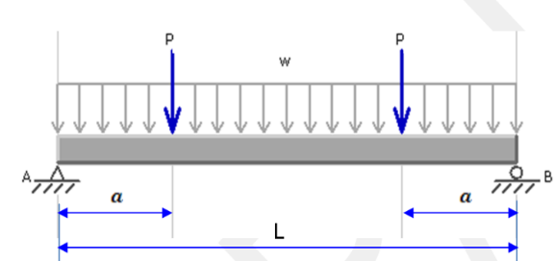 Simple Beam – Two Equal Concentrated Loads – Symmetrically Placed and Uniformly Distributed Load

P = 9,000 lb from left + 9,000 from right = 18,000 lb

- Calculate the end reaction and maximum moment.
R = P = 18,000lb
M = Pa = (18,000lb)(6.67ft) = 120,060 ft*lb

- Calculate the required nominal moment.
M_{n} $≥$ M_{a}Ω_{b} = (120,060 ft*lb)(1.67) = 200,500 ft*lb

- Determine the required plastic section modulus and select an efficient wide flange.
M_{n} = F_{y}Z_{x} = Z_{x} $≥$ (200,500 ft*lb)(12in/1ft) / (50,000 lb/in²) = 58.12 in³

W16x31
Z_{x} = 54 in³
I_{x} = 375 in⁴
d = 15.88 in
t_{w} = 0.275 in

- Check the shear strength.
V_{n} $≥$ V_{a}Ω_{v} $=$ (18,000 lb)(1.5) = 27,000 lb
V_{n} = 0.6F_{y}dt_{w} = 0.6(50,000 lb/in²)(15.88 in)(0.275 in) = 131,010 $≥$ 27,000 Good

- Calculate deflection limits.
∆_{DL+LL} ≤ L/240 = (20ft * (12 in/1ft))/ 240 = 1 in
∆_{LL} ≤ L/360 = (20ft * (12 in)) / 360 = 0.67 in

- Calculate actual deflections.
∆_{DL+LL} = (Pa/24EI)(3L² – 4a²) = $\frac{\left(18,000 lb\right)\left(6.67 ft*\frac{12 in}{1ft}\right)}{24(29,000,000\frac{lb}{{in}^{3}}}(3(20ft\frac{12in}{1ft})^{2}-4(6.66\frac{12in}{1ft})^{2})=$ 0.81$<$1 Good
∆_{LL} = 66.67% ∆_{DL+LL} = 0.667(0.81)= 0.54 $<$ 0.67 in Good

- Select a final design.
W16x31
Girder on Column Line 5

- Include the loading and beam diagrams.
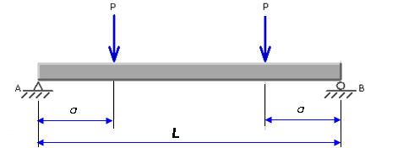Simple Beam – Two Equal Concentrated Loads – Symmetrically Placed

P = 4500 lb from left + 4500 lb from right = 9000 lb

- Calculate the end reaction and maximum moment.
R = P = 9000 lb
M = Pa = (9000 lb)(6.67 ft) = 60,030 ft*lb

- Calculate the required nominal moment.
M_{n} $≥$ M_{a}Ω_{b} = (60,030 ft*lb)(1.67) = 100,250 ft*lb

- Determine the required plastic section modulus and select an efficient wide flange.
M_{n} = F_{y}Z_{x} = Z_{x} $≥$ (1000,250 ft*lb)(12in/1ft) / (50,000 lb/in²) =24.06 in³

W12x19
Z_{x} = 24.7 in³
I_{x} = 130 in⁴
d = 12.16 in
t_{w} = 0.235 in

- Check the shear strength.
V_{n} $≥$ V_{a}Ω_{v} $=$ (9,000 lb)(1.5) = 13,500 lb
V_{n} = 0.6F_{y}dt_{w} = 0.6(50,000 lb/in²)(12.16 in)(0.235 in) = 85,728lb ≥ 13,500 lb
Good

- Calculate deflection limits.
∆_{DL+LL} ≤ L/240 = (20ft * (12 in/1ft))/ 240 = 1 in
∆_{LL} ≤ L/360 = (20ft * (12 in)) / 360 = 0.67 in

- Calculate actual deflections.
∆_{DL+LL} = (Pa/24EI)(3L² – 4a²) = $\frac{\left(9,000 lb\right)\left(6.67 ft*\frac{12 in}{1ft}\right)}{24(29,000,000\frac{lb}{{in}^{3}}}(3(20ft\frac{12in}{1ft})^{2}-4(6.66\frac{12in}{1ft})^{2})=$ 1.17 $>$1
Not Good

- Select a final design
W14x22

