Copper Compounds Lab Report
- Author: Malia Letourneaux
Date of Experiment: 12-18-20
Date Report Submitted: 12-21-20
Class: Chemistry

- In this experiment, we attempted to create four copper compounds by combining copper (II) sulfate with either sodium hydroxide, ammonia, sodium carbonate, or lime.

- Materials & Methods:
- Copper sulfate
- Water
- Sodium hydroxide (NaOH)
- Ammonia (NH₄OH)
- Sodium carbonate (Na₂CO₃)
- Lime (CaO)
- Magnetic stirrer
- Four test tubes
- Five beakers
- Four pipettes
- Stand for test tubes
- Scale
For this experiment, we first took 30g of copper sulfate and dissolved it in 300ml of water using a beaker and a magnetic stirrer. After the copper sulfate was dissolved in the water, making copper (II) sulfate (CuSO₄), we poured an equal amount into four separate test tubes. After we had done this, we used a pipette to put caustic soda (NaOH) into the first test tube, ammonium hydroxide (NH₄OH) into the second, washing soda, also know as sodium carbonate (Na₂CO₃), into the third, and calcium hydroxide (Ca(OH)₂) into the fourth. We then observed the differences between the four copper compounds we created.
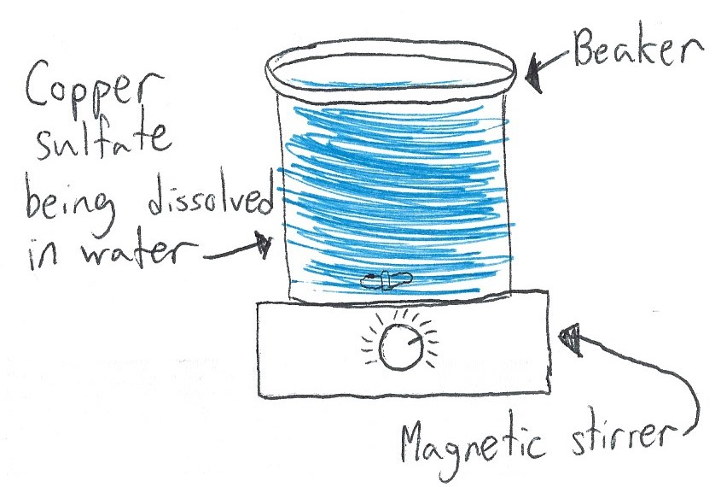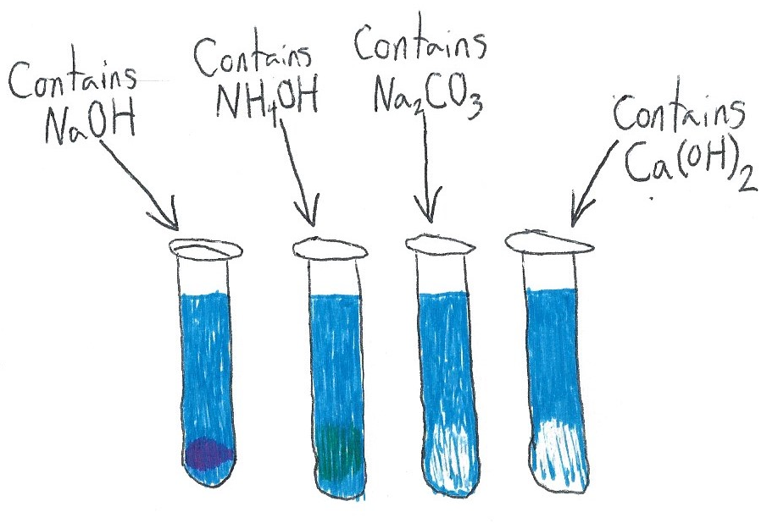
- Results:

When we put the sodium hydroxide (NaOH) into the first test tube, it reacted with the copper (II) sulfate (CuSO₄) and made copper hydroxide (Cu(OH)₂) and sodium sulfate (Na₂SO₄).

CuSO₄ + NaOH → Cu(OH)₂ ↓ + Na₂SO₄

When we put the ammonia (NH₄OH) into the second test tube, it reacted with the copper (II) sulfate (CuSO₄) and made copper (II) hydroxide (Cu(OH)₂) and ammonium sulfate ((NH₄)₂SO₄).

CuSO₄ + NH₄OH → Cu(OH)₂ ↓ + (NH₄)₂SO₄

When we put the sodium carbonate (a.k.a. washing soda) into the third test tube, it reacted with the copper (II) sulfate (CuSO₄) and made copper (II) carbonate (CuCO₃) and sodium sulfate (Na₂SO₄).

CuSO₄ + Na₂CO₃ → CuCO₃ ↓ + Na₂SO₄

When we put the calcium hydroxide (a.k.a. lime) into the fourth and final test tube, , it reacted with the copper (II) sulfate (CuSO₄) and made copper (II) hydroxide (Cu(OH)₂) and calcium sulfate (CaSO₄).

CuSO₄ + Ca(OH)₂ → Cu(OH)₂ ↓ + CaSO₄

All of the reactions that took place were double replacement reactions.

- Conclusion:

In this experiment, we created four different copper compounds using copper (II) sulfate, sodium hydroxide, ammonia, sodium carbonate, and lime. We observed the differences between the four compounds we created and discussed what they could be used for.

