**Corn Dihybrid Genetics lab**

Your name: _____________________ Team name: _________________________ Date: ___________

1. Study the photo below: F2 generation from a dihybrid cross of 2 corn plants *(Zea maize)*.

What are the 4 phenotypes you can identify on the kernels?

List them here:



1. Study photo “17-6900 Dihybrid Cross”
2. What is meant by P1?

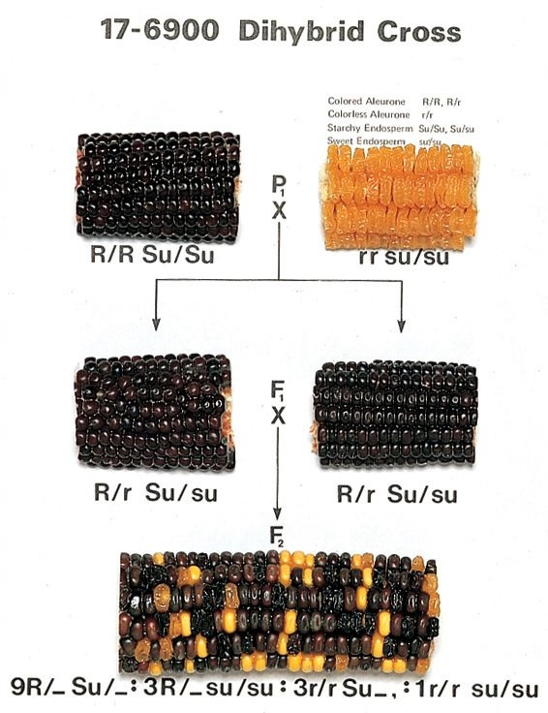

1. F1?
2. F2?
3. What is meant by dihybrid cross?
4. With a pen, carefully label on photo #1 examples of these four phenotypes:
5. R red (dominant)
6. r yellow (recessive)
7. Su smooth (dominant)
8. su wrinkled (recessive)
9. Look at the P1 parents in photo “17-6900 Dihybrid Cross”. Finish this table:

|  |  |  |
| --- | --- | --- |
|  | Genotype: | Phenotype: |
|  | Homozygous/heterozygous? | Red/yellow/smooth/wrinkled? |
| R/R |  |  |
| r/r |  |  |
| Su/Su |  |  |
| su/su |  |  |

1. Look at the F1 generation in photo “17-6900 Dihybrid Cross”
2. R/r This is (homozygous/heterozygous) for the phenotype ___________
3. Su/su This is (homozygous/heterozygous) for the phenotype ___________
4. Now let’s say you cross-pollinated the two P1 parent corn plants. Complete the Punnett Square leading to the F1 generation
5. How many different genotypes will the F1 generation have?
6. What many different phenotypes will the F1 generation have?

|  |  |  |  |  |
| --- | --- | --- | --- | --- |
| P1 gametes | r/su | r/su | r/su | r/su |
| R/Su |  |  |  |  |
| R/Su |  |  |  |  |
| R/Su |  |  |  |  |
| R/Su |  |  |  |  |

1. Now carefully examine your F2 corn cob. BE GENTLE. Don’t knock off any kernels! If you accidently do, we will need to glue them back on. These are *expensive* lab specimens.
2. With your lab partner, count the kernels one row at a time. Be patient and get an accurate count! This will take some time!
3. Use the table to help you count
4. From your table, what is the precise ratio of the four different phenotypes? (hint: it will not be exactly 9:3:3:1)

|  |  |
| --- | --- |
| 4 Phenotypes: | Add up the columns here |
| R/Su (red/smooth) |  |
| R/su (red/wrinkled) |  |
| r/Su (yellow/smooth) |  |
| r/su (yellow/wrinkled) |  |
| Total kernels on the cob |  |

1. Now let’s say you cross-pollinate the two F1 corn plants. Complete the Punnett Square leading to the F2 generation

|  |  |  |  |  |
| --- | --- | --- | --- | --- |
| F1 gametes | R/Su | R/su | r/Su | r/su |
| R/Su |  |  |  |  |
| R/su |  |  |  |  |
| r/Su |  |  |  |  |
| r/su |  |  |  |  |

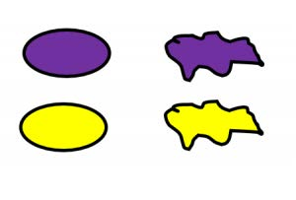

1. Using colored pens/pencils or a drawing App, draw the physical appearance of each kernel in the table. For example, you could draw them like this, or get creative and do your own.

|  |  |  |  |  |
| --- | --- | --- | --- | --- |
| F1 gametes | R/Su | R/su | r/Su | r/su |
| R/Su |  |  |  |  |
| R/su |  |  |  |  |
| r/Su |  |  |  |  |
| r/su |  |  |  |  |

1. According to your F2 Punnett Square above:
2. How many different genotypes does your F2 generation have?
3. How many different phenotypes would you expect to see on your F2 corn cob?
4. What is the theoretical ratio of the different phenotypes, as predicted by your Punnett Square?
5. Final analysis:
6. How close is your actual F2 ear of corn to the theoretical ratio? DO SOME CALCULATIONS to prove your point!
7. List four (4) possible sources of error to explain why your observed ratio isn’t exactly 9:3:3:1

**AP BIOLOGY STUDENTS COMPLETE THIS PART**

Your name ­­­­­­­­­­­­­­­­______________________________________ Date ____________________

1. Complete a Chi-Square (χ2) test for this lab. Write it all up, make it look professional, and turn it in on Canvas.
2. Using your own data from this lab, create a table or spreadsheet like Table 2 on the next page
3. Compute your Chi-Square value
4. Look up your probability from Table 1
5. Explain what it all means!

Chi-Square (χ2) test

Does your data, as recorded in the activities above, actually support your hypothesis about how the trait

is inherited? Genetics, like gambling, deals with probabilities. When you flip a coin, you have the same

chance of getting a head as a tail: a one-to-one ratio. That does not mean that if you flip a coin 100

times you will always get 50 heads and 50 tails. You might get 53 heads and 47 tails. That is probably

close enough to a one-to-one ratio that we would accept it without a second thought. But what if you

got 61 heads and 39 tails? At what point do you begin to suspect that something other than chance is at

work in determining the fall of your coin? Look back at your data. You were expecting a 9:3:3:1

phenotype ratio in the F2. This assumes that chance (and chance only) has been operating in the

assortment and recombination of alleles that gave rise to the F1 and F2 you have investigated. Thus, any

variation of the observed results from the expected results are due to chance. This is known as the **null**

**hypothesis**. Does your data actually support the null hypothesis?

The Chi-square (χ2) test is a statistical test used to determine how well observed ratios fit expected

ratios. The difference between the number observed and the number expected for a phenotype is

squared and then divided by the number expected. This is repeated for each phenotype class. The χ2

value consists of the summation of these values for all classes. The formula for χ2 is:

The calculated χ2 is then compared to the values given in a statistical table, such as the one shown here.

**Table 1: Chi-Square Values and Probabilities**

*(5% or Less is Considered Significant)*

**Poor fit data**

|  |  |  |  |  |  |  |  |
| --- | --- | --- | --- | --- | --- | --- | --- |
| Degrees of Freedom | *p* = 99% | 95% | 80% | 50% | 20% | 5% | 1% |
| 1 | 0.000157 | 0.00393 | 0.0642 | 0.455 | 1.642 | 3.841 | 6.635 |
| 2 | 0.020 | 0.103 | 0.446 | 1.386 | 3.219 | 5.991 | 9.210 |
| 3 | 0.115 | 0.352 | 1.005 | 2.366 | 4.642 | 7.815 | 11.345 |
| 4 | 0.297 | 0.711 | 1.649 | 3.357 | 5.989 | 9.488 | 13.277 |
| 5 | 0.554 | 1.145 | 2.343 | 4.351 | 7.289 | 11.070 | 15.086 |
| 6 | 0.872 | 1.635 | 3.070 | 5.348 | 8.558 | 12.592 | 16.812 |
| 7 | 1.239 | 2.167 | 3.822 | 6.346 | 9.803 | 14.067 | 18.475 |
| 8 | 1.646 | 2.733 | 4.594 | 7.344 | 11.030 | 15.507 | 20.090 |
| 9 | 2.088 | 3.325 | 5.380 | 8.343 | 12.242 | 16.919 | 21.666 |
| 10 | 2.558 | 3.940 | 6.179 | 9.342 | 13.442 | 18.307 | 23.209 |

In this table, note the column titled, “Degrees of Freedom.” The degree of freedom is always one less

than the number of different phenotypes possible. For a dihybrid F2, there are four possible phenotype combinations and 3 degrees of freedom. The numbers to the right of the Degrees of Freedom column in the table are χ2 values. The percentages given at the top of each column represent the probability that the variation of the observed results from the expected results is due to chance. If the probability value is greater than 5%, we accept the null hypothesis; that is, our data fits the expected ratios.

Table 2: Here’s an example to show you how to do it. Note that the Chi-Square value in this example is 1.80, which means the probability that this person’s data supports the theoretical ratio of 9:3:3:1 is around 60% correct according to Table 1 above, so this person would “accept” his or her data. Hopefully, yours will be higher than 60%, but don’t fudge your data if it isn’t.

|  |  |  |  |  |  |
| --- | --- | --- | --- | --- | --- |
| **Table 2:**  **“Chi-Square computation for Corn Dihybrid Genetics lab”** | | | | | |
| **Grain Phenotype** | **Observed Number** | **Observed Ratio** | **Expected Ratio** | **Expected Number** | **[Obs No. - Exp No.]2 ÷ Expected No.** |
| **Purple & Smooth** | **216** | **10.3:1** | **9:1** | **381 x 9/16 = 214** | **4 ÷ 214 = 0.019** |
| **Purple & Shrunken** | **79** | **3.8:1** | **3:1** | **381 x 3/16 = 71** | **64/71 = 0.901** |
| **Yellow & Smooth** | **65** | **3.1:1** | **3:1** | **381 x 3/16 = 71** | **36/71 = 0.507** |
| **Yellow & Shrunken** | **21** | **1.0:1** | **1:1** | **381 x 1/16 = 24** | **9/24 = 0.375** |
| **Total Number:** | **381** | ---------- | ---------- | **Chi Square Value:** | **1.80** |