Micro-Economics Midterm

Name and date submitted (3 pts):

Instructions: Answer the questions below. KEEP THE SAME NUMBERING!
Note: Highlighting and light-colored fonts DON’T SHOW UP. Indicate your answers some other way.

(50 questions, 2 points each)

- What is the main idea behind the study of economics?
  - Monetary policy
  - Efficiency of production
  - Allocation of scarce resources
  - Business decisions

- The five (5) foundations of economics:

- A company decides to purchase and install more machines and lay off workers. Which basic economic question is the company addressing?
  - What to produce
  - How to produce it
  - For whom to produce it

- Scarcity is the result of _______________ and ________________.

- In economic terms, what are land, labor, and capital?
  - Production possibility frontier
  - Factors of production
  - Production trade-offs
  - Opportunity costs

- Sally has enough money to buy either a CD or to go to a movie with her friends. In economics, what is the choice that Sally “gives up” called?
  - Positive cost
  - Negative cost
  - Opportunity cost
  - Marginal cost

- Consider the statement: “There is no free lunch.” In economic terms, what does this mean?
  - Someone must pay for it.
  - All production is designed to reduce scarcity.
  - Choices are never based on self-interest.
  - People only think of others when making choices.

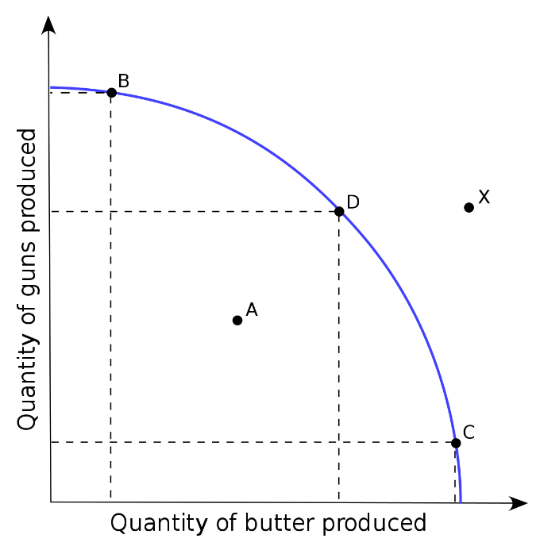
Production Possibilities Curve: Next 6 questions

- Points B, D, and C are
  - Efficient
  - Inefficient
  - Impossible currently

- Point ‘A’ is
  - Efficient
  - Inefficient
  - Impossible currently

- Point ‘X’ is
  - Efficient
  - Inefficient
  - Impossible currently

- A new, more efficient gun assembly line would move point ‘B’
  - Up
  - Down
  - Unchanged

- A new, more efficient butter production line would move point ‘C’
  - Right
  - Left
  - Unchanged

- A larger overall labor force would shift the entire curve
  - Out
  - In
  - Unchanged

- Consider the statement: “In free trade, there is always a loser. Therefore, free trade isn’t fair & just.” Your textbook strongly disagrees. How does trade create value for both parties? Use the proper economic terms.

- Three functions of “prices”:

Figure 1: Market Demand and Supply
Price | Quantity  Demanded | Quantity  Supplied | Surplus/  Shortage
$20 | 0 | 20 | 20
18 | 2 | 16 | 14
16 | 4 | 10 | 6
14 | 7 | 7 | 0
12 | 11 | 5 | ?
10 | 13 | 0 | –13

- Fig. 1: What is the equilibrium price?

- Fig. 1: At a price of $12 in the table, does the market have a surplus or shortage? Of how many units? Explain how you know.

Figure 2: Demand/Supply Schedule
Price | Quantity  Demanded | Quantity  Supplied
$1 | 14 | 2
2 | 12 | 3
3 | 10 | 4
4 | 8 | 5
5 | 6 | 6
6 | 4 | 7
7 | 2 | 8
8 | 0 | 10

- Fig. 2: What is the equilibrium price?

- Fig. 2: If the government imposed a price floor of $7, what would result? Surplus or shortage, and by how much?

- Fig. 2: If the government imposed a price ceiling of $4, what would result? Surplus or shortage, and by how much?

- Which of the following is an opportunity cost of building a new public high school?
  - Cost of hiring teachers for all subjects at the new school
  - Increase in the annual property taxes to pay for the new school
  - Cost of constructing the new school at a later date
  - Other goods and services given up in order to pay for the school

- Explain Adam Smith’s “Invisible Hand” idea:

- What is the economic system in which an elite group at the top determine how the economy will use its scarce resources?
- Market economy
- Capitalism
- Command economy
- Democratic Republic

- According to Adam Smith’s “Wealth of Nations”, what is the primary incentive that motivates a firm to produce and sell a product? (the line about the brewer, butcher, and baker….)
- Making profits on sales
- Putting others out of business
- Pleasing the government
- Serving humanity

- What is the most likely to happen when consumers want to buy more smart phones than the store has available for sale?

Profit on smart phone sales will be smaller.

Price of the smart phone will increase.

Manufacturers will stop making it.

Stores will make a different model.

On a supply and demand graph, what is the point called at which quantity demanded equals quantity supplied?

Surplus

Equilibrium

Shortage

Equidistant

Sugar is an important input in the production of cookies. If the world supply of sugar suddenly decreases, what would we expect to happen to the price of cookies?

No change

Increase

Decrease

Not enough information

Which of the following is the best example of the “law of supply”?

A supplier provides more shoes to local stores as prices of ladies shoes fall.

A restaurant buys a new dishwasher to make employees’ work easier.

A milling company builds a new factory to process flour to export.

A sandwich shop increases the number of sandwiches when the market price increases.

If a government sets a maximum price for a good or service, what is it called?

Price ceiling

Price floor

Inflated price

Illegal price

Consider a new law: “From now on, the price of gasoline shall not exceed $1.00 per gallon, punishable by fine or imprisonment”. What is the result of a price ceiling which is set below the current equilibrium price?

Shortage

Surplus

Equilibrium

Equidistant

- A hurricane hit Florida and destroyed half of the orange crop. What would most likely happen to the orange market?
- Demand for oranges will rise
- The price of oranges will fall
- The price of oranges will increase
- Supply of oranges will increase

- Which factor will decrease the demand for a product?
- Increased popularity of a product
- A decrease in the number of buyers
- A decrease in the price of a complementary good
- An increase in the price of a substitute good

- Pepsi vs. Coke: If the price of Pepsi (a substitute good) goes down, will the demand curve for Coke shift left or right? Explain.

- Peanut butter and jelly: If the price of peanut butter (a complimentary good) goes down, will the demand curve for jelly shift left or right? Explain.

Figure 3: Demand

Price

D₂

D₁

Quantity

- Fig. 3: If the demand curve moves from D₁ to D_{2,} what has happened?
- A decrease in demand
- An increase in demand
- A decrease in price
- An increase in quantity

- Fig. 3: True/False – If people’s incomes increase, and it’s a ‘normal good’, the demand curve shifts from D1 to D2.

- Fig. 3: True/False – If the price of a substitute good increases, the demand curve shifts from D1 to D2.

- Fig. 4: True/False – If consumers find out the price of the good will increase in the near future, the demand curse shifts from D1 to D2.
- How many businesses make up an oligopoly?
- Few
- None
- One
- Numerous

- Which of the following describes a market in which one firm controls the supply and pricing of the product?
- Monopolist competition
- Oligopoly
- Socialist competition
- Monopoly

- Two examples of elastic goods:

- Two examples of inelastic goods:

- What is an example of a negative externality? Explain why.

- What is an example of a positive externality? Explain why.

- What is the Coase Theorem? Give an example using a cattle farmer and wheat farmer.

- A firm has sales revenue of $1,000, cost of goods sold of $500, and operating expenses of $350.
  - Gross profit in dollars?

  - Net profit in dollars?

  - Gross margin in percentage?

  - Net margin in percentage?

Next several questions: A firm manufactures and sells 1,000 widgets having a selling price of $10 each, variable cost of $6 each, and a total fixed cost of $3,000.
EXAMPLE:
- Sales revenue? $10,000
- Total cost? $6,000 + $3,000 = $9,000
- Net profit overall? $1,000
- Net profit per widget? $1

- The next month, the above firm manufactures 1,500 widgets having a selling price of $10 each, variable cost of $6 each, and a total fixed cost of $3,000.
  - Sales revenue?

  - Total cost?

  - Net profit overall?

  - Net profit per widget?

- Why did the above firm make more net profit per widget in month #2? Explain using economic terms.

- In the third month, a competitor entered the market for widgets. During this month, the original firm was able to manufacture and sell only 500 widgets having a selling price of $9 each, variable cost of $6 each, and a total fixed cost of $3,000.
  - Net profit overall?

  - Net profit per widget?

- You have been hired by the firm as a consultant.
  - What is the firm’s ‘break even’ point of production at the current cost structure? In other words, how many widgets would it need to produce and sell, given its current cost structure and a selling price of $9 each, to just barely break even (i.e. net profit = $0).

  - Assuming that with this new, competitive environment, that 500 widgets per month can be sold at $9 each, and the total fixed cost of $3,000 can’t be reduced, what would the firm’s variable cost per unit need to be in order to just break even?

