“Energy Skate Park” weblab

Name and date submitted (3 pts):
(25 questions)
Instructions: Using the template below, answer all the questions. KEEP THE SAME NUMBERING SYSTEM and the original questions!
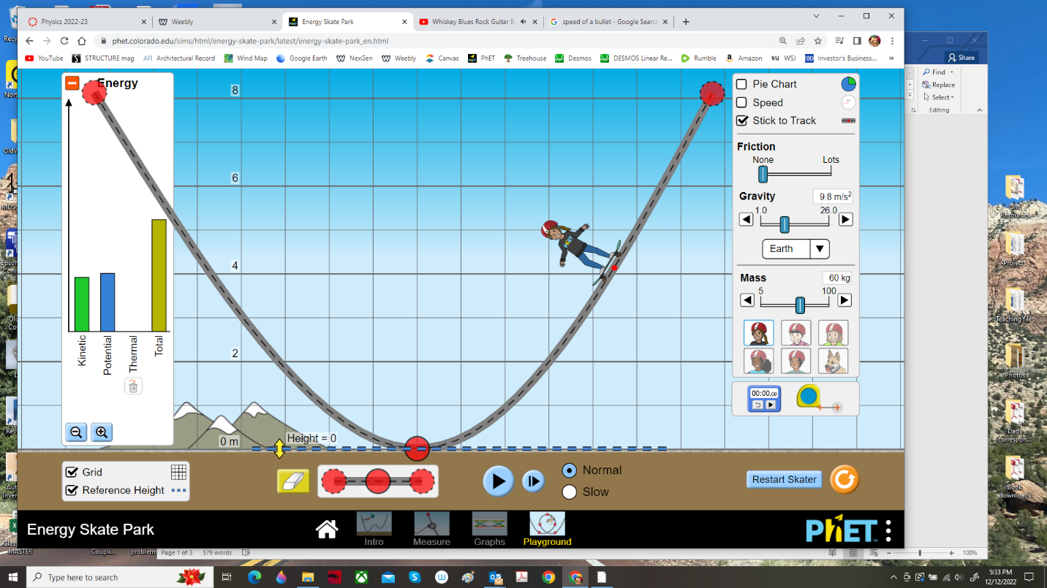

Energy is measured in Joules (J). 1 Joule = 1 Newton-meter (1 N-m)
Kinetic energy: KE = ½mv² m=mass in kg; v=velocity in m/s; g=9.8m/s²; h=height in m
Potential energy: PE = mgh

Instructions
Go to the University of Colorado ‘PhET’ website and open “Energy Skate Park” simulation. Choose the “Playground” option.
Turn on the energy bar graph and grid. Make sure the coefficient of friction is set to “none” or zero. DON’T turn on any of the graphs yet.
Stretch the track out horizontally and vertically, and bring the skater to a height level = 8m. Set his/her mass = 60 kg. Allow him to move up and down the track. Observe his motion.

- What happens to the total energy (TE) as you bring the skater up to height = 8m?

- What happens to the potential energy (PE) as you bring the skater up the height = 8m?

- What is the kinetic energy (KE) in Joules before releasing the skater?

- As the skater moves from one side of the ramp to the other, what happens to the total energy (TE)?

- The kinetic energy (KE)?

- The potential energy (PE)?

- Calculate the PE in Joules at the top and bottom of the ramp using the potential energy equation.

Moving with Friction
- Move the friction to about ½ way between “none” and “lots.” What happens to the skater?

- What happens to the total energy?

- What happens to the kinetic and potential energy? Explain what’s going on.

Changing Mass
Return the friction setting to none. Increase the mass of the skater (the amount isn’t important). Bring the skater up to the height = 8m, as before.

- How does the total energy of the system compare to the total energy of the system before you changed the mass?

- Does mass have an effect on potential and kinetic energy? Explain. Give equations for both as part of your justification.

- Does changing the mass have any effect on the height the skater moves from one side of the ramp to the other?

Analyzing Speed
- Where is the speed of the skater fastest?

- Where is the speed of the skater slowest?

- With his mass = 60 kg, calculate the skater’s speed at the bottom of the ramp using the energy equations (report the speed in m/s)

- Now reduce the mass of the skater. Is there any change in the fastest or slowest speed?

- What variable can you change in order to change the fastest and slowest speeds?

Work and Conservation of Mechanical Energy Analysis
- Turn off friction. Place the skater back at the 8m height. As you move the skater up to 8m, what minimum force would you need to apply in order to do work against gravity without accelerating the skater?

- Write a general equation for potential energy.

- As the skater moves down the ramp, what happens to the kinetic energy?

- What other variable is increasing as kinetic energy increases?

- Write a general equation for kinetic energy.

- What are the two types of mechanical energy? Hint: they were just mentioned

- Based on your observations, write an equation for the conservation of mechanical energy as the skater moves from 8m to 0m.

