Ethanol Biofuel Lab
In the process of fermentation, yeast breaks down sugar to produce ethanol. The ethanol thus produced is concentrated by distillation and then used as fuel, in the same way as gasoline or diesel.
The sugar used in fermentation can be sucrose, glucose, fructose, or derived from any starchy plant matter. If plant matter is used (e.g. corn, potatoes, beets, grains, fruit) then the starch must first be broken down into simpler sugars (glucose or fructose) in a process called ‘conversion’. In this lab we will use sucrose, which is the easiest and fastest method.
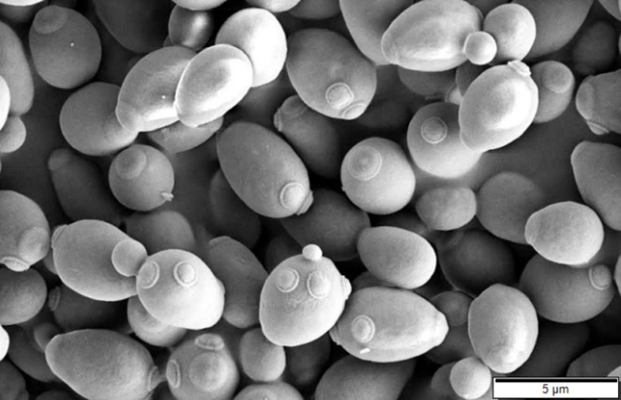
Yeast belongs to the fungus kingdom. They range in size from 5 to 14 microns (about 5-14 times larger than typical bacteria). They reproduce rapidly by cell sprouting, which is why they are also called “shoot fungi”. This process can occur up to 35 times. During fermentation, under anaerobic conditions (absence of oxygen), yeast converts sugars into ethanol and carbon dioxide. The most important yeast is Saccharomyces cerevisiae, known as Baker’s yeast or Brewer’s yeast. Saccharomyces = “sugar fungus”; Cerevisiae = “cereals”.
Production of ethanol:
Step 1 - Glycolysis: First, the yeast carry out glycolysis in the usual way, breaking-down glucose into pyruvate, and generating a ‘net’ 2ATP and 2NADH energy carriers:
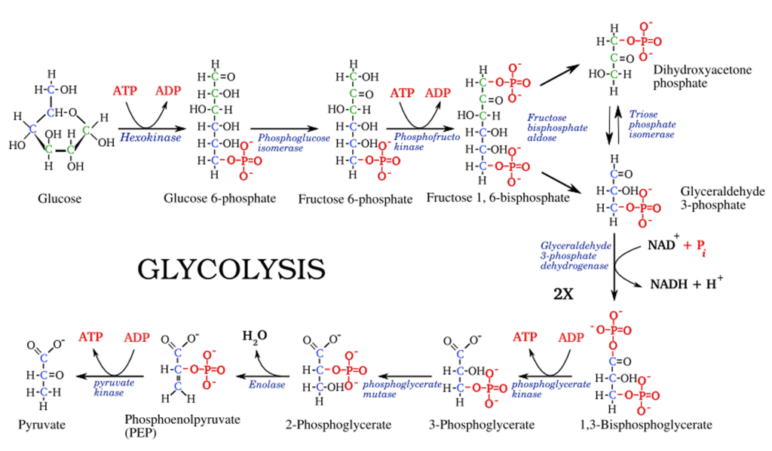
Glucose → Pyruvate + 2ATP + 2NADH energy carriers

Step 2 - Fermentation: Then, instead of using the Citric Acid Cycle and electron transport chain, the yeast ‘ferments’ the pyruvate to form ethanol as shown in the reaction below. Ethanol is the alcohol found in beverages and used as a biofuel.
CO₂ gas is liberated during reaction #1 (below). This is what causes bread to rise, and causes the balloon placed over the fermentation vessel to inflate.
NADH is used to energize reaction #2, in which the ethanol is produced. Ethanol is the final electron acceptor (the end of the road) in fermentation.

Step 3 - Distillation: The ethanol at this stage is too dilute to use as fuel. It’s only around 5-10% alcohol at this point (i.e. it’s mostly water). The ethanol needs to be concentrated up to at least 70-80% to use as biofuel.
The dilute mixture is called ‘sugar wash’ at this point (see below). It looks cloudy from the dead and dying yeast, and has a little froth on top left over from the fermentation process. It’s NOT anything you would want to drink!... in fact, it can make you very sick because it contains aldehydes and other organic compounds left over from fermentation.
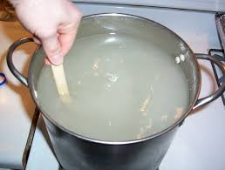
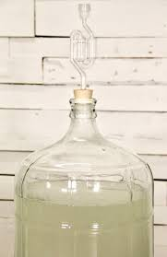

In distillation, the ethanol is separated from the water by virtue of the fact it has a lower boiling point (water = 212℉, ethanol = 173℉). The wash is slowly heated, the ethanol evaporates off the top and is condensed back into liquid, and collected as nearly pure ethanol fuel.
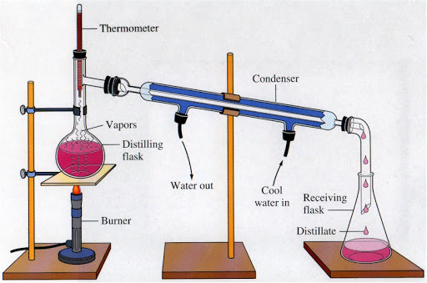
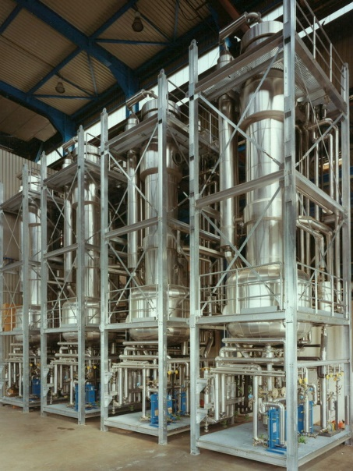
Laboratory still Industrial still

Step 4 – Combustion: The ethanol can now be used to power a Stirling Engine (below left) to generate electricity, or mixed with regular gasoline to power cars and trucks (below right).
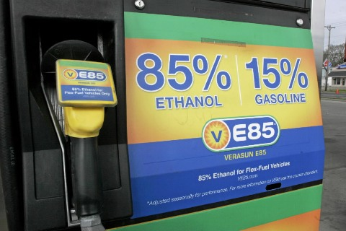
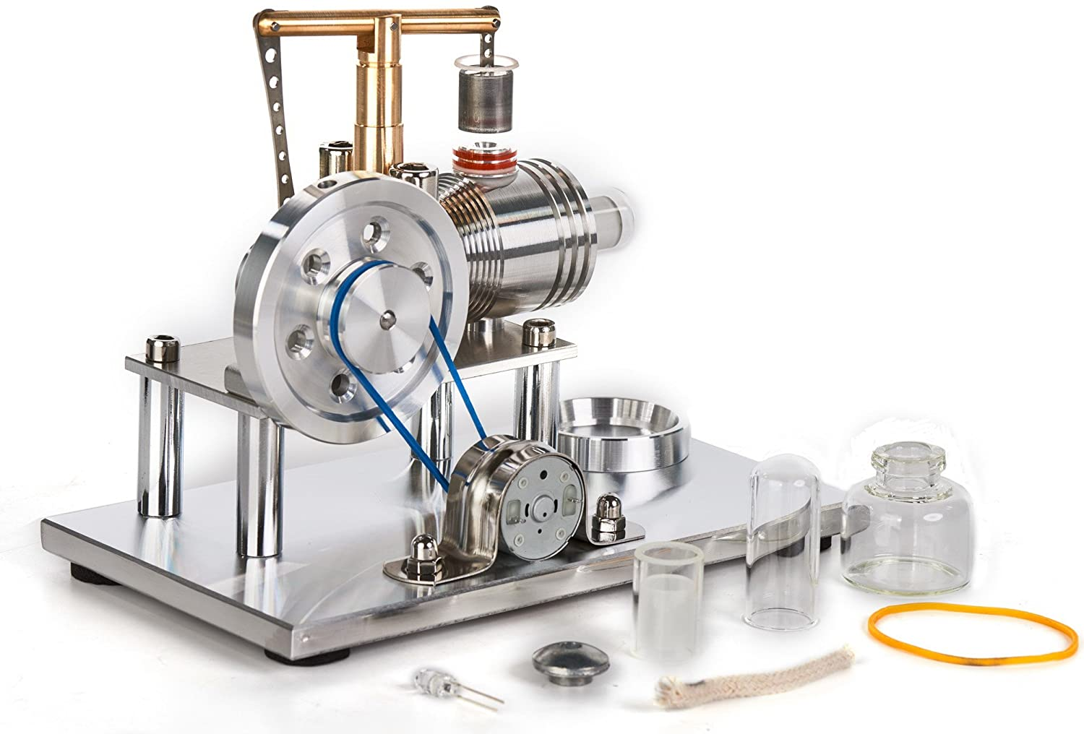

Lab Instructions:
Make the wash:
- The rule of thumb for sucrose-ethanol production is 350 g sucrose per L of warm water (~100℉).
  - How much sugar in g would you need for 200 ml water? ___________
  - How much sugar in g would you need for 100 ml water? _____________
- The rule of thumb for yeast is 100 g per 5 gallons of water, to make sugar alcohol. There are 3.8 L per gallon.
  - How many L are there in 5 gallons? __________
  - How much yeast in g would you need for a 200 ml batch? ____________
  - How much yeast in g would you need for a 100 ml batch? ____________
- Make sure your Erlenmeyer flask is clean! Bacteria will ruin fermentation. Fill the flask up to the mark with warm water. Using a paper funnel, add the sugar and stir until dissolved.
- “Activate” your yeast for a few minutes – don’t just dump it in your flask. Let it activate gently in a separate dish, carefully mixing it into a paste. Don’t stir it violently! After a few minutes, add it to your sugar water, and swirl it in gently.
- Let your flask stand for a couple hours, exposed to the air. Swirl it occasionally to oxygenate the mixture (you can shorten this step for lab purposes).
- Cover the flask with a balloon. This keeps out oxygen, and collects the CO₂ which will be produced.
- Let it ferment at 70-80℉ for 24 hours, or until CO₂ production ceases. Depending on the yeast and temperature, it may only take 12 hours – or it may take 36 hours. You will know it’s done when the balloon stops inflating and when the wash doesn’t appear to have any bubbles on its surface.
Demonstrate that CO₂ is a byproduct of fermentation:
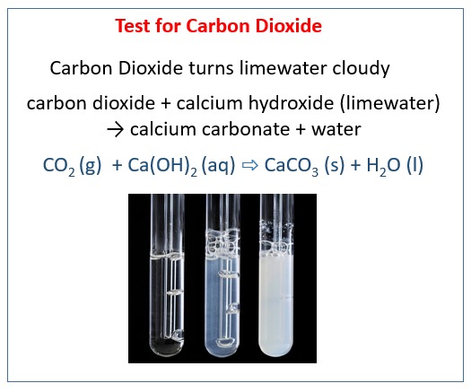
- Carefully remove the balloon and direct the CO₂ down a straw into lime water. The CO₂ will combine with the lime to create calcium carbonate, turning the limewater cloudy.
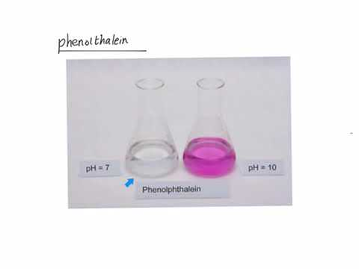
If you first add 4-5 drops of phenolphthalein pH indicator to your limewater, the CO₂ will lower the pH by creating carbonic acid, causing the phenolphthalein to turn “clear”. You can double check the beginning and ending pH with pH test strips; it should drop the pH from around 9-10 down to around 7-8.
Distillation:
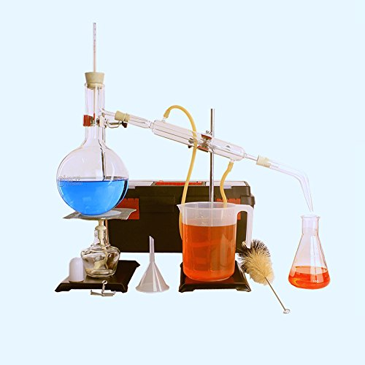
- Distill the wash in a large flask at low heat. The ethanol will begin evaporating from the wash mixture at around 90℉. Condense the ethanol and collect it in a small flask. Continue boiling the mixture gently until the temperature rises to around 95℉. At that point, most of the ethanol will have flashed off the mixture, and you need to stop at that point – otherwise the distillate will be too dilute to burn. You should recover around 10% of the wash volume as pure ethanol, i.e. for every liter of wash you should get about 100 ml of pure ethanol.

Combustion:
Ethanol burns (combines with oxygen) to produce CO₂, water, and heat energy.
C₂H₅OH + 3 O₂ → 2 CO₂ + 3 H₂O + heat
- Check to see if your ethanol fuel will burn. Pour a teaspoonful in a small dish and light with a match. If the ethanol is pure, it will gently burn with an almost-invisible flame.
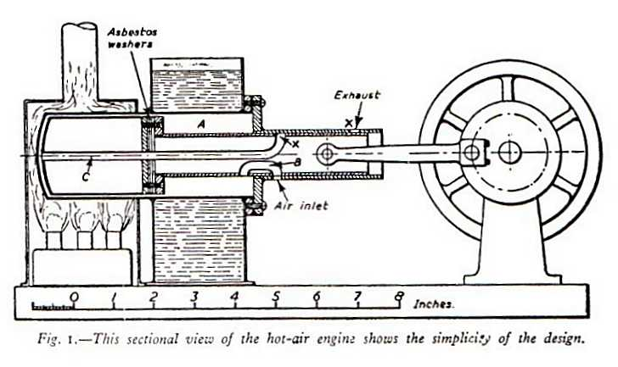
- Demonstrate your biofuel by powering a Stirling Engine, connected to a generator and light bulb.

Lab Report:
Your lab report must have all 5 elements below. Number them #1-5. Include all chemical equations, and sketch the lab equipment carefully.
- Title: Write the lab title, your name, date, and class
- Problem statement: State clearly what you are trying to do in the lab. For this lab report, you might pretend, for example, that you are doing research on alternate fuels, and reporting your results to the board of directors.
- Materials & Methods:
- List the equipment and supplies you used
- Write out what you did, and how you did it. Include all chemical equations!
- Include sketches and diagrams!
- Results: Present your results (in this lab, the ‘results’ are the fact that we produced fuel and ran an engine with a generator and light bulb; so one approach is to sketch everything, take pictures with your phone, show the engine running and light bulb flickering, show the formula for combustion, explain how the engine works, and so forth).
- Use tables, charts, and graphs.
- Label everything and show all units!
- Conclusion: Write a brief closing paragraph
What did you find out? What did you learn? What did you discover? What do you recommend to the board of directors?

