Apple iPhone 2007 Marketing Plan assignment
Your name and date submitted (3 pts):
Instructions: Download the original 2007 Apple iPhone ‘Generation-1’ marketing plan which is posted on the student portal. Create space in the TEMPLATE below and respond to the following questions.
(10 questions, 100 points)
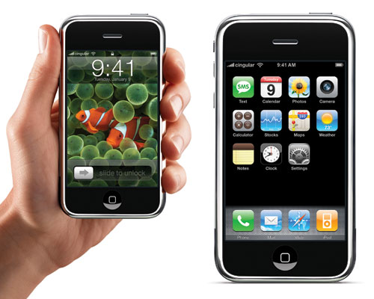The picture shows the original ‘Generation-1’ phone, circa 2007.
Market Summary (p. 1)
- Read the market summary
  - List the 5 groups they are targeting
  - Why do they think the market is “small”?
  - Why do they think the market will “rapidly increase”?
SWOT Analysis (p. 2-3)
- What do they think are the iPhone’s 6 biggest “strengths”? List them here, and summarize IN YOUR OWN WORDS.
- What do they think are the iPhone’s 3 biggest “weaknesses”? List them here, and summarize IN YOUR OWN WORDS.
- What do they think are the iPhone’s 3 biggest “opportunities”? List them here, and summarize IN YOUR OWN WORDS.
- What do they think are the iPhone’s 3 biggest “threats”? List them here, and summarize IN YOUR OWN WORDS.
Product Offering (p. 3-4)
- Explain these product features IN YOUR OWN WORDS
  - Phone
  - Camera
  - Style
Objectives (p. 4)
- State their 1st year objectives IN YOUR OWN WORDS
- State their 2nd year objectives IN YOUR OWN WORDS
Pricing (p. 5)
- What is their pricing strategy, including the specific dollar amounts? Why are they taking a low-price-strategy?
Distribution (p. 5)
- Explain their distribution “roll-out” plan IN YOUR OWN WORDS

