Requirements for a Lab Report
Instructor: K. Johanson
In the sciences, the purpose of a lab report is to 1) keep good notes so you can refer to them later, 2) allow you to repeat the experiment if necessary, 3) explain to your team members, professors, and boss what you did, and 4) protect your intellectual property.
Preparing a lab report takes practice, and you will get better at it with time.
Take notes and make sketches during the lab!
Use a 3-ring binder or spiral notebook for your lab notes. Take notes during each lab!
Your lab report needs (5) sections, below. Number them!
- Title: Write the lab title, your name, date, and class
- Problem statement: State clearly what you are trying to do in the lab
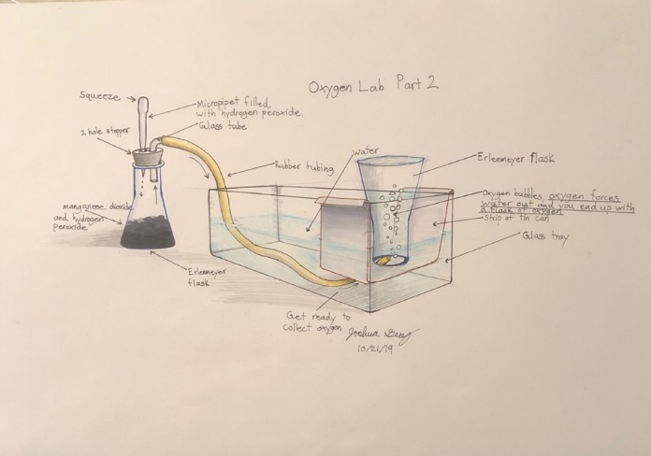
- Materials & Methods:
- List the equipment and supplies you used
- Write out what you did, and how you did it
- Include sketches and diagrams!
- Results: Present your results
- Use tables, charts, and graphs.
- Label everything and show all units!
- Conclusion: Write a brief closing paragraph
What did you find out? What did you learn? What did you discover?
Grading breakdown
Each lab write up is worth 100 points:
- 50 points for technical content
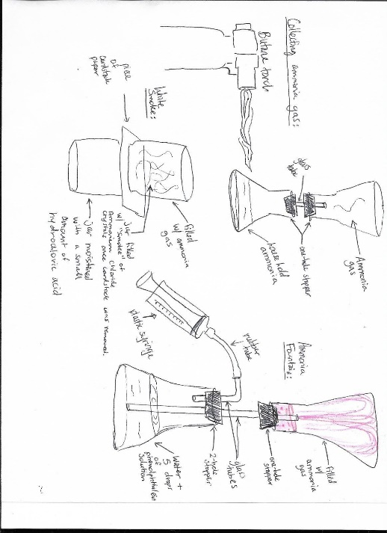
- 50 points for professional appearance. Take pride in your work!
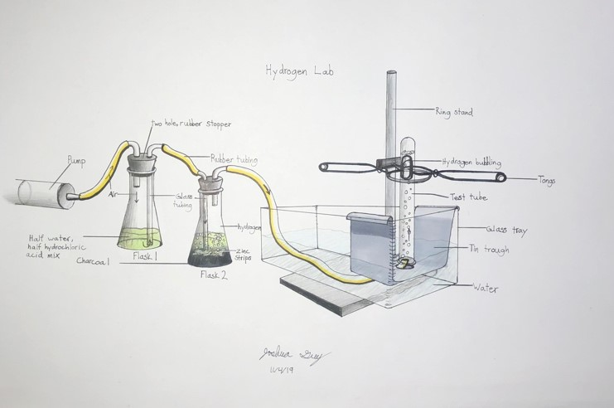
Several student example lab reports are posted near this handout. Look at them to get ideas!

