Lab Report Requirements

Your lab reports need (5) sections. Number them! Take pride in your work.
- Title: Write the lab title, your name, date, and class
- Problem statement: State clearly what you are trying to do in the lab
- Materials & Methods
- List the equipment and supplies you used
- Write what you did, and how you did it
- Include sketches and diagrams of the lab set-up!
- If it includes Chemistry, you must write out the reactions!
- Results: Present your results
- Use tables, charts, and graphs.
- Label everything and show all units!
- Conclusion: Write a closing paragraph
What did you find out? What did you learn? What did you discover?
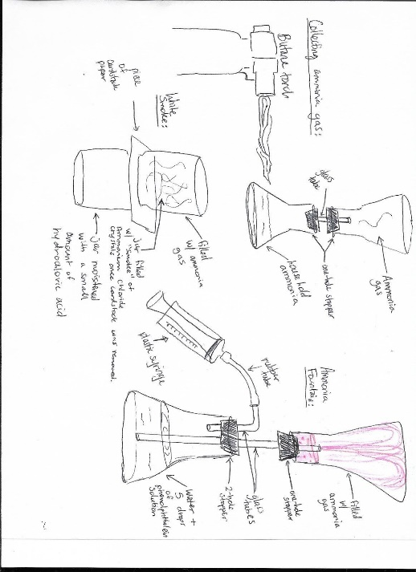
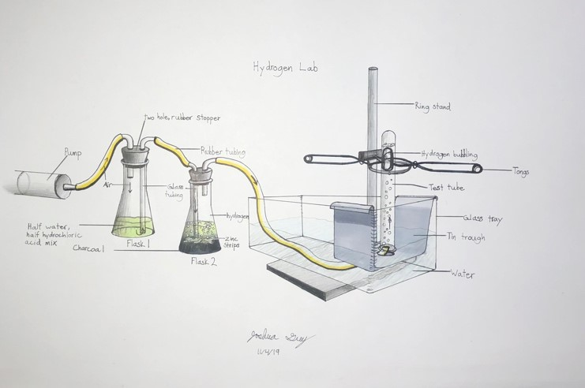
Several student examples are posted near this handout. Look at them to get ideas!

