**9.2** CHAPTER NINE



Several disadvantages of the magnesium battery are its ‘‘voltage delay’’ and the parasitic corrosion of magnesium that occurs during the discharge once the protective ﬁlm has been removed, generating hydrogen and heat. The magnesium battery also loses its excellent storability after being partially discharged and, hence, is unsatisfactory for long-term inter- mittent use. For these reasons, the active (nonreserve) magnesium battery, while used suc- cessfully in military applications, such as radio transceivers and emergency or standby equip- ment, has not found wide commercial acceptance.

Furthermore the use of this magnesium battery is declining signiﬁcantly, as the present trend is towards the use of lithium primary and lithium-ion rechargeable batteries.

Aluminum has not been used successfully in an active primary battery despite its potential advantages. Like magnesium, a protective ﬁlm forms on the aluminum, which is detrimental to battery performance, resulting in a battery voltage that is considerably below theoretical and causing a voltage delay that can be signiﬁcant for partially discharged batteries or those that have been stored. While the protective oxide ﬁlm can be removed by using suitable electrolytes or by amalgamation, gains by such means are accompanied by accelerated cor- rosion and poor shelf life. Aluminum, however, has been more successfully used as an anode in aluminum / air batteries. (See chapter 38)



***9.2 CHEMISTRY***



The magnesium primary battery uses a magnesium alloy for the anode, manganese dioxide as the active cathode material but mixed with acetylene black to provide conductivity, and an aqueous electrolyte consisting of ~~magnesium perchlorate,~~ with barium and lithium chro- mate as corrosion inhibitors and magnesium hydroxide as a buffering agent to improve storability (pH of about 8.5). The amount of water is critical as water participates in the anode reaction and is consumed during the discharge.1



The discharge reactions of the magnesium / manganese dioxide battery are



Anode Mg + 2OH-



= Mg(OH)2 + 2*e*



Cathode 2MnO2 + H2O + 2*e* = Mn2O3 + 2OH-



Overall Mg + 2MnO2 + H2O = Mn2O3 + Mg(OH)2



The theoretical potential of the battery is greater than 2.8 V, but this voltage is not realized in practice. The observed values are decreased by about 1.1 V, giving an open-circuit voltage of 1.9–2.0 V, still higher than for the zinc-carbon battery.



The rest potential of magnesium in neutral and alkaline electrolytes is a mixed potential, determined by the anodic oxidation of magnesium and the cathodic evolution of hydrogen. The kinetics of both of these reactions are strongly modiﬁed by the properties of the passive ﬁlm, its history of formation, prior anodic (and to a limited extent cathodic) reactions, the electrolyte environment, and magnesium alloying additions. The key to a full appreciation of the magnesium electrode lies in an understanding of the predominantly Mg(OH)2 ﬁlm,2 the factors which govern its formation and dissolution, as well as the physical and chemical

properties of the ﬁlm.

The corrosion of magnesium under storage conditions is slight. A ﬁlm of Mg(OH)2 that forms on the magnesium provides good protection, and treatment with chromate inhibitors increases this protection. As a result of the formation of this tightly adherent and passivating oxide or hydroxide ﬁlm on the electrode surface, magnesium is one of the most electropos-

itive metals to ﬁnd use in aqueous primary batteries. However, when the protective ﬁlm is broken or removed during discharge, corrosion occurs with the generation of hydrogen,

Mg + 2H2O → Mg(OH)2 + H2

MAGNESIUM AND ALUMINUM BATTERIES **9.3**

During the anodic oxidation of magnesium, the rate of hydrogen evolution increases with increasing current density due to destruction of the passive ﬁlm, which exposes more (ca- thodic) sites on the bared magnesium surface. This phenomenon has often been referred to as the ‘‘negative difference effect.’’ An appreciable rate of anodic oxidation of magnesium can only take place on the bare metal surface. Magnesium salts generally exhibit low levels of anion conductivity, and one could theoretically invoke a mechanism wherein OH- ions migrate through the ﬁlm to form reaction product Mg(OH)2 at the magnesium-ﬁlm interface. In practice this does not occur at a sufﬁciently rapid rate and instead the ﬁlm becomes disrupted, in all likelihood mechanically, as the result of anodic current ﬂow.3 A theoretical model for the breakdown of the passive ﬁlm has been proposed.4–7 This model involves, successively, metal dissolution at the metal-ﬁlm interface, ﬁlm dilatation, and ﬁlm break- down. This wasteful reaction is a problem, not only because of the need to vent the hydrogen from the battery and to prevent it from accumulating, but also because it uses water which is critical to the battery operation, produces heat, and reduces the efﬁciency of the anode.

The efﬁciency of the magnesium anode is about 60 to 70% during a typical continuous discharge and is inﬂuenced by such factors as the composition of the magnesium alloy, battery components, discharge rate, and temperature. On low drains and intermittent service, the anode efﬁciency can drop to 40 to 50% or less. The anode efﬁciency also is reduced with decreasing temperature.

Considerable heat is generated during the discharge of a magnesium battery, particularly at high discharge rates, due to the exothermic corrosion reaction (about 82 kcal per gram- mole of magnesium) and the losses resulting from the difference between the theoretical and operating voltage. Proper battery design must allow for the dissipation of this heat to prevent overheating and shortened life. On the other hand, this heat can be used to advantage at low ambient temperatures to maintain the battery at higher and more efﬁcient operating temper- atures.

A consequence of the passive ﬁlm on these metals is the occurrence of a voltage delay— a delay in the battery’s ability to deliver full output voltage after it has been placed under load—which occurs while the protective ﬁlm on the surface of the metal becomes disrupted by the ﬂow of current, exposing bare metal to the electrolyte (see Fig. 9.1). When the current is interrupted, the passive ﬁlm does indeed reform, but never to the original degree of pas- sivity. Thus both the magnesium and the aluminum batteries are at a signiﬁcant disadvantage in very low or intermittent service applications.3 This delay, as shown in Fig. 9.2, is usually less than 1 s, but can be longer (up to a minute or more) for discharges at low temperatures and after prolonged storage at high temperatures.

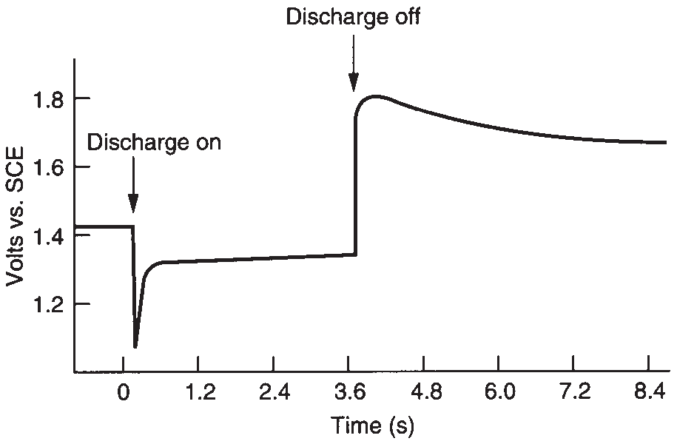

**FIGURE 9.1** Voltage proﬁle of magnesium primary battery at

20 C.

**9.4** CHAPTER NINE

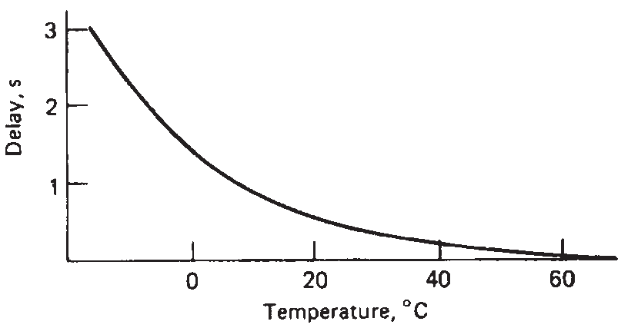

**FIGURE 9.2** Voltage delay vs. temperature, Mg / MnO2

battery.



**9.2.1 Aluminum**



The standard potential for aluminum in the anode reaction, Al → Al3+ + 3*e*

is reported as -1.7 V. A battery with an aluminum anode should have a potential about

0.9 V higher than the corresponding zinc battery. However, this potential is not attained, and

the potential of an Al / MnO2 battery is only about 0.1 to 0.2 V higher than that of a zinc battery. The Al / MnO2 battery never progressed beyond the experimental stage because of the problems with the oxide ﬁlm, excessive corrosion when the ﬁlm was broken, voltage delay, and the tendency for aluminum to corrode unevenly. The experimental batteries that were fabricated used a two-layer aluminum anode (to minimize premature failure due to can perforation), an electrolyte of aluminum or chromium chloride, and a manganese dioxide- acetylene black cathode similar to the conventional zinc / manganese dioxide battery. The



reaction mechanism is

Al + 3MnO2 + 3H2O → 3MnO OH + Al(OH)3

***9.3 CONSTRUCTION OF Mg / MnO*2 *BATTERIES***

Magnesium / manganese dioxide (nonreserve) primary batteries are generally constructed in a cylindrical conﬁguration.

**9.3.1 Standard Construction**

The construction of the magnesium battery is similar to the cylindrical zinc-carbon battery. A cross section of a typical battery is shown in Fig. 9.3. A magnesium alloy can, containing small amounts of aluminum and zinc, is used in place of the zinc can. The cathode consists of an extruded mix of manganese dioxide, acetylene black for conductivity and moisture retention, barium chromate (an inhibitor), and magnesium hydroxide (a pH buffer). The electrolyte is an aqueous solution of magnesium perchlorate with lithium chromate. A carbon rod serves as the cathode current collector. The separator is an absorbent kraft paper as in the paper-lined zinc battery structure. Sealing of the magnesium battery is critical, as it must be tight to retain battery moisture during storage but provide a means for the escape of hydrogen gas which forms as the result of the corrosion reaction during the discharge. This is accomplished by a mechanical vent—a small hole in the plastic top seal washer under the retainer ring which is deformed under pressure, releasing the excess gas.8