Concentration Phet WebLab -
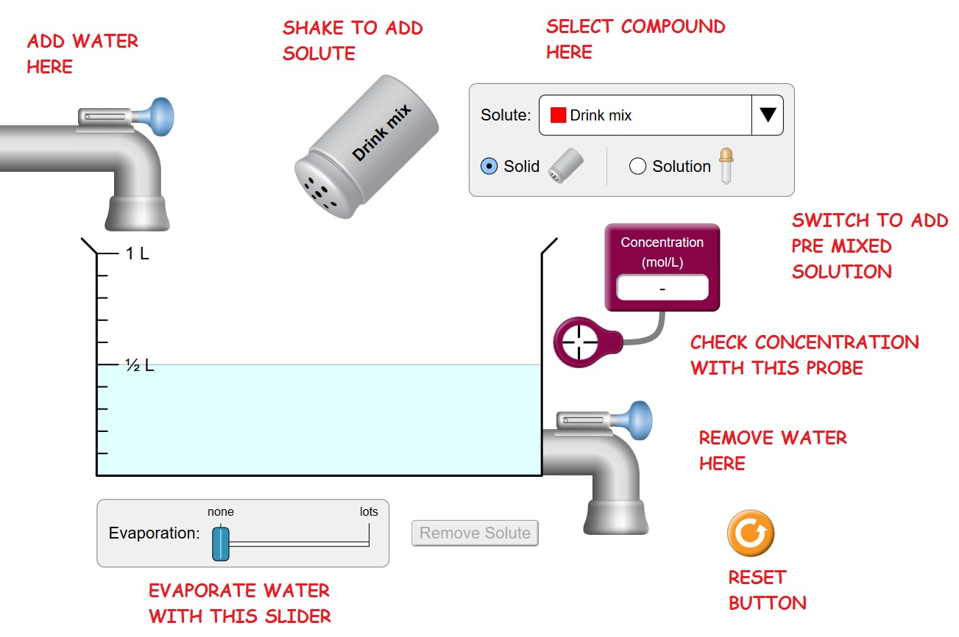https://phet.colorado.edu/sims/html/concentration/latest/concentration_en.html
Instructions:
Step 1: Download the lab handout from the NexGen student portal.
Step 2: Open the PhET simulation. If you need Java or Flash, download them. They are free. Get help/figure it out. Be resourceful.
Step 3: Do the lab. You may work in teams of two, but each person needs to turn it in separately to receive a grade in Canvas.
Step 4: Respond to ALL 30 questions in the lab handout.
Step 5: Copy and paste your Q&A's into Canvas. Make sure the formatting isn't messed up, and I don't need to see the clip art at this point. I can now grade and comment on your lab report directly in Canvas, and you can read all the feedback WITHOUT needing to scan or photograph anything. This should be a big improvement!
Let me know if questions.

Familiarize yourself with the operation of the various functions of the simulation. You can always press the RESET button to get back to the original situation.

Press Reset. Move the Concentration Probe into the liquid. Then Shake some Drink mix into the water. Continue to add More Solute.

PART 1 – Effect of Changing Amount of Solute/Solvent

- What happens to the concentration as more solute is added?

- What are the units of concentration on the meter measuring concentration?

- What happens to the color as more solute is added?

- Now add water. What happens to the concentration as the quantity of water increases? Explain why.

- Now remove water with the valve on the lower right. What happens to the concentration as the quantity of water decreases? Explain why. (Mention what is happening to the quantity of solvent and solute)

- Now remove water with the Evaporation Slider Bar on the bottom. What happens to the concentration as the quantity of water decreases? Explain why. (Mention what is happening to the quantity of solvent and solute)

PART 2 - Saturation
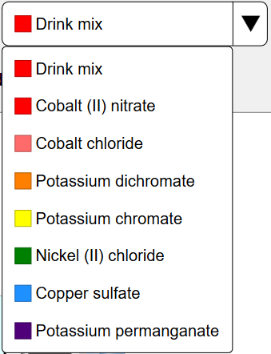
Press Reset then. Switch to a different Compound by selecting the Drop down menu called SOLUTE. Select CuSO4 - [Copper Sulfate].

- Can a saturated solution be created?

- How do you know when a saturated solution is created?

- Move the Concentration Probe into the liquid. (At this time the solution should be saturated) What is the concentration? (Include units)

- Add more solute. What happens to the concentration? (Explain why)

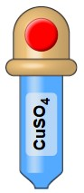
PART 3 – Using the Eye-dropper
Press Reset. Switch to the eye dropper by selecting Solution in the upper right.

- Using the concentration meter, what is the concentration of the solution in the Eyedropper? Hint: drain the water out first, and then dump some eyedropper solution into the beaker, and measure it.

PART 4 – Controlling the Concentration
Press Reset, then select CuSO4.

- What is the molecular weight (MW) of CuSO4 in g/mol? Cu=64 g/mol, S=32 g/mol, O=16 g/mol. Hint: The MW is between 155 and 175 g/mol. Answer ____________ g/mol

Drain the water level down to 0.25 L. Then add enough eyedropper CuSO₄ to create a .5 Molar Solution in the 0.25 liter of water originally in the beaker. (you will now have more than 0.25 L of solution in the beaker)

- Show the calculation of the number of moles in the beaker. Hint: Molarity (M) = # of moles of solute/liter of solution. [mols solute/L solution] Answer: ____________ mols (Self check: it’s .25 mol, but you must show your work!)

- Predict the concentration if the solution is diluted with water to a volume of 1 liter. Show the calculation of this concentration, include units.

After you make the calculation/prediction, actually add water with the valve up to the 1L mark.
- What is the concentration? Does this match your calculation? Yes or No

- Predict the concentration if the solution is now concentrated (by using evaporation) to a volume of .75 liters (1/2 way between .5 liters and 1 liter). Show the calculation of this concentration, include units in all your work.

After you make the calculation: Evaporate water with Evaporation Slider Bar at the bottom until there is .75 liter of solution in the beaker.
- What is the concentration? Does this match your calculation? (Self check: the concentration at this point should be .33 M. If it isn’t, go back and try it again.)

- From the concentration & volume, calculate the number of moles of solute in the solution. Show your calculation with units. (It’s .25 mol, but show your work!)

- How does the # of moles of solute compare to the # of moles of solute calculated in question 13. Explain why these numbers compare as they do.

- Predict the concentration AND # of moles of solute if water is added until the volume is 1 liter. Self check: it’s .25 mol/L and .25 mol, but show your work!)

Open the Remove Water Valve (on the lower right) until there is ½ liter of solution in the beaker.

- What happened to the concentration when ½ of the solution was allowed to run out? (Explain why in terms of the amount of solute and solvent)

- From the concentration & volume calculate the number of moles of solute in the solution. Show your calculation with units. (it’s .125 mol, but show your work!)

- How does the # moles of solute compare to the # of moles of solute calculated in question #18. Explain why these numbers compare as they do.

- Predict the concentration if the solution is diluted to a volume of 1 liter. Show the calculation of this concentration, include units in all your work.

After you make the calculation, actually add water with the valve in the upper left until there is 1 liter of water in the beaker .
- What is the concentration? Does this match your calculation? Yes or No (Self check: it’s .125 M, but show your work!)

SUMMARY OF LEARNING OBJECTIVES

Some of these you may have to test right now using the Sim in order to answer!

- Adding solute (solid) to an unsaturated solution causes the concentration of the solution to: INCREASE /DECREASE/ REMAIN UNCHANGED.
- Adding pure water to a saturated solution will cause the concentration of the solution to: INCREASE /DECREASE/ REMAIN UNCHANGED.
- Adding a solid salt to a saturated solution causes the concentration of the solution to: INCREASE /DECREASE/ REMAIN UNCHANGED.

- Evaporation acting on an unsaturated solution causes the concentration of the solution to: INCREASE /DECREASE/ REMAIN UNCHANGED

- Evaporation acting on a saturated solution causes the concentration of the solution to: INCREASE /DECREASE/ REMAIN UNCHANGED.

