Physics: Course Outline
Welcome!
This is an introductory Physics course with hands-on labs. The course covers the standard California curriculum, including classical Newtonian mechanics, heat & thermodynamics, electricity & magnetism, optics & light. This is not calculus-based Physics. Prerequisite: Algebra I.

Technical requirements: Access to a computer with Internet connection, and a scientific calculator (A $15-20 version will suffice).

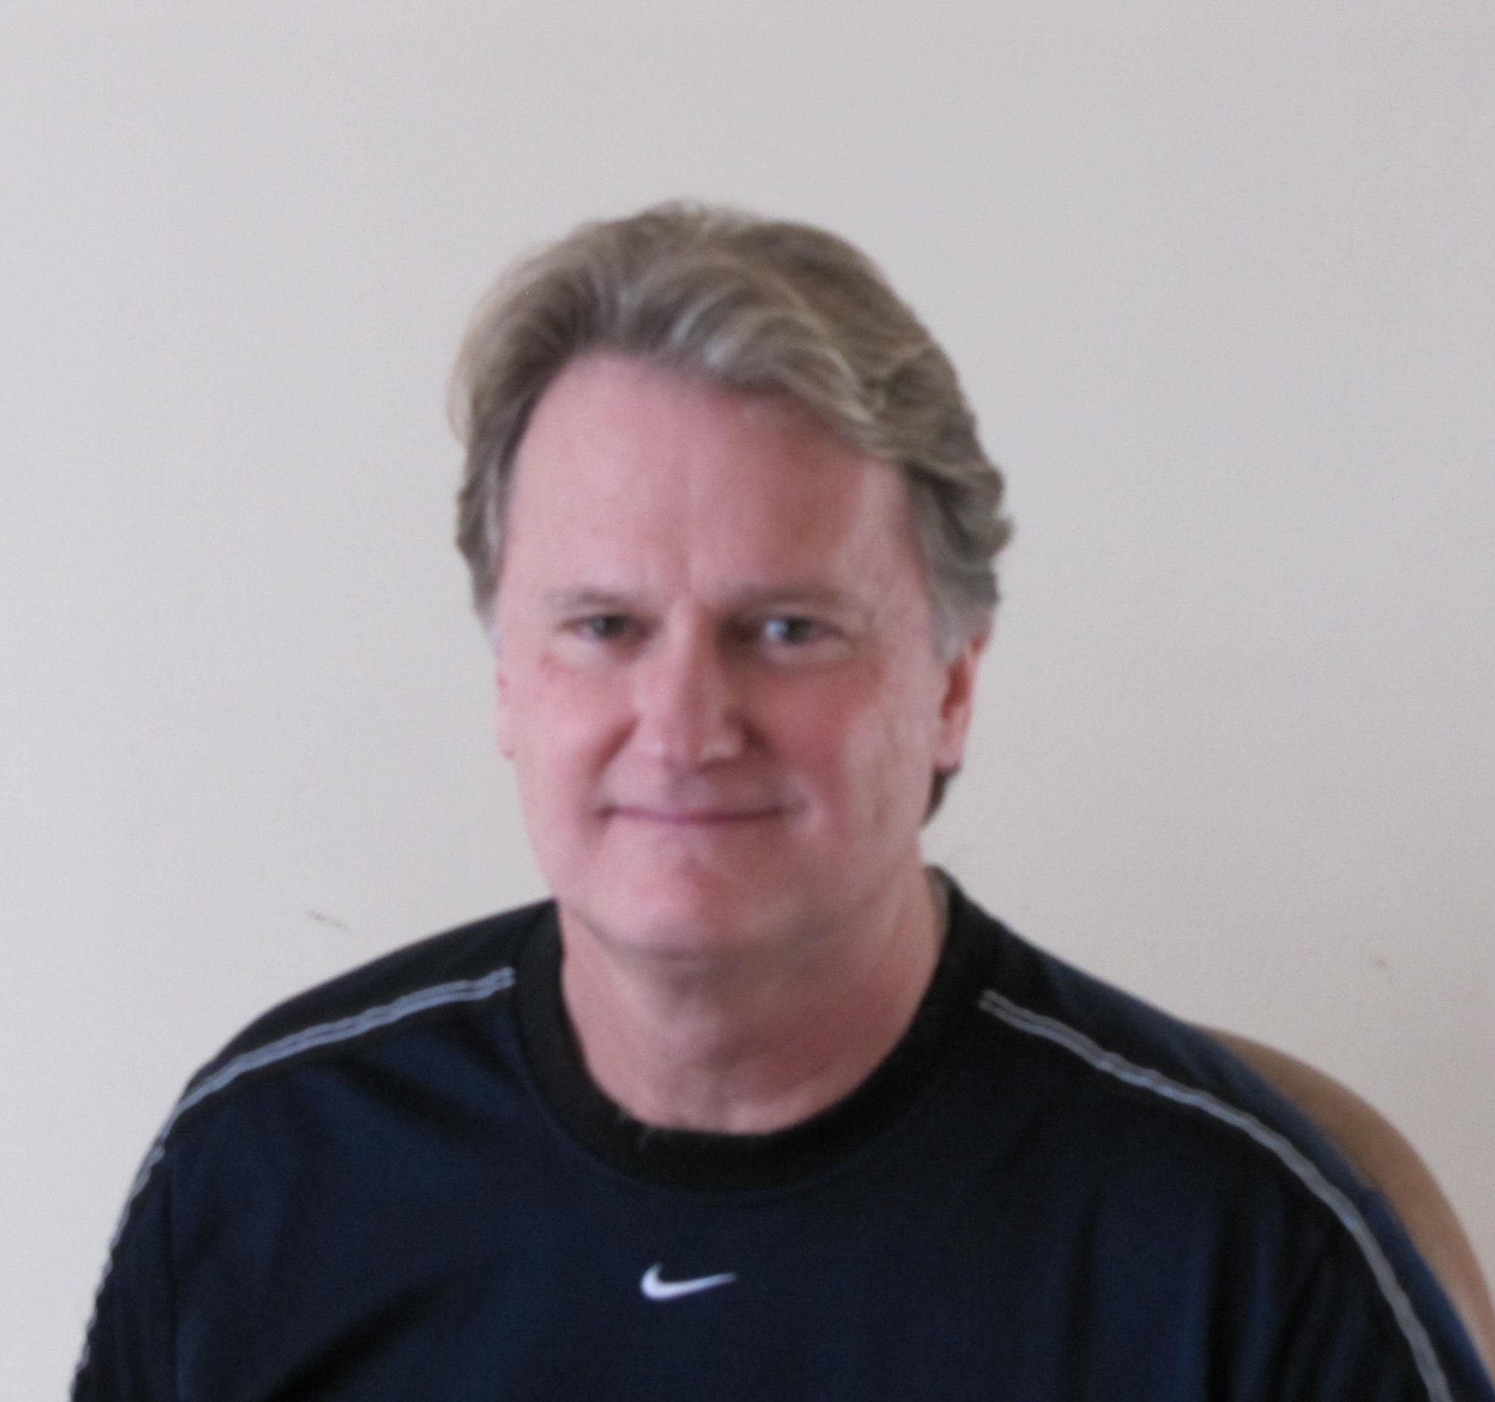
Instructor: Kris Johanson, M.S.

Contact: kjohanson@san.rr.com. I am available throughout the week to answer questions about your homework or the labs.

Textbook: For this class you may use either 1) BJU Physics 3rd edition, or 2) Apologia Physics 2nd edition. You don’t need to buy a lab manual. I will provide lab protocols as needed throughout the course.

Course Outline Labs
Unit 1 – Motion in a straight line Cart-Ramp lab I: velocity
Unit 2 – Vectors Cart-Ramp lab II: acceleration
Unit 3 – Motion in a plane Outdoor Surveying lab: using vectors
Unit 4 – Newton’s Laws Mass & Acceleration lab: Newton’s 2nd law
Unit 5 – Applying Newton’s laws Simple Machines lab: Block & tackle
Unit 6 – Circular motion & gravity Gravity & Orbits lab
Unit 7 – Work and energy Energy Skate Park lab
Unit 8 – Momentum Collision lab
Unit 9 – Periodic motion and sound waves Spring-Mass lab: Hooke’s law
Take-home Midterm
Unit 10 – Temperature and expansion Gas Laws lab
Unit 11 – Thermal energy and heat Thermodynamics lab
Unit 12 – Thermodynamic laws Stirling Motor lab
Unit 13 – Electric charge and Coulomb’s law Braun Electroscope lab
Unit 14 – Electric potential and capacitors Circuits lab I
Unit 15 – Electrical circuits Circuits lab II
Unit 16 – Magnetism Electromagnets build & test
Unit 17 – Electromagnetic waves and light Light lab
Unit 18 – Geometric optics Open/flex
Take-home Final

Homework
Weekly homework will be assigned from each chapter. Typical homework for this class consists of standard end-of-chapter problems and lab write-ups. I go over the homework problems carefully during the online webinar sessions. Students should read the chapter ahead of time and be prepared to take notes and participate in discussion. Estimated homework and study time is 30 minutes per day.

Teaching Pedagogy
The course uses a combination of hands-on labs, face-to-face instruction, and live webinar sessions which help to solidify the homework assignments.

Exams
Yes, exams are necessary for a host of reasons. There will be a take-home style, open-book, midterm and final exam, covering material learned that semester. The exams are not burdensome, and you will be given a week to complete each one. Emphasis is on applications, not on rote memorization.

Course Requirements
- Attend the classes (including both in-person and webinar sessions). Be on time.
- Take notes and ask relevant questions during the lectures
- Participate in the class labs
- Turn in your homework assignments by the due date
- Don’t fall behind in your work. Do not procrastinate!

Grading Policy
Your work will be graded on a point system. Your total points earned will be divided by total points possible and converted to a percentage as shown:

Grading Scale Grading Elements
above 90% A: advanced Class participation 25%
89 – 80% B: proficient Labs 25%
79 – 70% C: basic Weekly homework 25%
69 – 60% D: below basic Midterm & Final 25%
Below 60% F: far below basic Total 100%

Timely completion of the required assignments is a basic requirement. Assignments turned in early will receive a “bonus incentive”. Assignments turned in later than the due date will receive a reduced grade.

Progress Reporting
Detailed student progress reports are emailed to parents at the end of each semester.

