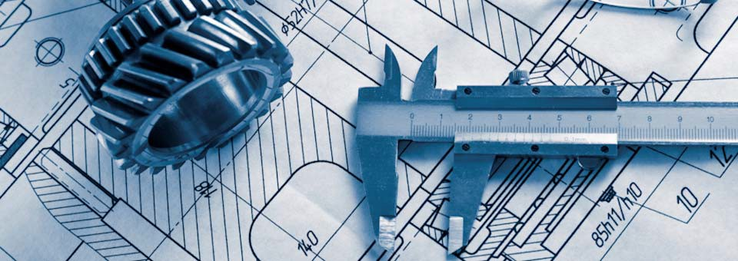
Welcome!
Are you interested in technology? Enjoy working with computers? Are you curious about how things work?

Principles of Engineering is a high school-level course for those interested in science, engineering, or the technical trades. Students employ engineering and scientific concepts in the solution of various design problems. They develop problem-solving skills, create solutions to various challenges, document their work, and communicate their solutions. The course includes an introduction to AutoDesk® CAD software (free download). Prerequisites: Algebra 1 or Integrated Math 1 (concurrent okay). Recommended grades: 8th and up.

Technical requirements: A reasonably modern computer (typically no more than 5 years old), a reliable Internet connection, a Scanner for homework, and a scientific calculator in the range of $10-20 (example: TI-30Xa). You will also need reliable email to communicate and receive weekly class emails.
Instructor: Kris Johanson MS, MBA. kjohanson@san.rr.com.
Office hours: I am available throughout the week to answer questions about your work.

The required textbook and workbook are shown here. They are available “used”.

Course Outline
Unit 1: Machines and Mechanisms | Unit 3: Engineering Materials
Simple Machines | Material Properties
Compound Machines | Mechanics of Materials
Pushrods, Cams, and Bearings | Material Testing
Gears, Pulleys, and Chain Drives
 | Unit 4: Structural Design
Unit 2: Energy and Power | Statics
Thermodynamics | Beams and Girders
Energy Sources | Trusses
Electrical Systems I | Final Project – Bridge Design
Electrical Systems II
Fluid Power

© 2016 P
Course Schedule
The course sequence is posted on the student portal. Exact dates will be posted during class. Students will be informed of upcoming assignments and due dates through weekly updates. It is the responsibility of the student to carefully read the weekly updates and stay current with classwork.

Homework
This is a project-based course, which means students are always working in the context of a “design scenario”. Assigned work consists of various research assignments, homework questions, assigned reading, and using CAD design software to document their work. I go over the assigned work carefully during the online webinar sessions to make sure everyone understands. Estimated homework and study time is at least 5 hours per week.

Teaching Pedagogy
The course uses a combination of live Webinar instruction, custom online teaching videos, homework-help videos, reading assignments, design scenarios, and various Internet research assignments. The entire course is completed in 32 weeks (not counting Holidays), beginning after Labor Day and ending in May. The live Webinars take place every week; they cannot be recorded for a host of reasons, and it is the student’s responsibility to attend each webinar.

Exams
Exams are not used in the Online version of the course.

Make-Up Work/Late Work
Refer to the “Policies” tab on the student portal.

Course Requirements
- Attend the weekly Webinar sessions. Be on time.
- Do the assigned reading ahead of time.
- Take notes and ask relevant questions during the Webinar lectures.
- Participate in the online collaborative projects when assigned.
- Turn in your assigned work by the due date.
- Don’t fall behind in your work. Do not procrastinate!

Software
This course uses a variety of software. You will need a reasonably modern computer (typically less than 5 years old), access to a standard suite of Office software (Word, Excel, PowerPoint, Google Docs, Office 365, or other), a reasonably fast Internet connection, a Scanner for homework, a reliable email account for class communications, and AutoDesk® Inventor 2019. The AutoDesk software can be downloaded for free by signing up for an educational account at www.autodesk.com. It is the student’s responsibility for adjusting his/her computer settings if needed, and downloading the software. I believe the 2019 version is compatible with Windows 7, 8, and 10 – but it is the student’s responsibility for checking and verifying all compatibility issues! The download takes a while (sometimes a few hours), so you must plan ahead and allow enough time to adjust your computer’s settings and/or memory if needed. Keep in mind this is a full, professional version of the software. You can review the “system requirements” on the AutoDesk website.

Supplies Needed
Standard writing and note-taking supplies
Textbook and student workbook (both are available “used”)
Scientific calculator (TI-30Xa is sufficient)
Engineering graph paper (download from www.printfreegraphpaper.com)

Grading Policy
Your work will be graded on a point system. Your total points earned will be divided by total points possible and converted to a percentage as shown:

Grading Scale Grading Elements (Online class)
above 90% A: advanced Class Participation** 33%
89 – 80% B: proficient Homework & Design Projects 67%
79 – 70% C: basic Total 100%
69 – 60% D: below basic (**Means actively participating in the Webinars and
Below 60% F: far below basic the Online collaborative projects when assigned)

Timely completion of the required assignments is a basic requirement. Assignments turned in early will receive a “bonus incentive”. Assignments turned in later than the due date will receive a reduced grade.

Progress Reporting
Detailed student progress reports are emailed to parents at the end of each semester.

