Skate Park Velocity-Acceleration Weblab, part 1
Name and date submitted (3 pts):
Create space in the Word document below, and write or type your answers. Turn in your completed work by the due date.
(20 questions, 100 points possible)
Go to https://phet.colorado.edu/ and find the “Energy Skate Park” simulation. At the time of writing, it was located here https://phet.colorado.edu/en/simulations/energy-skate-park
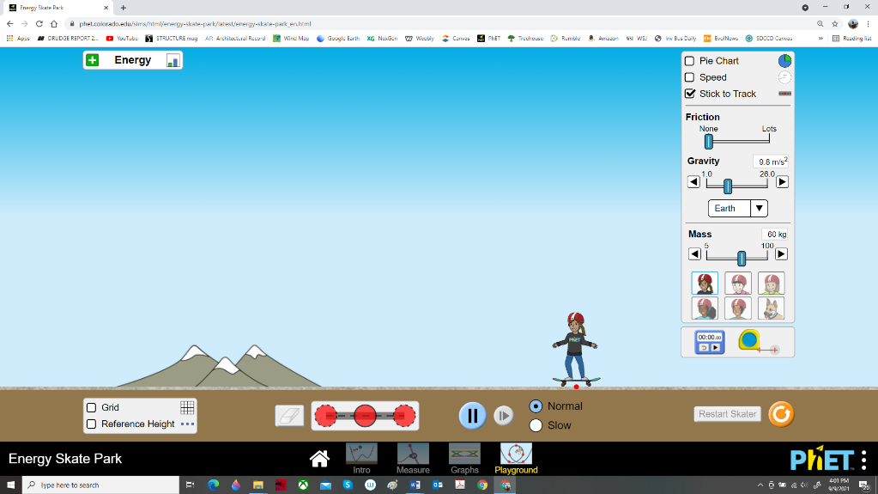
Hit the “play” button and select the “Playground” option.

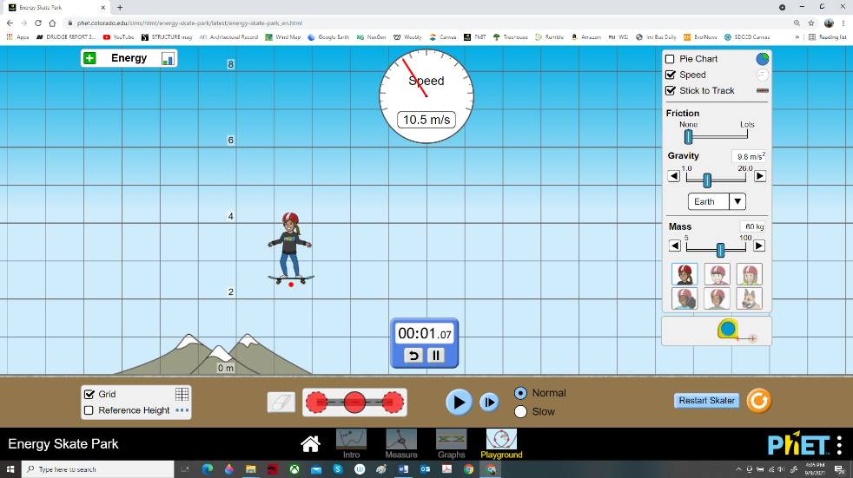
Add “grid” and “speed” by checking the boxes, and drag in the “digital timer”. Drop the skater from 8 meters and accurately measure the time to reach the ground, and the final velocity just before hitting the ground. These will be important in part 2 of the lab, so take your time and get accurate numbers.

Freefall scenario
- What is the time in seconds to hit the ground from 8 m?

- What is the final velocity in m/s just before hitting the ground?

Now build 3 different ramps – steep, medium, and shallow. Measure the length of each ramp using the tape measure. Use the grid to obtain the beginning and ending elevations of each ramp. Run the skater down each ramp, carefully measuring the time and final velocity for each scenario. Use the slow motion button as you near the end of the ramp to get accurate measurements. Hint: make sure your ramps are straight! Bowing in the middle, either up or down, will mess up the results. You can use the tape measure as a straight edge. Three (3) examples are shown below. Everyone will have slightly different angles, lengths, and so forth; the important thing is that you get accurate measurements.
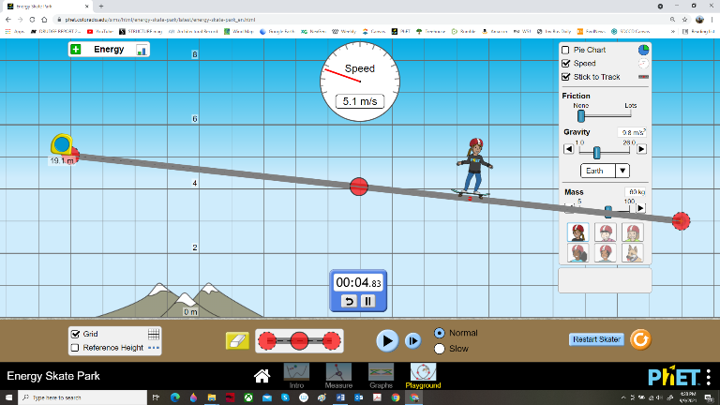
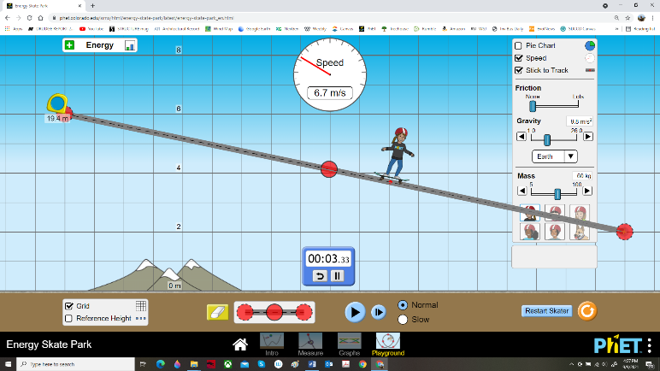
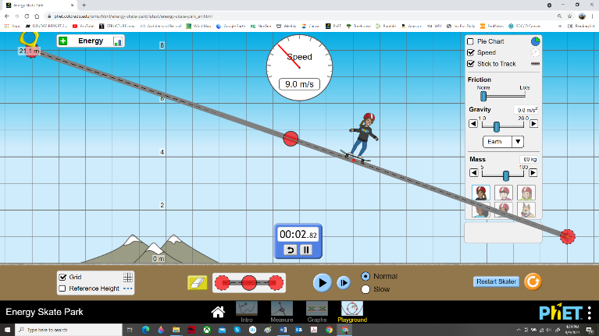
Steep ramp
- Length of ramp in m

- Time in s to reach the bottom

- Elevation difference in m between start and end

- Final velocity in m/s

Medium ramp
- Length of ramp in m

- Time in s to reach the bottom

- Elevation difference in m between start and end

- Final velocity in m/s

Shallow ramp
- Length of ramp in m

- Time in s to reach the bottom

- Elevation difference in m between start and end

- Final velocity in m/s

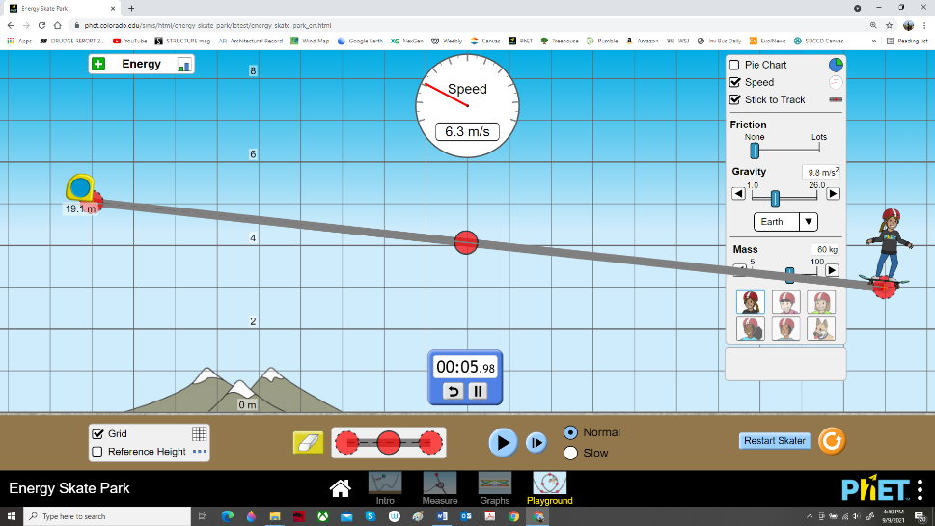
Here’s an example to make sure you understand
My shallow ramp in the screenshot above has a ramp length of 19.1m, has a time of 5.98 s, has an elevation difference of 2 m, and has a final velocity of 6.3 m/s.
Calculate the average velocity $v_{avg}$ in m/s for each scenario using the equation:
$$v_{avg}=\frac{x_{2}-x_{1}}{t_{2}-t_{1}}$$
- What is the average velocity in m/s for the freefall scenario (show your work):

- What is the average velocity in m/s for the steep ramp scenario (show your work):

- What is the average velocity in m/s for the medium ramp scenario (show your work):

- What is the average velocity in m/s for the shallow ramp scenario (show your work):

Here’s what my example ramp calculations would look like:
$$v_{avg}=\frac{x_{2}-x_{1}}{t_{2}-t_{1}}= \frac{19.1 m-0.0 m}{5.98 s-0.0 s}= \frac{19.1 m}{5.98 s}=3.19 m/s$$
How does mass effect the results?
- Build a ramp. Any ramp is fine. Experiment by using 3 different masses for the skater. Record your results:
  - Mass in kg: Time in s: Final velocity in m/s:
  - Mass in kg: Time in s: Final velocity in m/s:
  - Mass in kg: Time in s: Final velocity in m/s:

How does gravitational acceleration effect the results?
- Build a new ramp, or use the same ramp as above. Experiment by changing the gravitational acceleration. Record your results:
  - Moon Time in s: Final velocity in m/s:
  - Earth Time in s: Final velocity in m/s:
  - Jupiter Time in s: Final velocity in m/s:

