The U.S. Money Supply
Fig. 1: The definitions of M1, M2, and M3
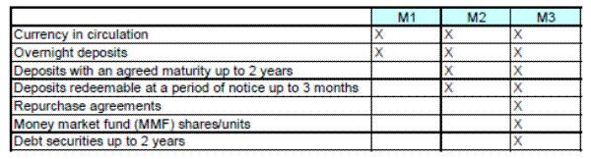
Fig. 2: The government has been printing money – lots of it recently. Why would a government want to keep increasing the money supply like this?
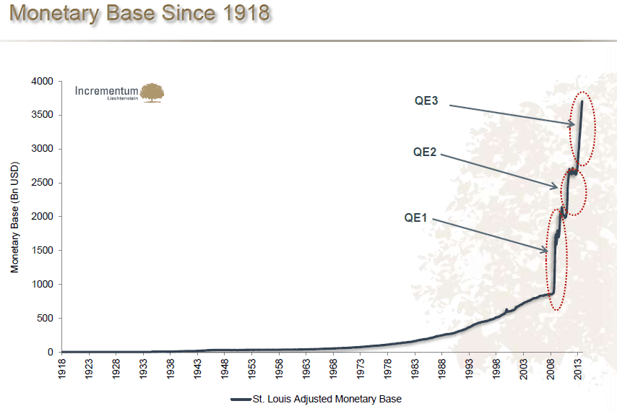
Fig. 3: The true value of the Dollar has been eroded. This is what “inflation” does. Who does inflation help? Who does it hurt?
