Wind Turbine Calculations

Measuring the Swept Area of Your Wind Turbine

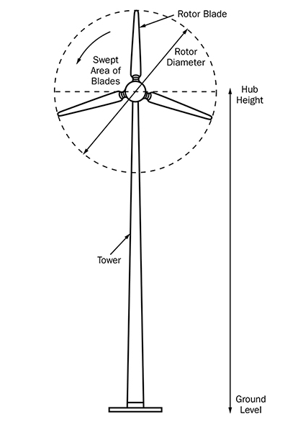
Being able to measure the swept area of your blades is essential if you want to estimate the total energy potential in a given area of wind.

The swept area refers to the area of the circle created by the blades as they sweep through the air.

To find the swept area, use the following equation:

Swept Area = ∏r2

∏ = 3.14 (pi)
r = Radius. This is equal to the length of one of your blades.

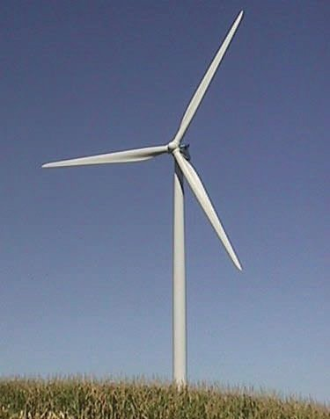Why is This Important???

You will need to know the swept area of your wind turbine to calculate the total power in the wind that hits your turbine.

Wind Power Equation:

$$P=\frac{1}{2}ρAv^{3}$$

P = Power (Watts)
ρ = Air Density (1.225 kg/m3 at sea level)
A = Swept Area of Blades (m2)
v = Velocity of the wind (m/s)

By doing this calculation, you can see the total energy potential in a given cross section of wind.

Problems:

- What is the swept area in m² of a wind turbine with 3 blades that are each 3 meters long?

- If the wind is blowing at 3 meters/second, how much total power (Watts) is in the wind hitting the wind turbine from question one (blades 3-meters long)? Assume the wind turbine is at sea level.

- How much power (Watts) would be contained in the column of wind hitting the wind turbine if the wind was blowing at 6 m/s? (very strong wind)

- How much power (Watts) would be contained in the column of wind hitting the wind turbine if the wind was blowing at 9 m/s? (extremely strong wind)

Calculating the Tip Speed Ratio of Your Wind Turbine

The Tip Speed Ratio (TSR) is an extremely important factor in wind turbine design. TSR is equal to the wind speed divided by the tip speed of your blades.

Calculate the tip speed:

Tip Speed = RPM x circumference ÷ 60
Tip Speed – as measured in m/sec
RPM (revolutions/min) – you can usually measure this using stopwatch
Circumference (m/revolution) – you can calculate this using C=Π x dia

Calculate the Tip Speed Ratio (TSR):
TSR (λ) = tip speed ÷ wind speed
TSR doesn’t have units
Wind speed (m/sec) = look it up on wind map, or it’s stated in the problem
Tip speed (m/sec) = compute from tip speed equation, above

Figure below: You can also compute tip speed using radians/sec, but using RPM’s is easier because you can usually measure RPM’s with a stopwatch.
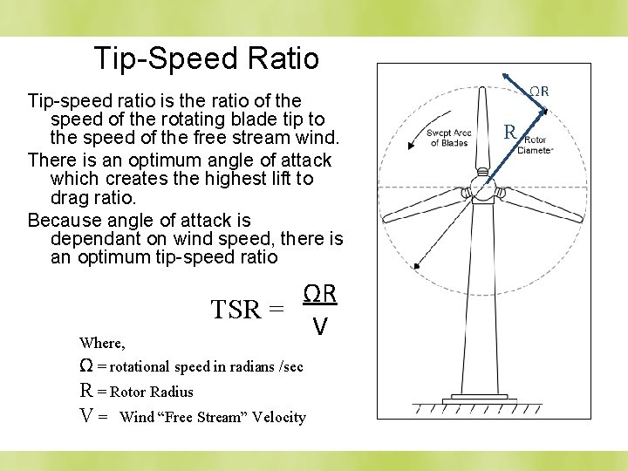

If the rotor of the wind turbine spins too slowly, most of the wind will pass straight through the gap between the blades, therefore giving it no power!
But if the rotor spins too fast, the blades will blur and act like a solid wall to the wind. Also, rotor blades create turbulence as they spin through the air. If the next blade arrives too quickly, it will hit that turbulent air. So, sometimes it is actually better to slow down your blades!
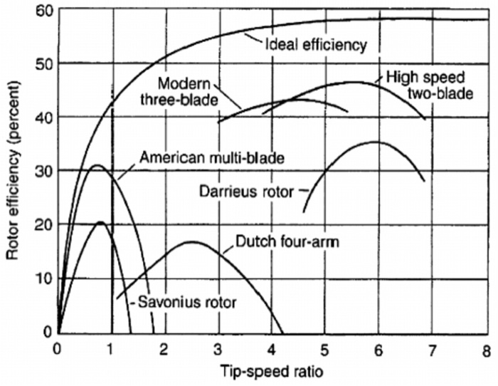

HOW DO YOU OPTIMIZE TSR FOR MAXIMUM POWER ???

$Optimum TSR \left(λ\right)= \frac{4π}{n}$ (n = number of blades)

# of blades | Optimum TSR
2 | 6
3 | 4-5
4 | 3
6 | 2

Why is This Important???

Knowing the tip speed ratio of your turbine will help you maximize the power output and efficiency of your wind turbine. Remember that if your rotor spins too slowly, a lot of wind will pass through the gaps between the blades rather than giving energy to your turbine. But if your blades spin too quickly, they could create too much turbulent air or act as a solid wall against the wind. So, if you want to maximize your turbine’s efficiency, you’ve got to calculate the perfect Tip Speed Ratio.

Problems:

- Using your 3-blade turbine with 3-meter blades, what is the optimum RPM’s with a wind speed of 3 m/s? Strategy: compute the optimum TSR, then compute the tip speed in m/s, then compute the RPM’s.

- Using your 3-blade turbine with 3-meter blades, what is the optimum RPM’s with a wind speed of 6 m/s?

- Using your 3-blade turbine with 3-meter blades, what is the optimum RPM’s with a wind speed of 9 m/s?

- If you went with a 4-bladed turbine, would it need to turn slower or faster than a 3-bladed unit? Strategy: pick a wind speed, say 3 m/s, and compute its optimum RPM’s, and compare.

Gear Ratios

Without a gearbox, utility-scale wind turbines using an ordinary generator would have to rotate at over 1,000 rpm to generate the 60 Hz AC electricity we use in our homes. That means the tips of those long blades would be rotating at over TWICE THE SPEED OF SOUND!!!

Therefore, to get the generator spinning at over 1,000 RPM, we use a system of gears.

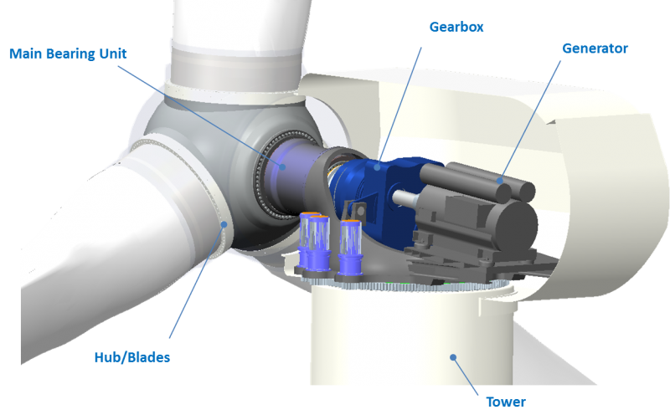

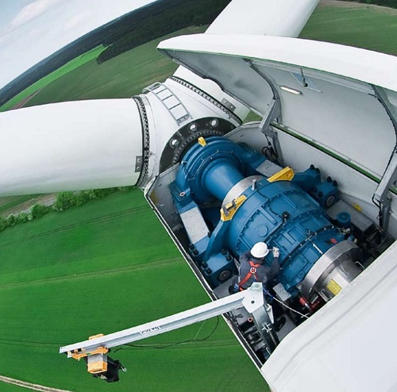
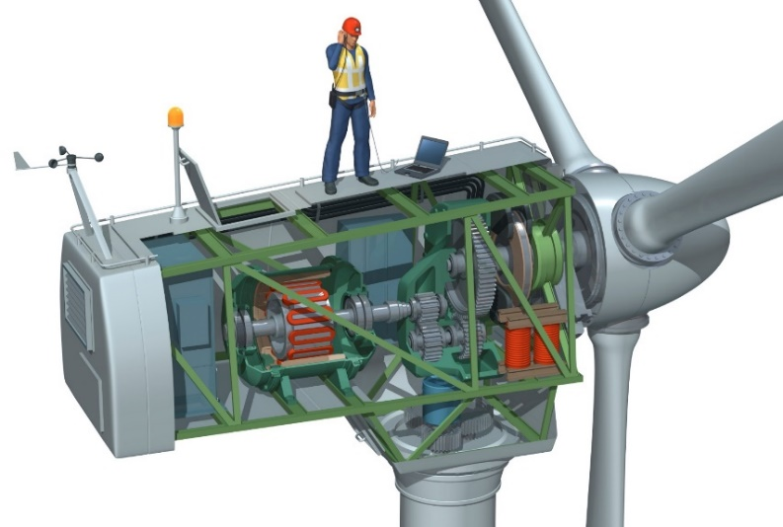

Strategy: So in your wind turbine, you will run the propeller shaft (slow) into the gearbox, the gears will then step up the speed, and then you run the output shaft (fast) from the gearbox to the generator.

The “gear ratio” of a system of gears can be computed many ways:

Gear Ratio equations:

$$GR= \frac{{RPM}_{in}}{{RPM}_{out}}=\frac{ω_{in}}{ω_{out}}=\frac{n_{out}}{n_{in}}$$

where RPM is revolutions/min, ω is radians/sec, and ‘n’ is the # of teeth.
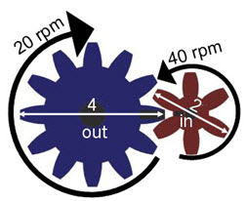

For example, the ‘gear ratio’ of the gears shown above would be

$GR=\frac{{RPM}_{in}}{{RPM}_{out}}=\frac{40}{20}=2$, or we might say “2:1”

With your wind machine, let’s say you have a blade rotation speed of only 60 RPM, but you need your generator to spin at 1,200 RPM to generate consequential amounts of electricity. Therefore, you will need a gear ratio of

$GR=\frac{{RPM}_{in}}{{RPM}_{out}}=\frac{60}{1200}=.05,$ or we might say a gear ratio of “1:20”.

Problems:

- Using your 3-bladed machine with 3-m blades, and a wind speed of 6 m/s (strong wind), you calculated the optimum RPM’s in a problem above. Let’s assume your generator needs to be rotating at 1,750 RPM to make enough volts. What gear ratio (GR) would your gearing system need to have?

- Design a wind turbine: Let’s say you have available wind at 3.50 m/s. Furthermore, let’s say you are limited to a blade length of no more than 4 meters (because your installation site has height restrictions). Let’s say your generator needs to spin at least 1,800 RPM to operate efficiently. You can use 2, 3, or 4 blades.

Answer/calculate the following: SHOW ALL WORK
  - Decide how many blades you are going to use (3 blades is most common, but it’s up to you):

  - What is your swept area in m²?

  - What is the power in Watts of the wind hitting your blades?

  - What is your optimum TSR?

  - What is the tip speed in m/s?

  - What is the RPM of the blades?

  - What gear ratio does your gearing system need?

